ColorOS 7 User Guide

Here is everything you need to know about ColorOS 7.

Further explore the comprehensive screen, show endless care in the subtleties, and achieve the beauty of simplicity in the brief.The icons are lighter, lighter in style, easier to interact, and lighter in vision.

The technology beauty is hidden into life, giving users the most delicate and natural quality experience.Algorithm blessing gives you a better shooting experience. Take a shot, the best work is out.

The operation is more sensitive and the operation is smoother. The mobile phone seconds change game console, giving you a more intense immersion, faster and more enjoyable gaming experience.

ColorOS 7, Smooth and delightful.



Communication and Network
SIM Card Settings
If your OPPO smartphone supports Dual SIM, the card tray one is for Nano-SIM. The card tray two supports both Nano-SIM and MicroSD Card.

In Dual SIM mode, you can set a default SIM card for dialing, or manually select one when dialing. You can also set a SIM card for cellular networks.

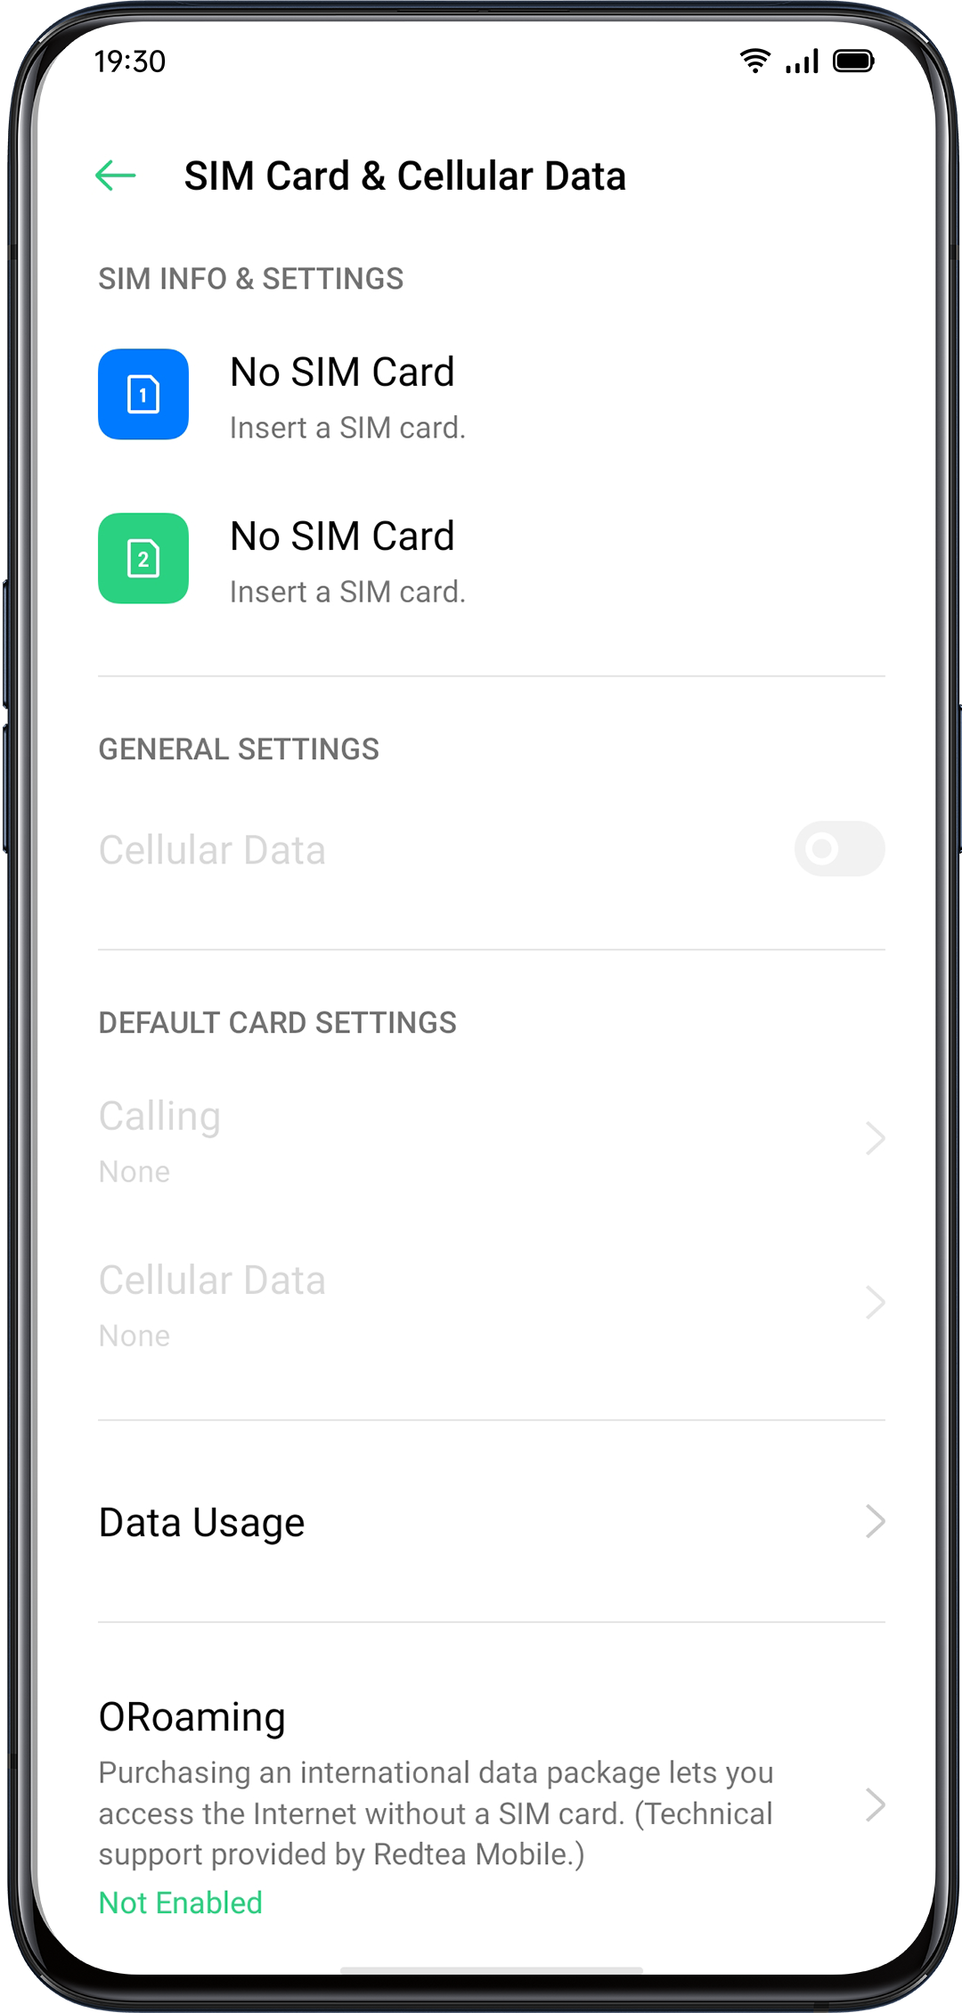

You can rename two SIM cards and modify the network settings

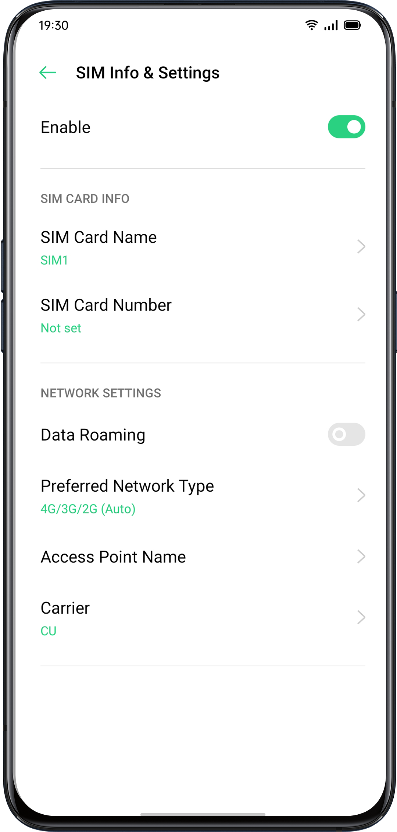

Wi-Fi
Wi-Fi Connection
Go to "Settings" > "Wi-Fi", enable Wi-Fi.
Detected Wi-Fi networks will be displayed.

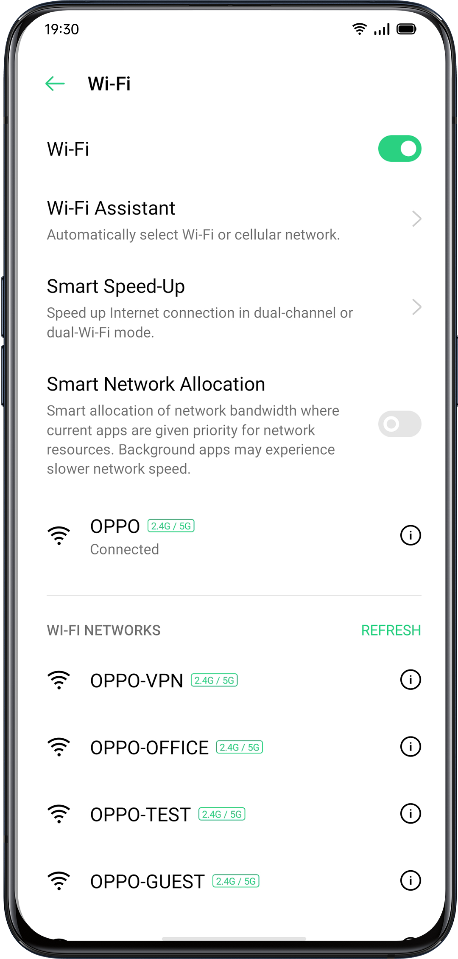

- Wi-Fi Without Password
If you want to connect to Wi-Fi without a password, tap the network directly.
- Password-Required Wi-Fi
Tap the network and enter the password if required.
- Manually Add a Network
If you cannot find the network that you intend to connect, enter both the network name and password after you click the option "Manually Add a Network".

Once the device is successfully connected to a network, whenever the network is available, the device will connect to the network without having to re-enter the password.

If you do not want to connect to a network automatically, tap  to remove the connected network.

You can view the "Saved Networks" in "Advanced Settings".

Enhance Internet Experience
What if the Wi-Fi signal is unstable?
- Wi-Fi Assistant
Enable "Automatically Select the Best Wi-Fi", the phone will connect to the best Wi-Fi network by detecting and analyzing the quality of all Wi-Fi signals.

You can also activate "Auto-switch to Cellular Network". When all Wi-Fi networks are of poor quality while the cellular data is on, the phone will switch to the cellular network automatically.

- Dual Channel Network Acceleration
When "Dual Channel Network Acceleration" is turned on, network speed will be intelligently accelerated when cellular data and Wi-Fi are used concurrently. Then you can enjoy a smoother Internet connection.

Apps for network acceleration are displayed below.

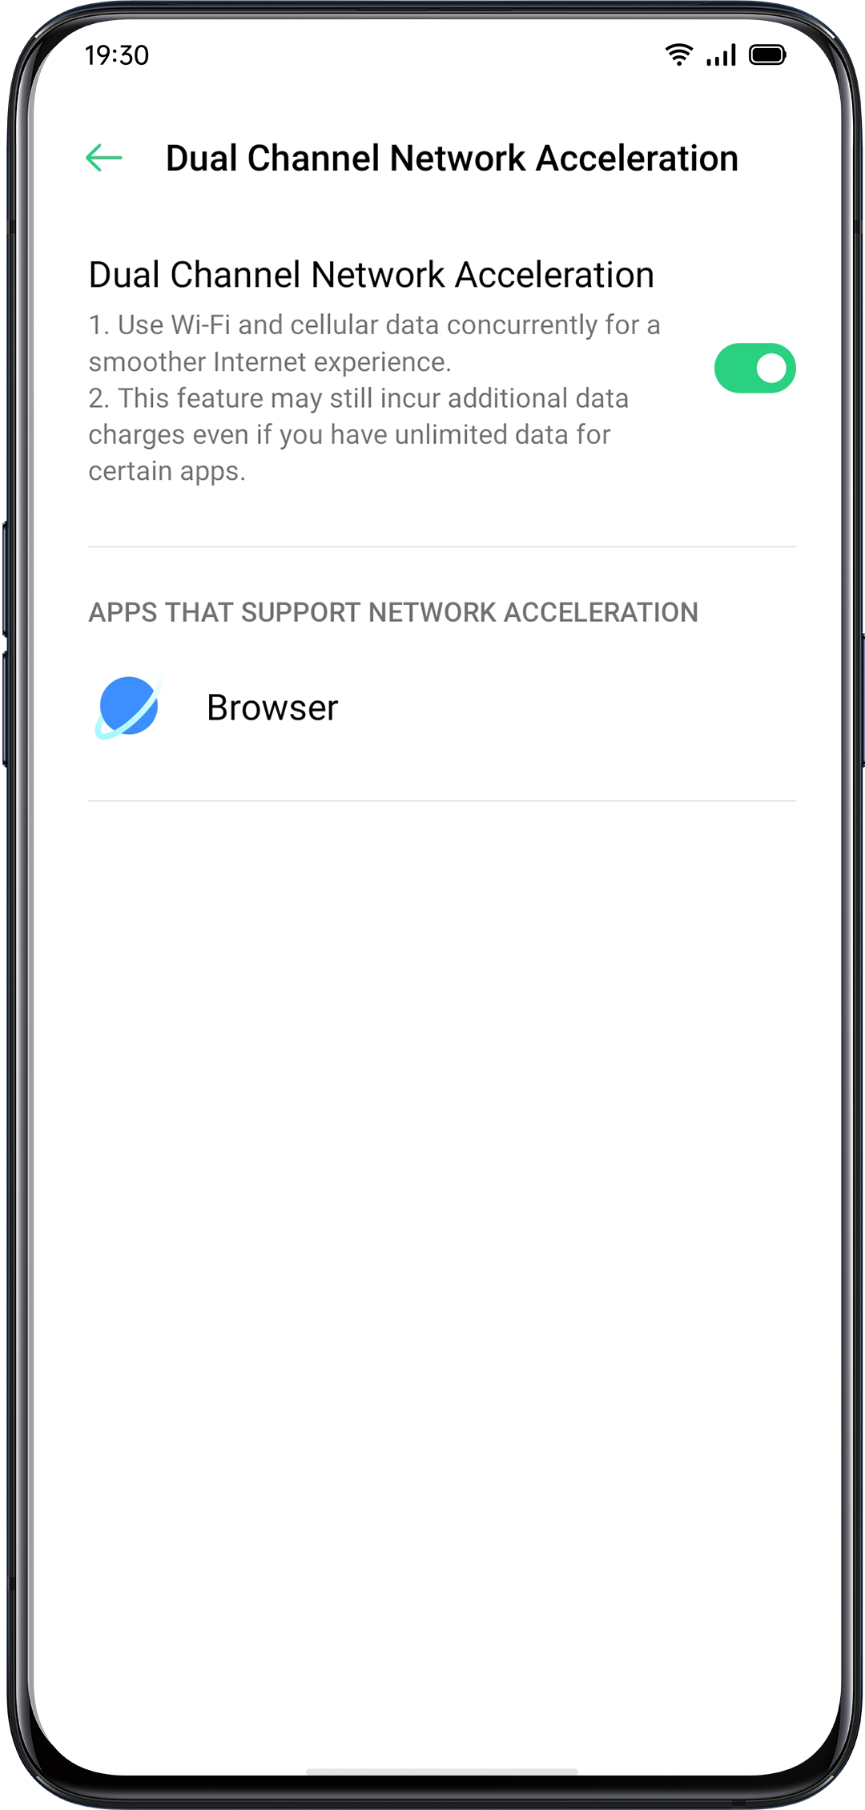

Dual-Wi-Fi Speed-Up

After turning on Dual-Wi-Fi mode, two Wi-Fi networks will be connected at the same time, and network connection acceleration and seamless switching will be realized.

Turn on Dual-Wi-Fi Mode
Go to "Settings" > "Wi-Fi" > "Smart Speed-Up" > Enable "Dual-Wi-Fi Speed-Up".

Notes:
2 Wi-Fi hot spots. One is 2.4 Ghz, the other is 5 Ghz. No mutual disturbance lies between them and each hot spot can receive and send data independently.
2 hot spots can be named either the same or differently.
2 hot spots can share the same router or be supported by different routers.
（Only some phones support this feature）

Apps Using Wi-Fi and Mobile Data
You can customize network permission settings for each app in "Wi-Fi and Mobile Data", "Wi-Fi" or "Close". You can also view the total traffic used by each app.

Go to "Settings" > "SIM Card & Cellular Data" > "Data Usage" > "Network Permissions".

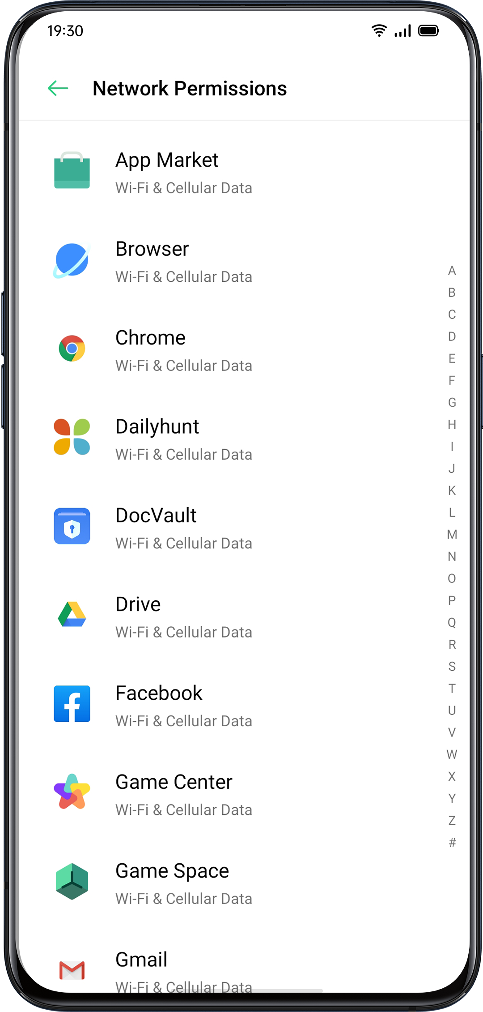

Other Wireless Connections
VPN
VPN is a professional network communication device, extending a private network across a public network. VPN enables users to send and receive data across shared or public networks as if their computing devices were directly connected to the private network.

Add VPN
Go to "Settings" > "Other Wireless Connections" > "VPN" > . Enter the name, VPN type, server address and more information to add a VPN.

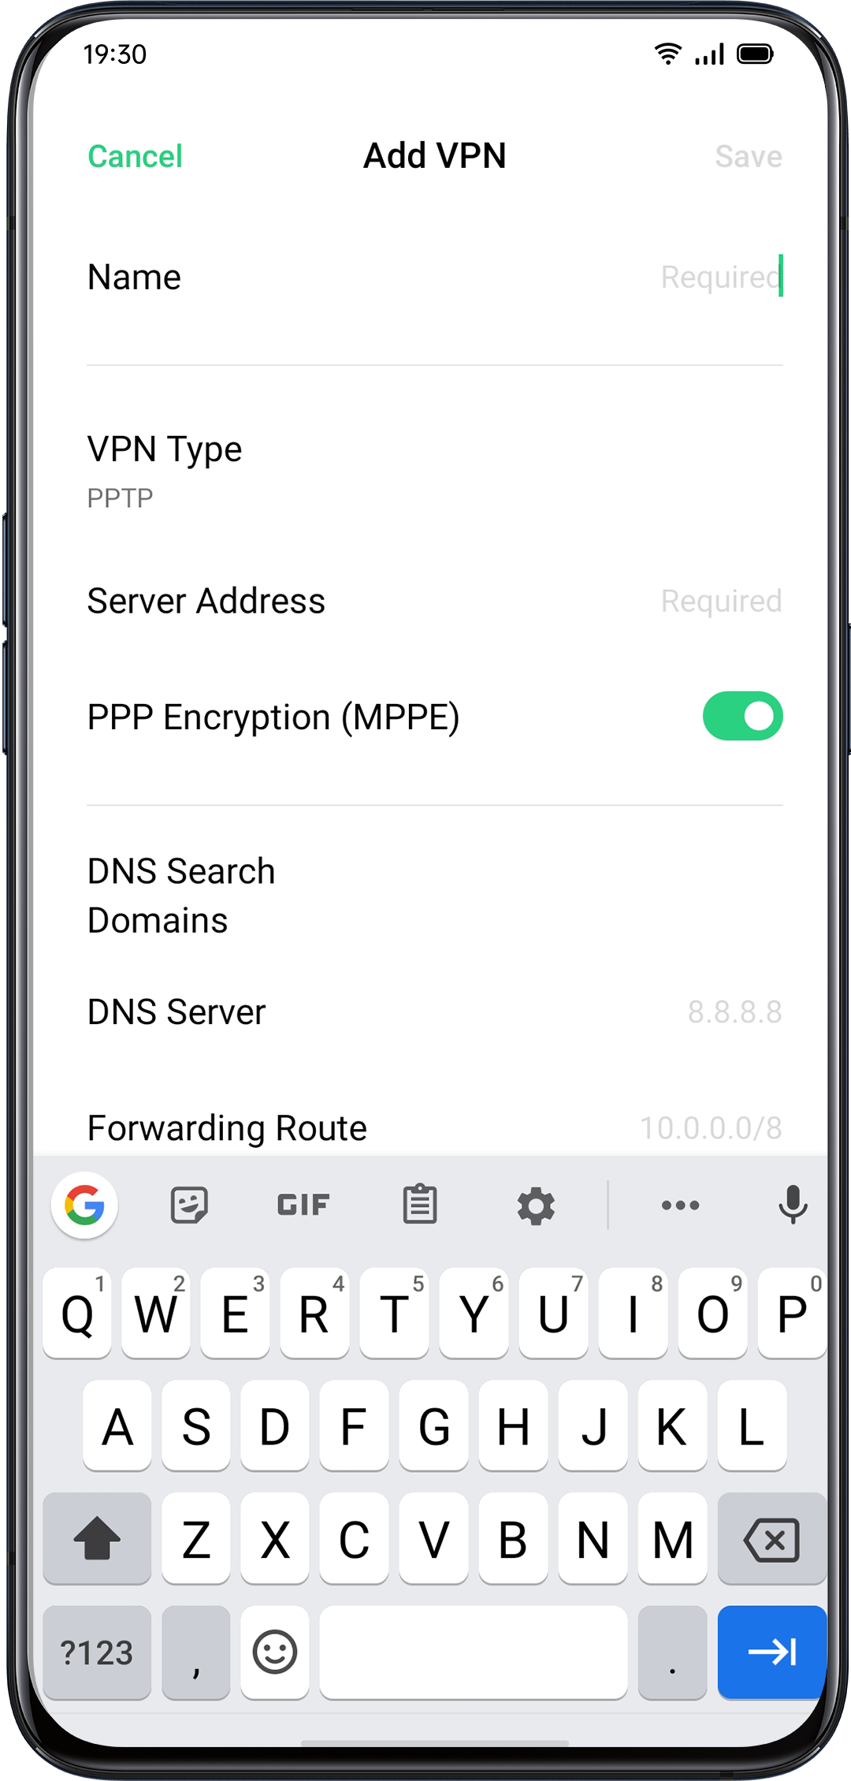
Tethering
You can share your network in the following four ways.

- Personal Hotspot
Go to "Settings" > "Other Wireless Connections" > "Personal Hotspot".
When Personal Hotspot is on, your Internet connection can be detected and shared by surrounding devices. It should be noted that more data and power may be consumed. Personal Hotspot will automatically turn off after 10 minutes when no device is connected.

Enter "Personal Hotspot Settings" to set the name and password for your personal hotspot.

You can also set blacklist, maximum connected devices, and data restriction in "Connection Management".

- Wi-Fi Tethering
Go to "Settings" > "Other Wireless Connections" > "Wi-Fi Tethering".
When Wi-Fi Tethering is on, your Wi-Fi network will be shared. More data and power may be consumed. Personal Hotspot will automatically turn off after 10 minutes when no device is connected.

Enter "Wi-Fi Tethering Settings" to set the name and password for your hotspot. When "Visible to Other Devices" is turned off, you can manually add networks to connect to the hotspot.

Other Devices Connect to Your Hotspot
- Search the name of your hotspot.
- Enter the password as prompted to connect.
Note: Up to 10 devices can connect to your hotspot at the same time. Wi-Fi Tethering cannot be used simultaneously with OPPO Share, Wi-Fi Direct, Multi-screen Interaction, and other functions.

- USB Tethering
Connect your phone to the computer with a data cable. Go to "Settings" > "Other Wireless Connections".
Turn on "USB Tethering", the computer will automatically recognize and share your Internet connection.

When the pairing is done. Go to "Settings" > "Other Wireless Connections" > "Bluetooth Tethering".

Another device should turn on the Bluetooth and tap the name of your Bluetooth to share your Internet connection.

To turn off Bluetooth Tethering. Go to "Settings" > "Other Wireless Connections" > "Bluetooth Tethering".
Or, you can tap "Unpair" to disconnect Bluetooth and stop sharing your Internet connection.
NFC
Go to "Settings" > "Other Wireless Connections" > "NFC".
When "NFC" is on, the phone is allowed to exchange data with any device in close proximity.
You can also use "Touch & Pay" and "Android Beam". Your phone is allowed to make a payment or transfer data via NFC.

Wireless Transport
- Wi-Fi Direct
Through "Wi-Fi Direct", you can transfer data swiftly to peer devices when connecting to the same wireless network.
- Screencast
Go to "Settings" > "Other Wireless Connections" > "Screencast".
Your phone's display can be paired in real time with a display device after enabling wireless display on the display device.
- DLNA
When "DLNA" is enabled, the phone will automatically search for the DLNA device in the same Wi-Fi wireless network, and then project the phone screen to the target device.
Wake the PhoneThere are multiple ways to wake your phone.
Press Power Button
Press the Power Button on the right side to wake the phone.

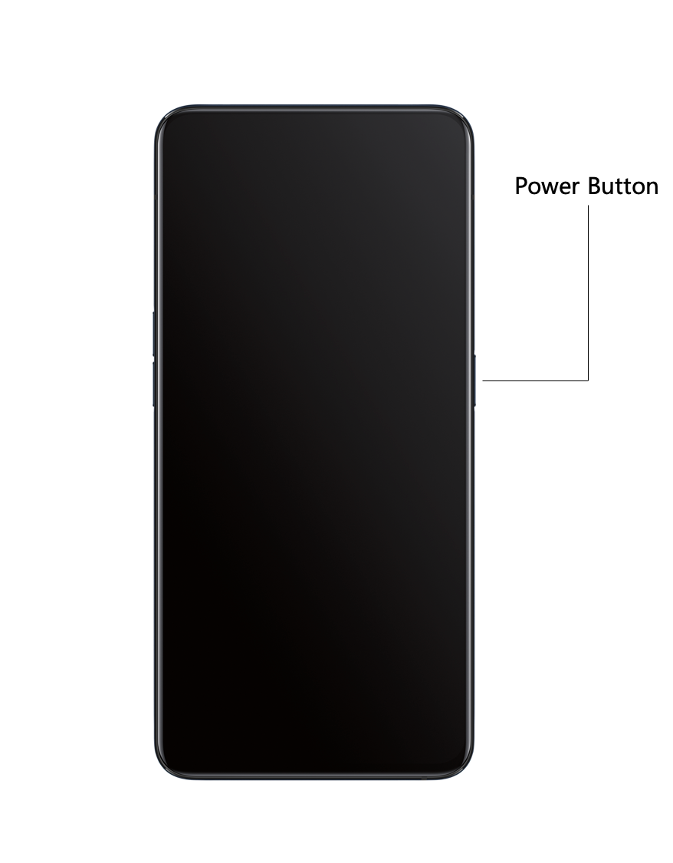

Use Raise to Wake
Enable "Raise to Turn On Screen". When you raise your phone to look at it, it will automatically wake the locked screen.

Go to "Settings" > "Convenience Aid" > "Gesture & Motions", enable "Raise to Wake".

Unlock the PhoneFor safety consideration, you can set diverse ways to unlock your phone, including passcode, fingerprint, and facial recognition. You can use more than one method to unlock your phone.

Passcode
You can set a 6-digit numeric code to unlock your phone. After waking the phone, slide the phone and enter the passcode.

Go to "Settings" > "Fingerprint, Face & Password" > "Lock Screen Password".

Your lock screen password is used to unlock your phone. If you forget it, you must reset it by restoring your phone to factory defaults, which will erase all data on your phone.

Fingerprint
You can also unlock the phone through fingerprint. Follow the onscreen instructions the first time you set up your fingerprint passcode. You can add up to five different fingerprints.

Go to "Settings" > "Fingerprint, Face & Password" > "Fingerprint" > "Add a Fingerprint".

Tap "Animation Style", you can choose the animation style of fingerprint you like.
If you want to show Fingerprint Icon when sreeen-off, tap "Screen-Off Unlock" to set it.

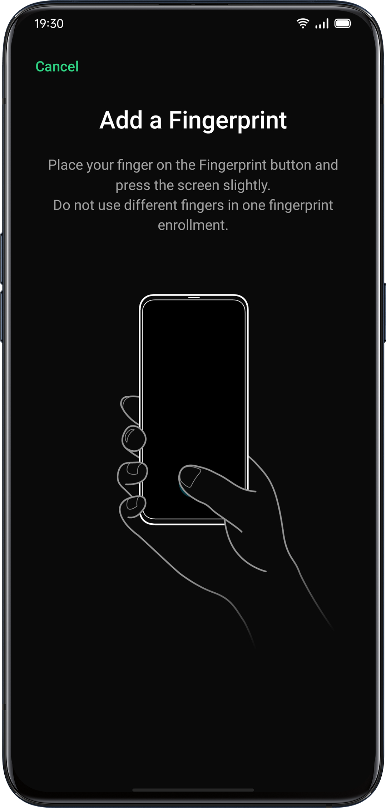
Enroll Face
You can also unlock your phone within only 0.08 seconds with a simple glance at the phone.

To use Face enrollment, you should set up the facial-recognizing passcode on your phone.

Go to "Settings" > "Fingerprint, Face & Password" > "Add Face" > "Enroll Face".

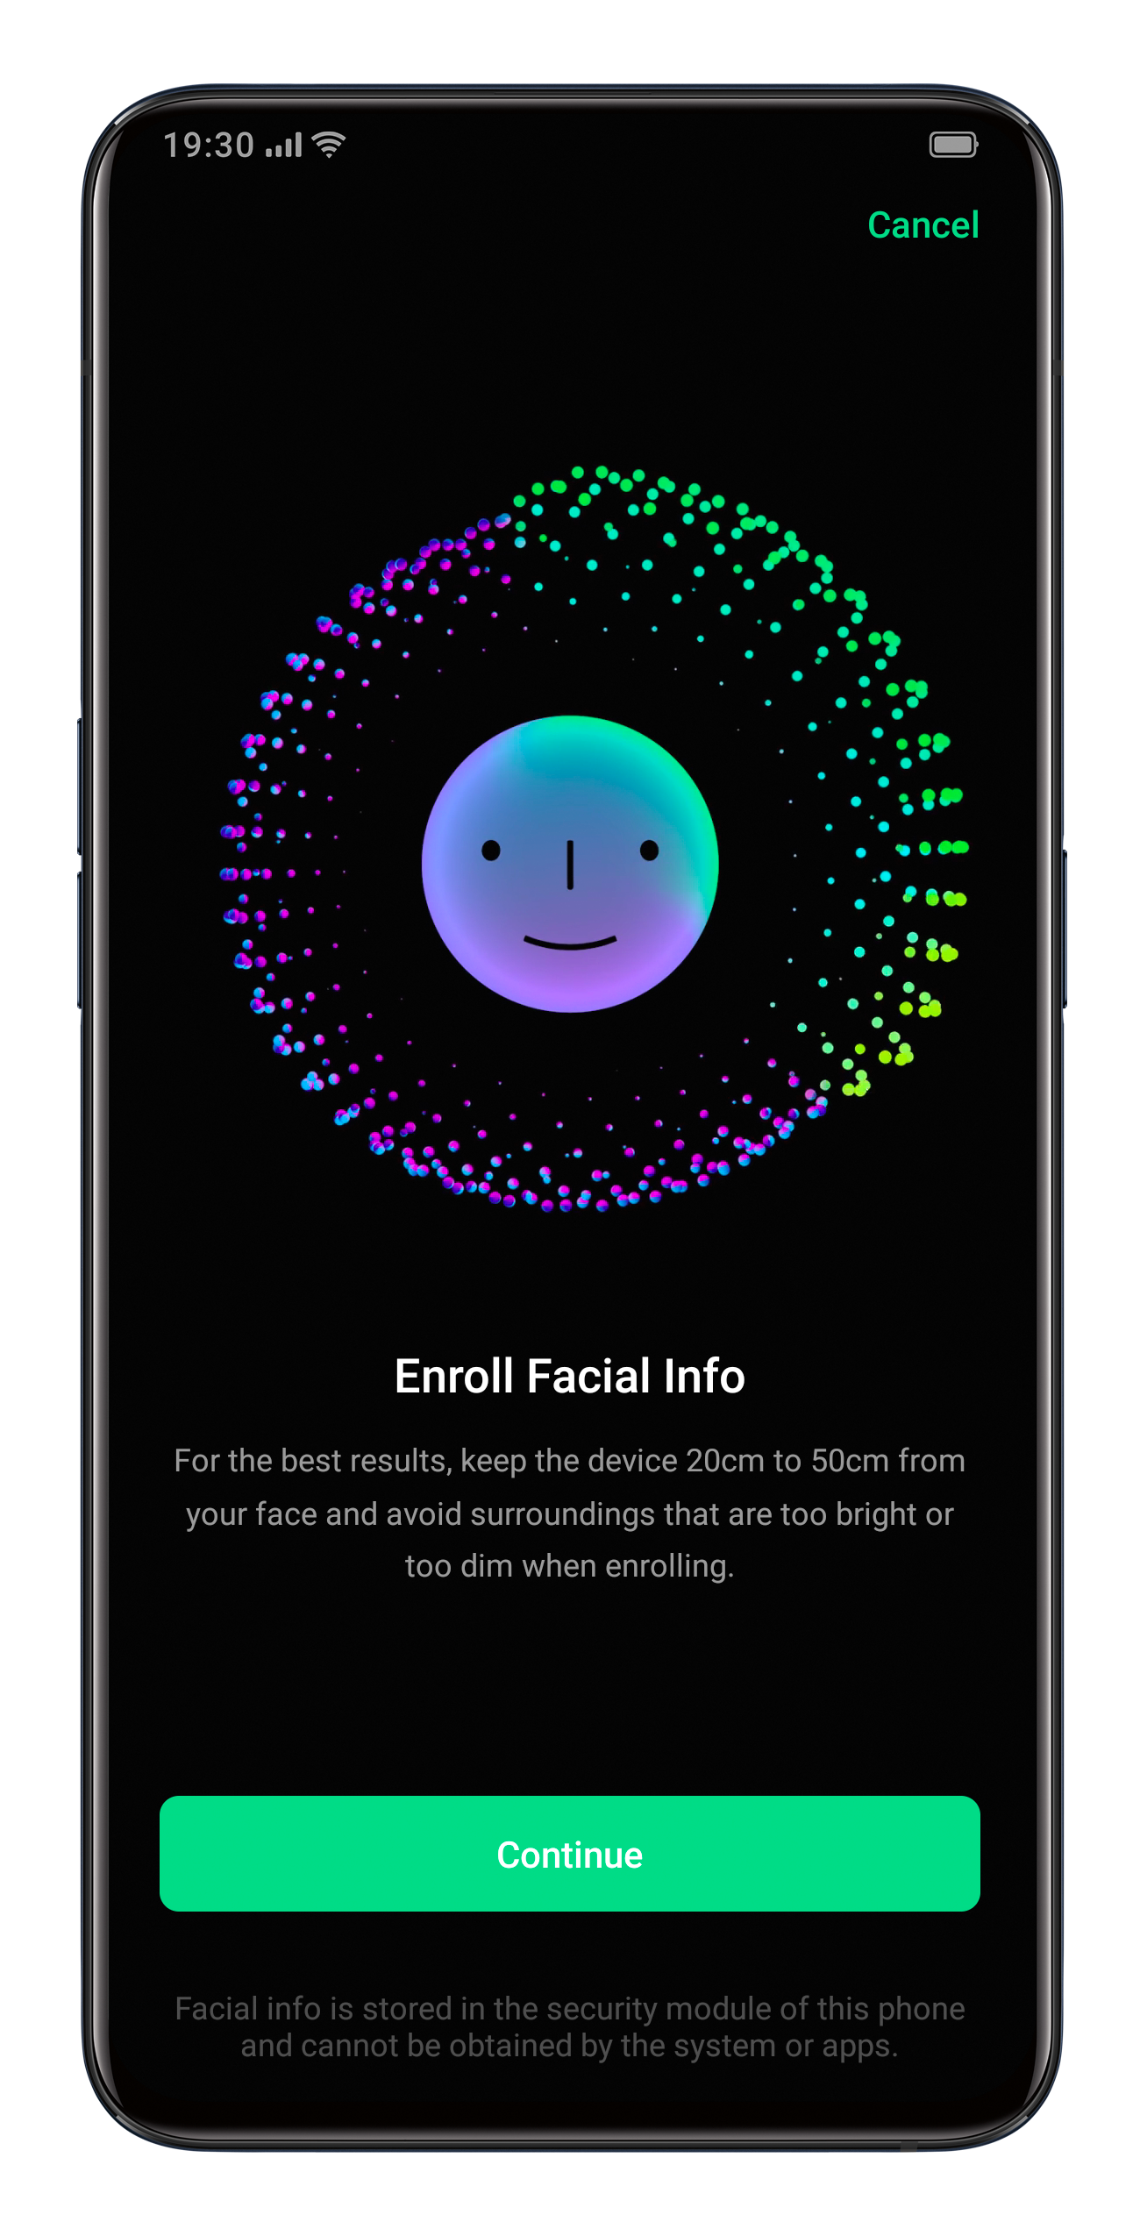

Remember to follow the onscreen instructions by enrolling your face to acquire the best results.

Look straight to the screen. Keep the phone 20-50 cm away from your face and position your entire face in the circle until the enrollment is finished. Avoid exposing your face to the bright or dim environment.

You are advised to turn on Raise to Turn on Screen, to better identify your face.

There are two ways to unlock while using face enrollment:
- Swipe up to unlock
- Wait for the automatic unlock if the screen light is on.
Tip: You can further protect personal security if you set your phone as inaccessible to be unlocked when your eyes are closed.

Navigation Keys
Tap "Settings"-"Convenience Aid"-"Navigation Keys", there are three types of navigational gestures, including Swipe Gestures from Both Sides, Virtual Keys, and Swipe-Up gestures.

Swipe Gestures from Both Sides
- Back
Swipe inward from the bottom left or the bottom right of the screen.
- Back to Home screen
Swipe upward from the bottom of the screen.
- View Recent Tasks
Swipe upward from the bottom of the screen and then hold.
- Switch to Previous App
Swipe inward from the bottom left or the bottom right of the screen and then hold.

You can also enable "Mistouch Prevention for Swipe Gestures from Both Sides". When using the full screen in landscape mode, gestures need 2 swipes to take effect.

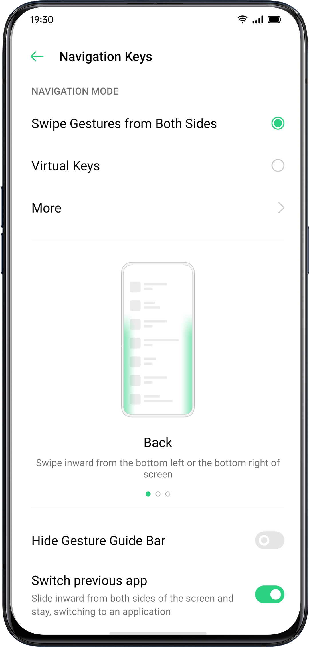

Virtual Keys
Virtual Keys show up at the bottom of the screen once enabled. You can also customize the layout, or choose to hide Virtual Keys according to your daily usage habits.
Android P Navigation Keys consist of navigation shortcuts. Switch between different pages by easily swiping, dragging or tapping.

- Multi-Tasks: Swipe the middle button up
- Switch Between Apps: Slide the middle button left or right.
- Go to the Home screen: Tap the middle button.
- Awake Google Assistant: Press and hold the middle button.
- Back to Previous Page: Tap the back button.

Go to "Settings" > "Convenience Aid" > "Virtual Keys".
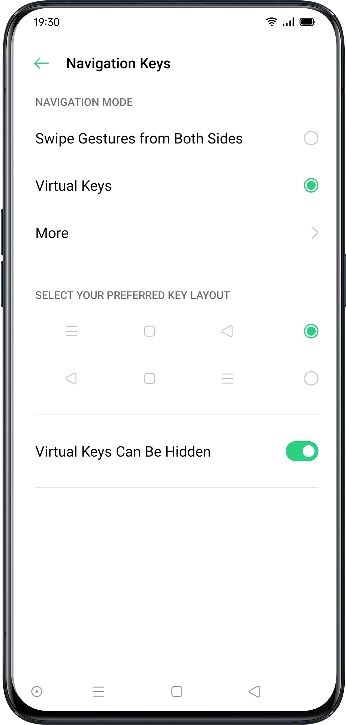

Swipe-Up Gestures
Tap "More", you can enable "Swipe-up" Gestures". With the help of Swipe-Up Gestures, it will be easier to operate your phone with a larger display and more immersive user experience.

Swipe up to:
- Return to the previous page
- Go to the Home screen
- View recent tasks
You can also customize different gestures, such as:
- Simple gestures. Swipe up from the middle bottom to get to the Home screen, and swipe up from the middle bottom and pause 1 second to view recent tasks.
- Back on the right. Swipe up from the left bottom to view recent tasks, swipe up from the middle bottom to get to the Home screen, and swipe up from the right bottom to return to the upper page.
- Back on the left. Swipe up from the left bottom to return to the upper page, swipe up from the middle bottom to get to the Home screen, and swipe up from the right bottom to view recent tasks.

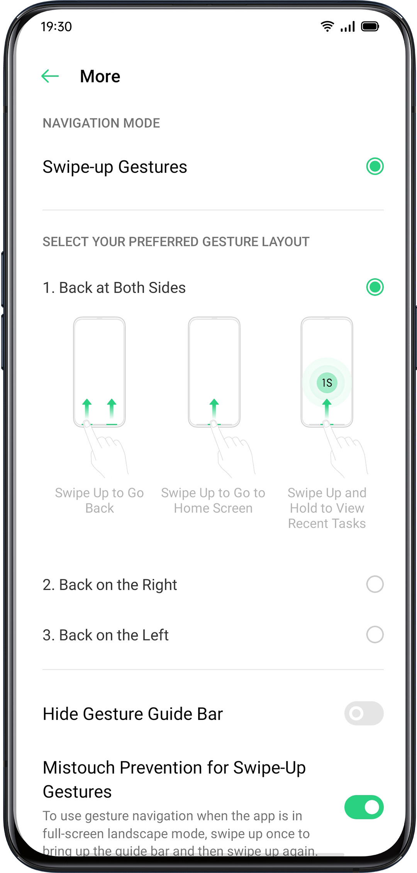

Adjust and Control the Volume
Keeping in line with our infinite design concept, we redesigned system sounds to make them simple but refined.The new sounds are more mellow and are designed to evoke pleasant feelings.

ColorOS offers personalized volume adjusting and controlling solutions. You can set customized volume levels for different uses.

Volume Control Buttons
Use buttons on the left side of the phone to adjust the audio volume if you are listening to songs, movies, or other media.

If you want to adjust the volume for ringtones, alerts, and other sound effects, tap on the sidebar and slide the bar to adjust the volume.

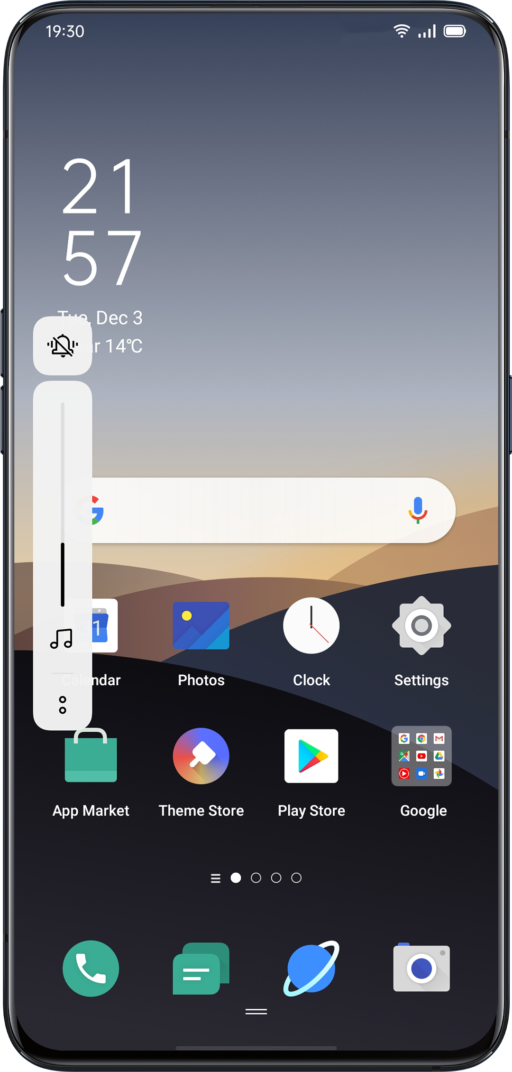

Click  on the bottom to personalize volume for media, ringer, and alarm. For example, you can turn off the volume for media and ringer and turn on the alarm before sleep, in order to ensure the best quality during your rest.

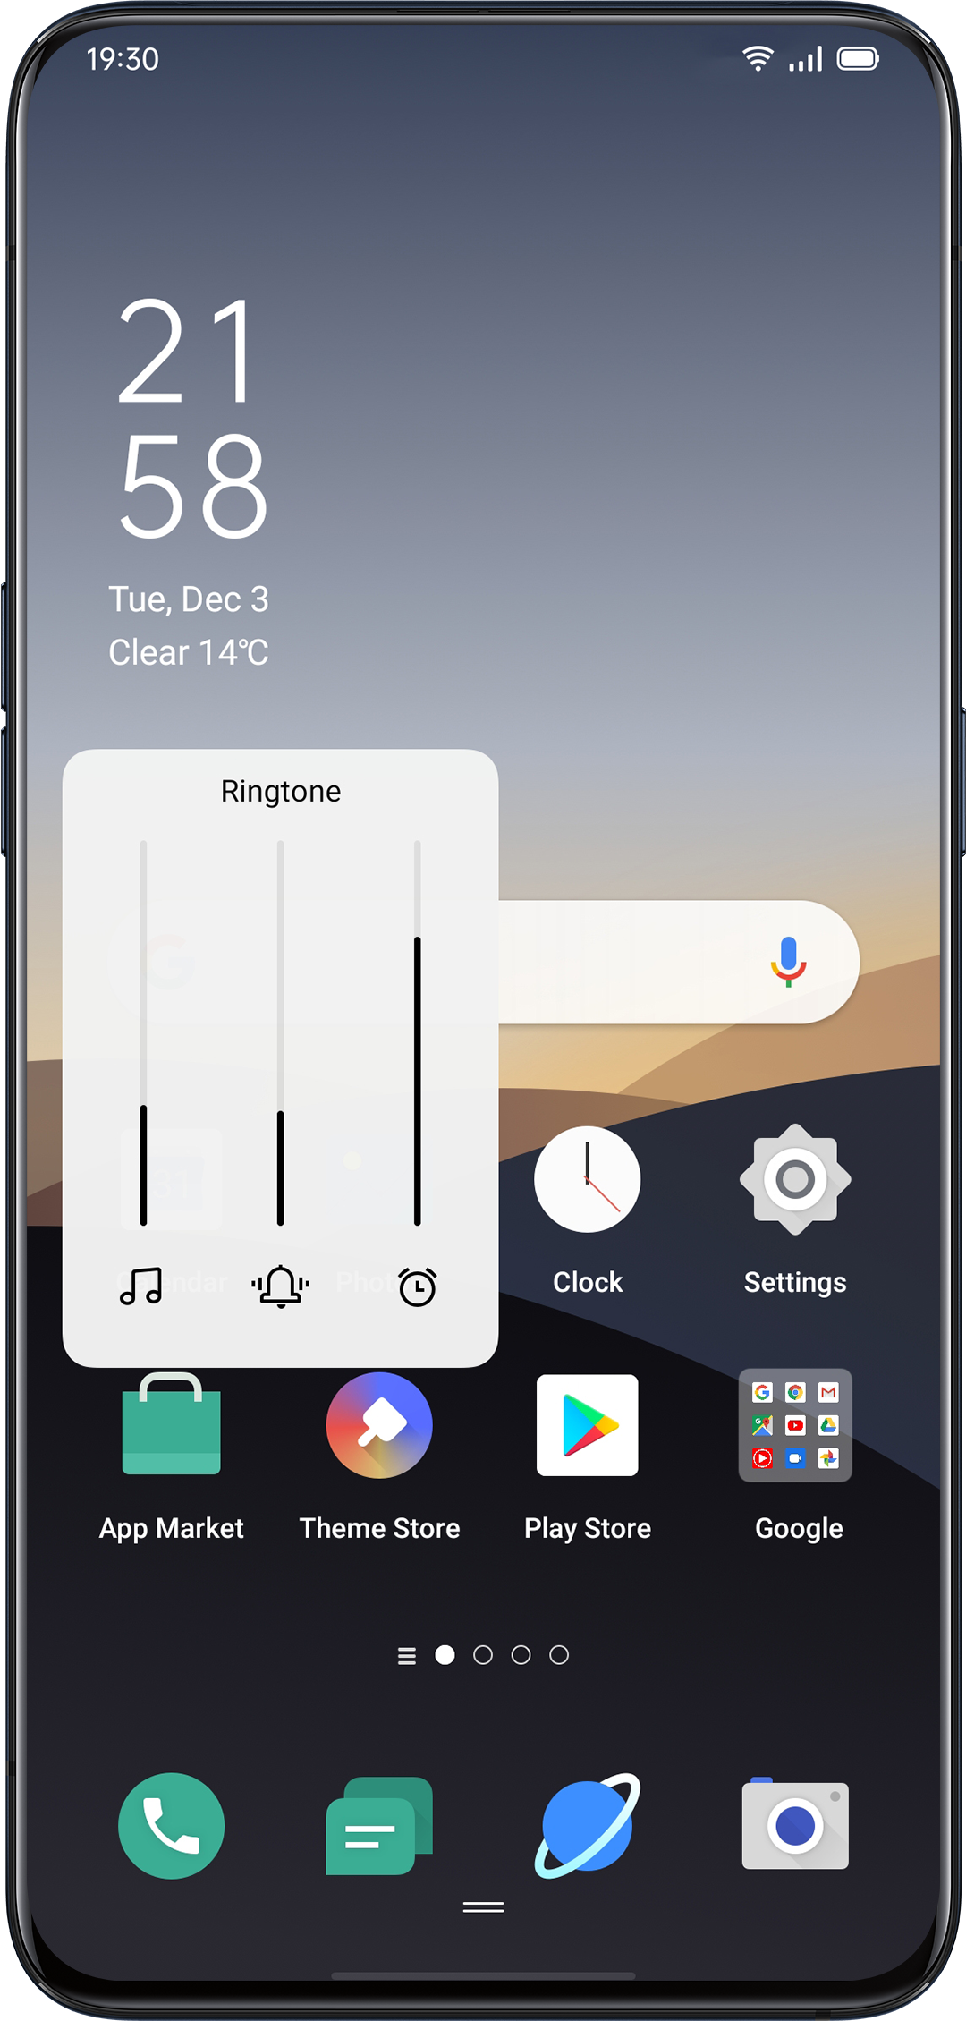
Customize the Ringtones
ColorOS enables the user to customize ringtones. You can set different ringtones to identify incoming calls, messages, and calendar notifications. You may also customize the ringtones by importing alert files on your phone or from online sources.

Go to "Settings" > "Sound & Vibration".

Silent Mode
You can turn on the silent mode if you're not hearing or seeing incoming calls and alerts when you expect.

How to turn on the silent mode:
- Swipe down the screen from atop, go to Control Center, and tap "Mute".
- Tap on the volume button on the side of the phone, click  at the lower-left area of the volume button.
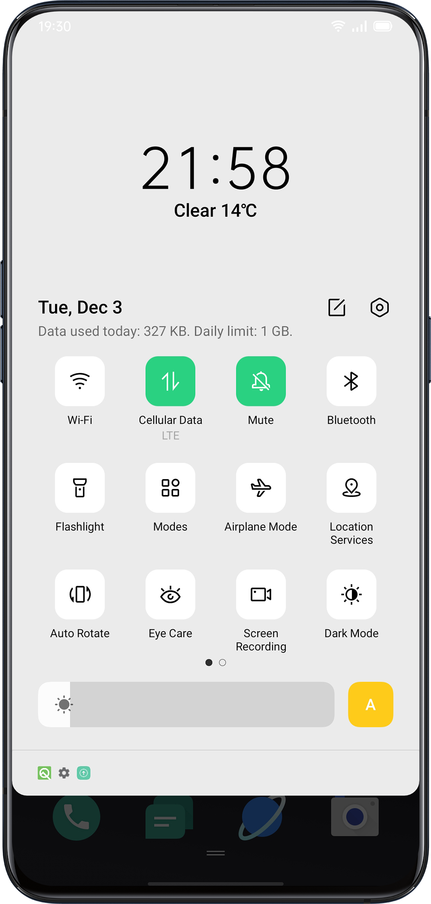
More Options for Ringtone Customizaton
To provide better operational feedback, ColorOS 7 offers four personalized ringtones settings.

Go to "Settings" > "Sound & Vibration" > "System Feedback".
- Dial-Pad Tone
- Touch Sounds
- Lock Screen Tone
- Vibrate on Touch
- Screenshot Sound
- Fingerprint Animation Sound
- Deletion Sound
Dolby Atmos
Dolby Atmos is activated by default, you can choose to turn it off when your device is connected to an earphone.
Besides Smart mode, there are Movie, Gaming and Music modes for you to choose according to use scenarios.

Go to "Settings" > "Sound & Vibration" > "Dolby Atmos".
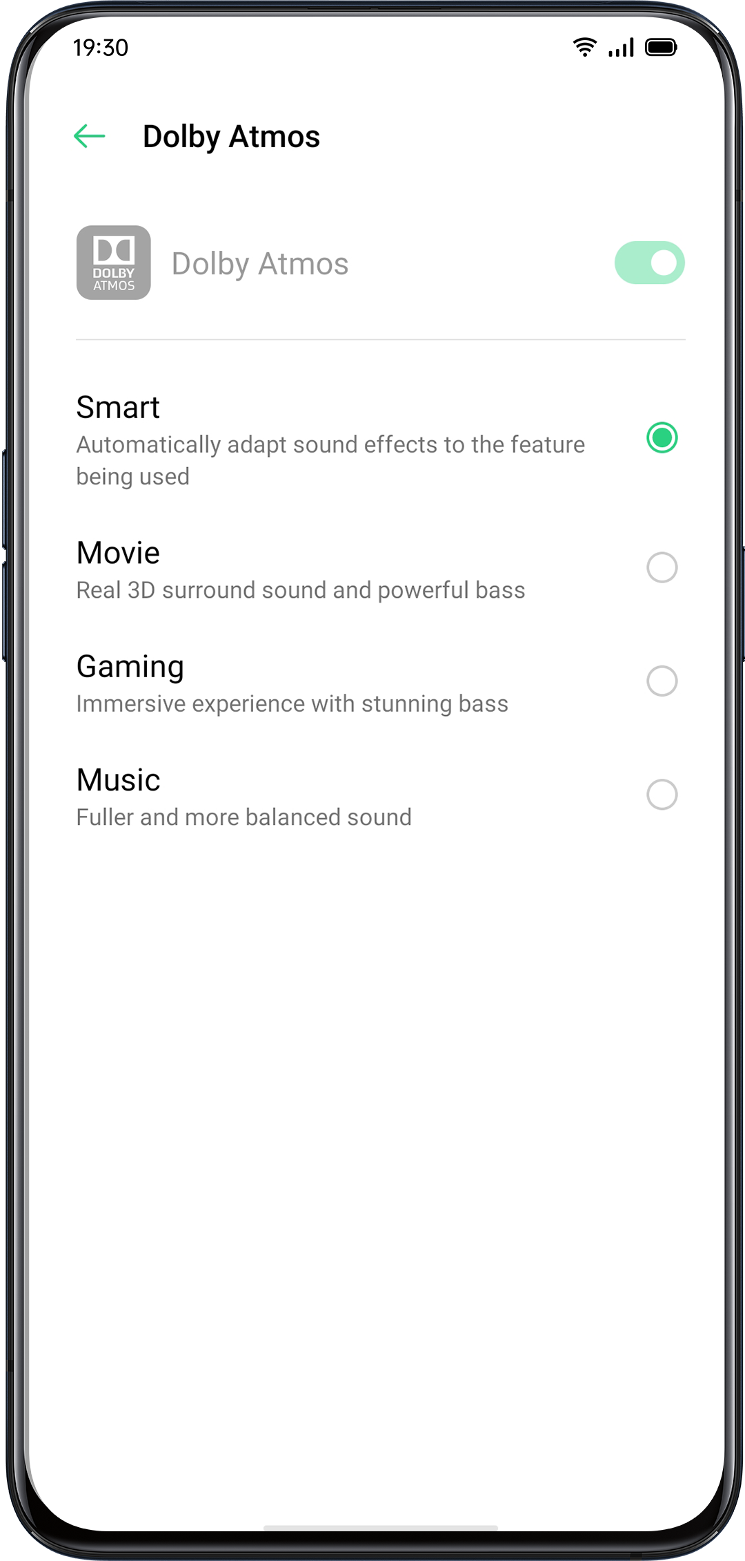

Adjust Screen Brightness
You can adjust screen brightness under different lighting conditions to have a better visual display.

Adjust the screen brightness manually
- Swipe down from the top of the screen, enter Control Center and drag the slider.
- Go to "Settings" > " Display & Brightness", drag the slider.


Automatically adjust the screen brightness
After you turn on Auto-Brightness, ColorOS 7 will adjust the screen brightness for current light conditions using the built-in ambient light sensor, to prevent eye fatigue and increased power consumption.
- Swipe down from the top of the screen, enter Control Center and tap button  on the right side of the brightness slider.
- Go to "Settings" > "Display & Brightness" > "Auto-Brightness".
Screen Color Temperature Adjustment
You can set the screen tone as either warm or cool.

Go to "Settings" > "Display & Brightness", set screen tone by dragging the slider.

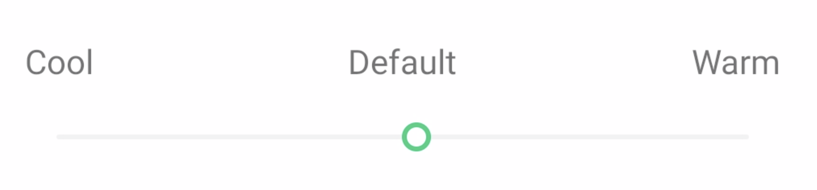
Switch on Eye-Protection Mode
ColorOS 7 makes it easier when you use the phone at night or under dimming light. You can turn on the eyes-protective mode to reduce eye strain and fatigue when exposing to digital display for a long time.

There are two types of eyes-protective mode.

Eye Care
The Eye Care mode could help reduce the blue light emitted from the display to prevent eye fatigue. You can adjust the screen color temperature from cool to warm.You also can set the schedule time.

Low-Brightness Flicker-Free Eye Care
When Low-Brightness Flicker-Free Eye Care is turned on, eye fatigue will be much relieved as it is in the minimum brightness in dimly-lit environments. But the image noise may be slightly increased if you turn on the none-stroboscopic dim light mode.

Go to "Settings" > "Display & Brightness" > "Low-Brightness Flicker-Free Eye Care."

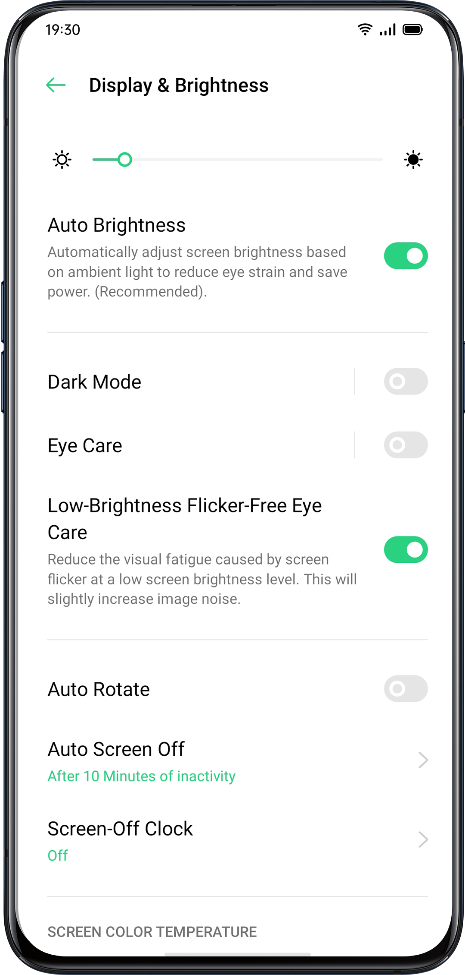

Dark Mode, Delivering a Comfortable Experience All Day Long
With automatic backlighting, your eyes will be comfortable no matter whether it is strong or dark, noon or night. In addition, we have also upgraded the color structure to improve the dark contrast, so that the page is well-defined, patchwork, and the key information is more prominent. In the dark mode, the power consumption of the screen is effectively reduced, and the power of the mobile phone is also comfortable.

Enabling Dark Mode

You can enable dark mode in two ways:
- Choose Settings > Display & Brightness, and enable Dark Mode.
- Go to the Control Center, and enable Dark Mode.

Setting Dark Mode to Start at a Specific Time
After dark mode has been enabled, you can choose to always use dark mode or set a start time as desired.
Choose Settings > Display & Brightness, enable Dark Mode, enable Schedule Time, and set the start and end times.

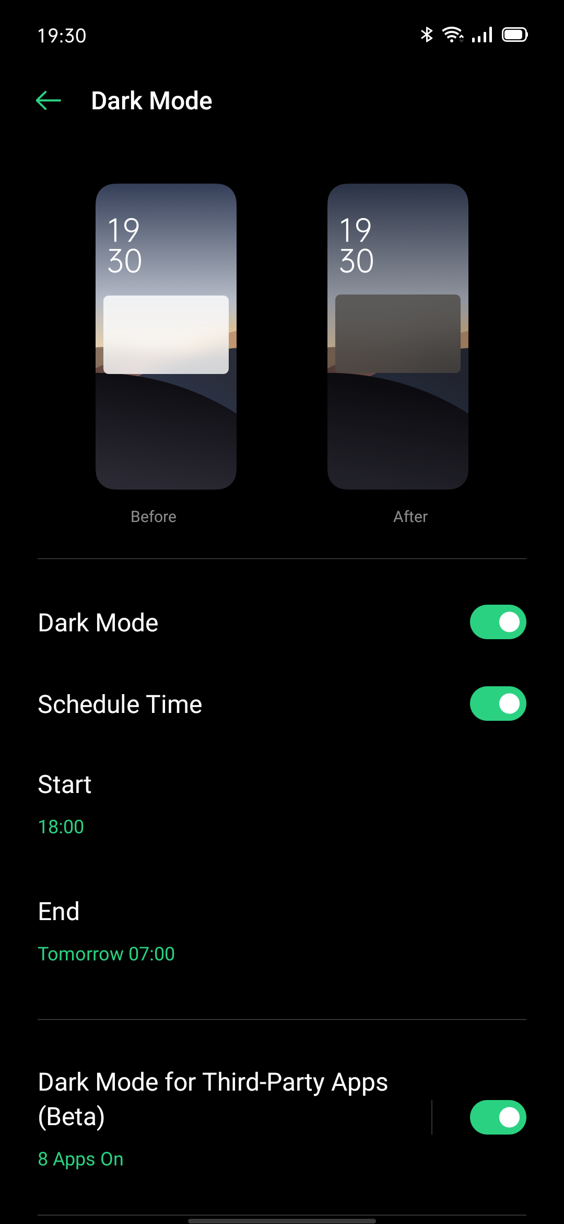

Changing the Wallpaper as Desired
You can change the wallpaper of your mobile phone as desired. ColorOS 7 provides various brilliantly designed static wallpapers, live wallpapers, and interactive live wallpapers. You may also choose a photo from Photos as the wallpaper, making your phone beautiful both inside and out.

Changing the Wallpaper
- Choose Settings > Home Screen and Lock Screen Magazine > Set Wallpaper.
- Choose your favorite wallpaper from Static Wallpapers or Live Wallpapers. You can enlarge the wallpaper using two fingers or move the wallpaper to adjust the location of the picture.
- You can set a static wallpaper as your Home Screen, Lock Screen, or Home Screen & Lock Screen, and a live wallpaper as Home Screen or Home Screen & Lock Screen.

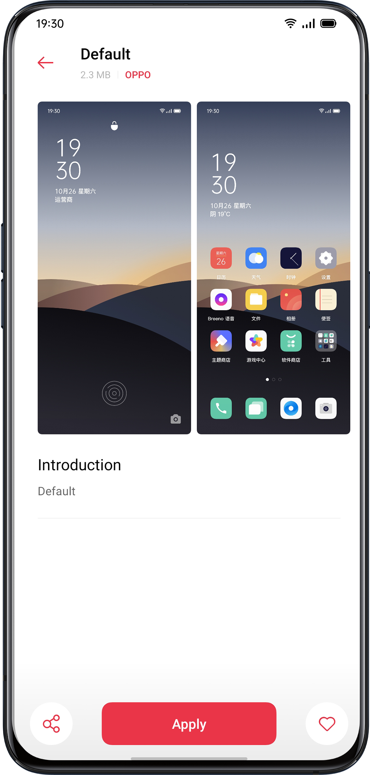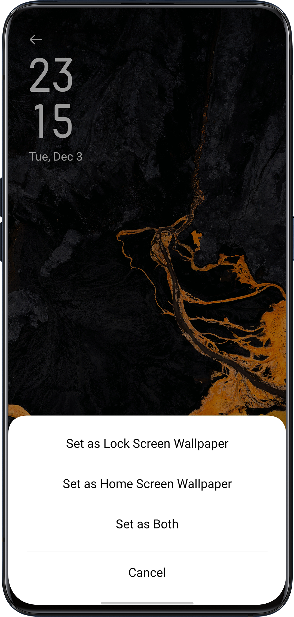

Choosing a Photo from Photos as the Wallpaper

- Choose Settings > Home Screen and Lock Screen Magazine > Set Wallpaper.
- Tap Photos and choose a photo. You can enlarge the photo using two fingers or move the photo to adjust the location of the picture.
- Tap Set as, and choose Set as Lock Screen Wallpaper, Set as Home Screen Wallpaper, or Set as Both.

Auto-lock Clock
You don't need to unlock the phone to check the time. Turn on the Auto-lock Clock to view the exact time and dates.
- The longer the Auto-lock time remains, the more the battery drains.
- The Auto-Lock Clock will be no longer available if there is less than 10% battery.

Auto Screen Off
By default, your device will be automatically locked if you don't operate the phone for over 30 seconds, as a way to protect personal privacy. You can modify this by adjusting the auto-lock time.

Go to "Settings" > "Display & Brightness" > "Auto Screen Off".
Options range from 15 seconds to 30 minutes.

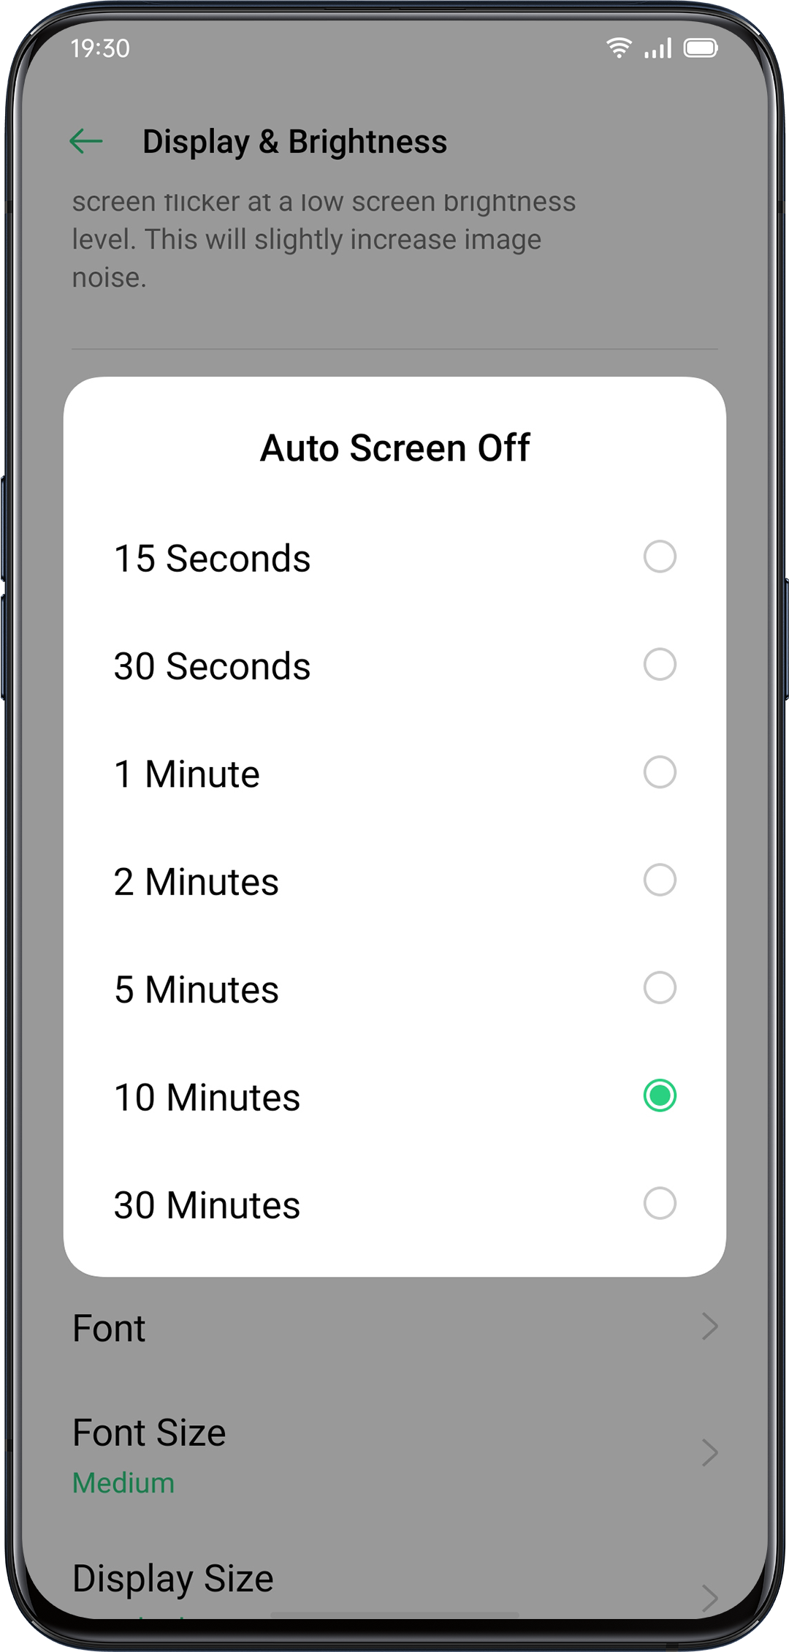
Auto Rotate
You will have different views if you rotate your phone when you are typing texts or watching movies. You can turn on "Auto-Rotate" to automatically switch from landscape or vertical orientation.Swipe down from the top of the screen, enter Control Center and tap 

- Swipe down from the top of the screen, enter Control Center and tap
- Go to "Settings" > "Display & Brightness" > "Auto Rotate".
Full-Screen Display
To acquire the more immersive experience in using ColorOS 6, you can optimize the app display into full-screen.

Go to "Settings" > "Display & Brightness" > "Full

-screen Display". Select the apps you want to make it into full-screen.

Airplane Mode
You can turn on/off Airplane Mode manually. When the Airplane Mode is on, the Bluetooth, Wi-Fi, Cellular Data will disconnect.
- Go to "Settings" > Turn on/off "Airplane Mode".
- Slide the screen down fromthe top to enter Control Center, tap  to turn on/off Airplane Mode.

Data Manager
Mobile Data Usage
View mobile"Tap"Data Usag Data Usage or data usage to start.
Cellular Data recently amounts counted by your carrier may differ from those on your divice.

Tap "Cellular Data Limit">Data Limit"> "Cellular Data Limit", You can set the start date for data usage to start and daily cellular data limit. if you want to know the daily usage.

You will receive notifications when data usage reaches a limited amount.
Data Saving

When "Data Saving" is on, apps in the background will not be able to use mobile data. Application in the foreground will decide if data-saving measures are to be taken, e.g. reducing image resolutions. In addition, you will not be able to use the network tethering function, and the status bar will display the data saving icon.
You can also set an unrestricted app. When Data Saving is on, those unrestricted ones will be able to receive new messages over cellular data.
"Settings" > "SIM Card & Cellular Network" >"Data Usage">"Data Saving".

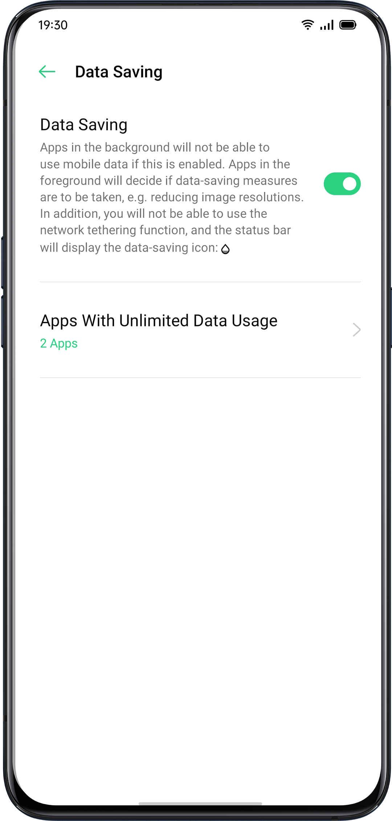

Contacts
Create New Contacts Manually
- Open "Contacts", tap  in the upper right corner.
- You can add other additional information for each contact, such as avatar, name, workplace, email address, birthday.
- You can customize ringtones and align contacts with a particular group.

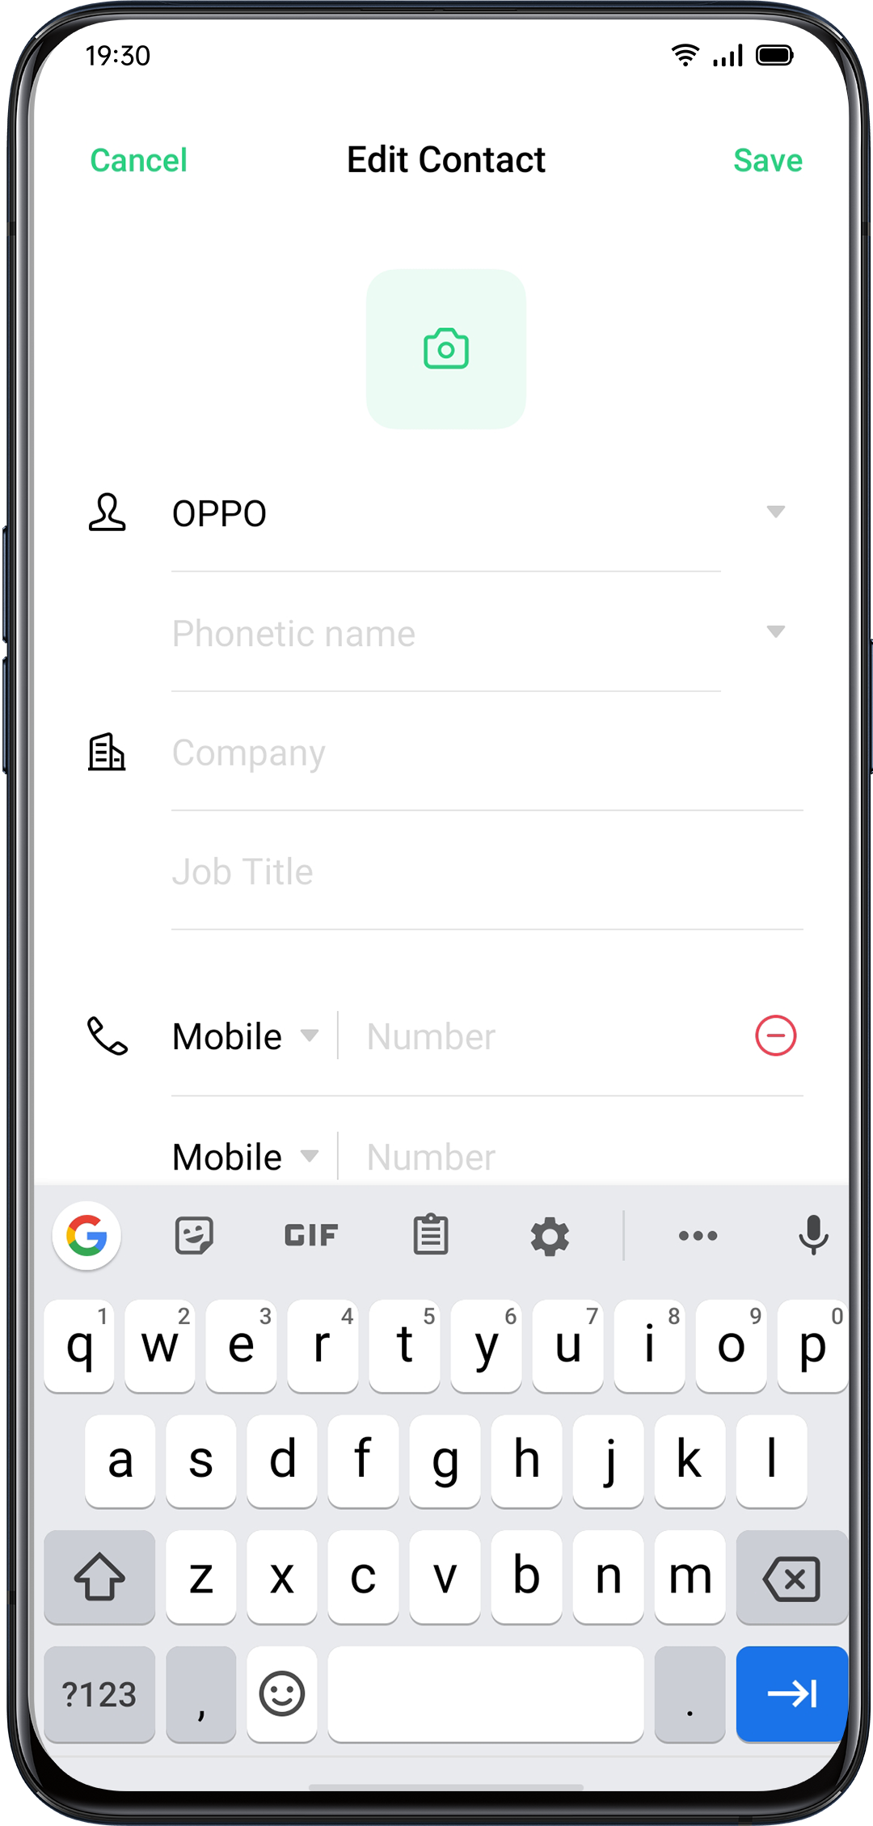
Import Contacts
- Import Contacts from Storage Device. You can import contacts from your SIM card. If you have contacts stored in the MicroSD Card on your old phone, you can export contacts as a VCF file, and open the file to import contacts into your new phone.
- Import Contacts from Another Phone. Import the contacts stored on other phones to the new phone.

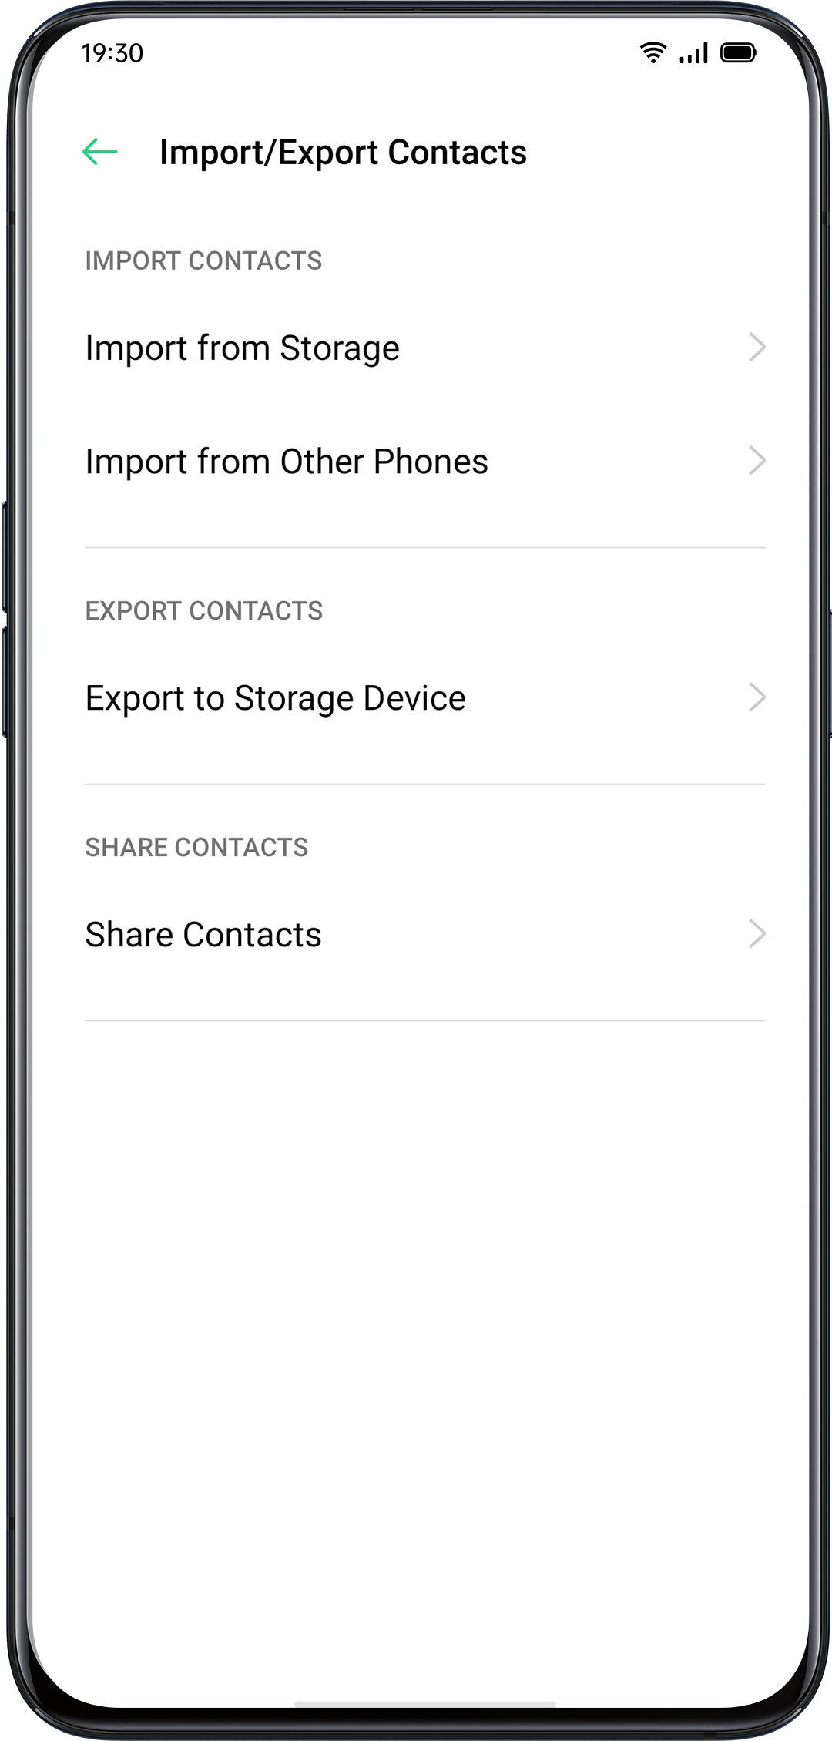
Name Cards Scan
Tap > “Name Card Folder” in the top left corner, scan the name card to identify and save as a new contact.

Manage Contacts
Tap> “Settings”

Contacts to display. You can choose contacts that you want to display, or you select contacts with numbers to display.

Merge duplicate contacts. Tap "Merge Duplicate Contacts", and then the phone will automatically merge contacts with the same name.

Manage contacts. You can manage contacts without name or number or quickly remove invalid numbers.

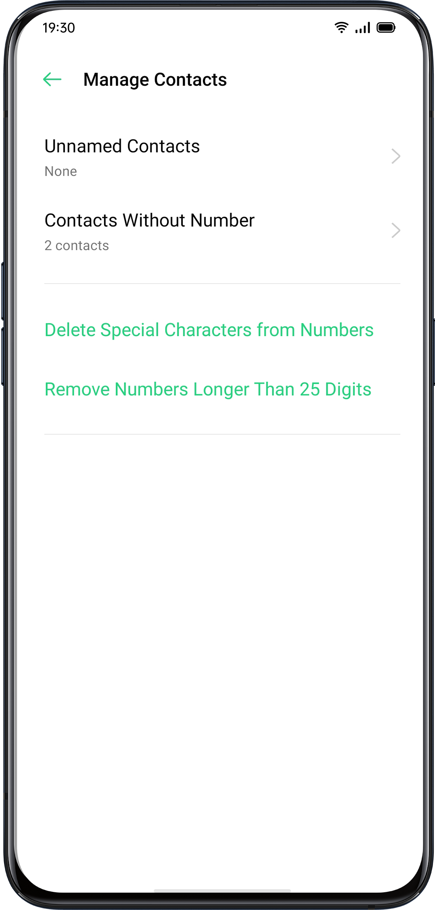
VIP Contacts
When you switch the phone into Silent Mode, or when you set the phone to block calls and notifications using Quiet Time, Game Acceleration, or Anti-harassment, you could still add certain contacts to your VIP Contact list, allowing them to ride the phone settings and have their calls come through and ring.

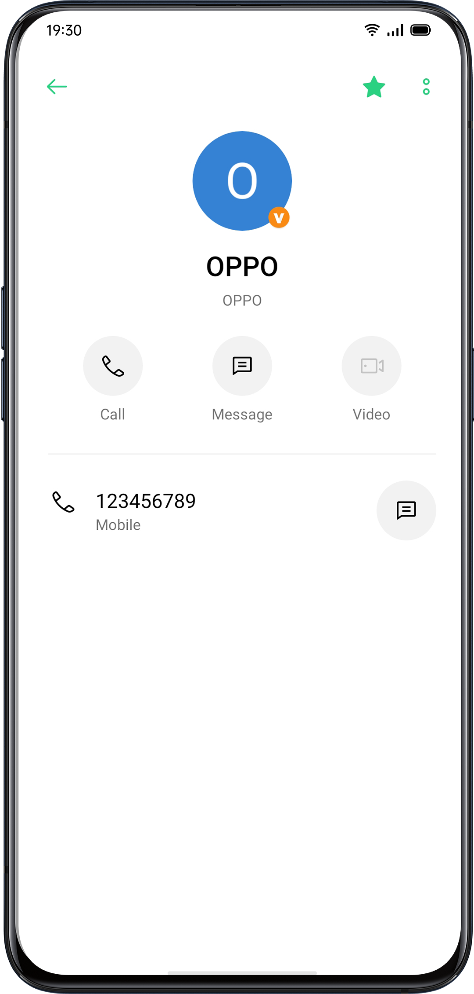
All Call Logs
In "Contacts", you can view all call logs of a specific contact.
Go to "Contacts" > Select a contact > Tap "View All".

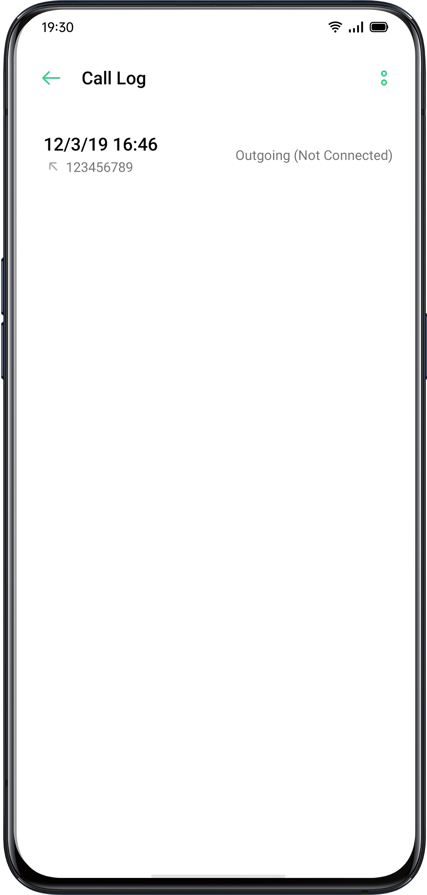

My Groups

You can contact people from "Contacts" in batches through "My Group".

New Group
Go to "Call" > > "My Groups". Tap and enter a group name to create a new group.
- Enter group name and select an account to add groups.
- Tap "Select" and choose members to be removed, then tap "Remove".
- You can send messages or emails to one or many members of a group. You can customize ringtones for VIP contacts and self-created groups.

VIP Contacts
Calls from VIP Contacts will not be affected by Silent Mode, Do Not Disturb, Do-Not-Disturb Gaming, Do-Not-Disturb Driving, Do-Not-Disturb Cycling contacts. You can send a message and email to contacts in smart groups.
Do Not Disturb

If you are attending a meeting or in sleep, turn on "Do Not Disturb" to exempt from phone disturbance. In this mode, calls, messages, and notifications will be muted.

Turn on "Do Not Disturb"

Go to "Settings" > "Do Not Disturb".

When "Do Not Disturb" is turned on, calls, messages, and notifications will be muted except for alarm clock, countdown timer, and alerts that you previously permit. A warning-moon-shaped symbol will show up in the status bar.

You can choose to turn on the "Do Not Disturb" manually or automatically.

In the Auto-on mode, you can customize the time not to be disturbed or the content allowed to show up.

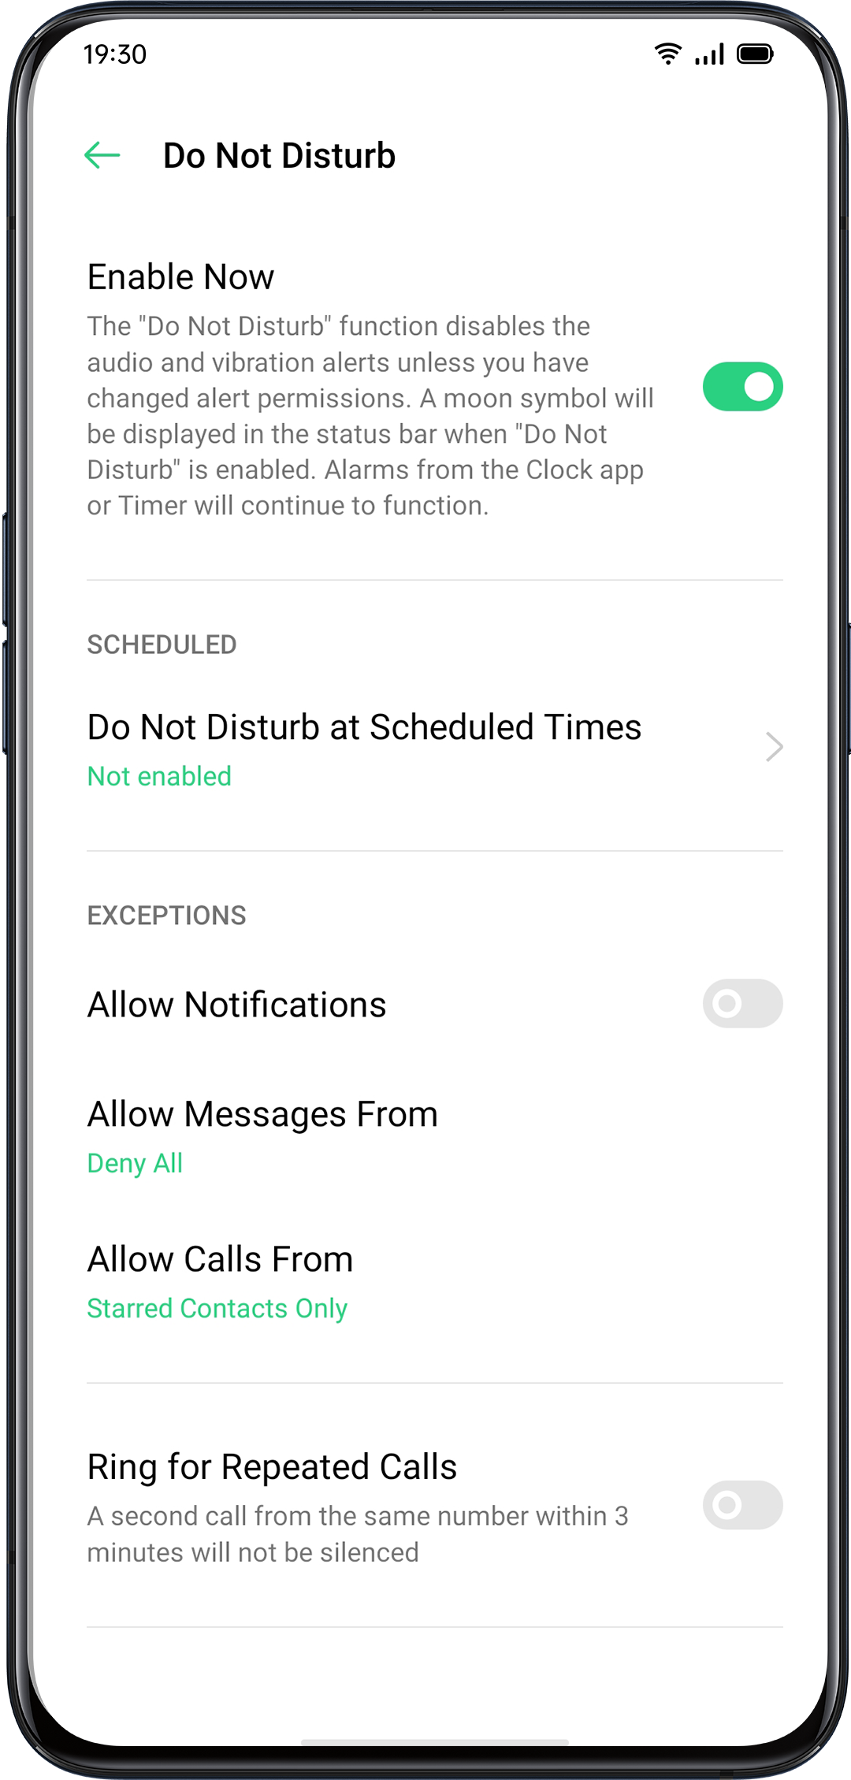
Customize "Do Not Disturb"
If you want to activate "Do Not Disturb" mode during either on weekdays or at night automatically, you can choose to start the m on particular dates, and set the starting and ending time as well.

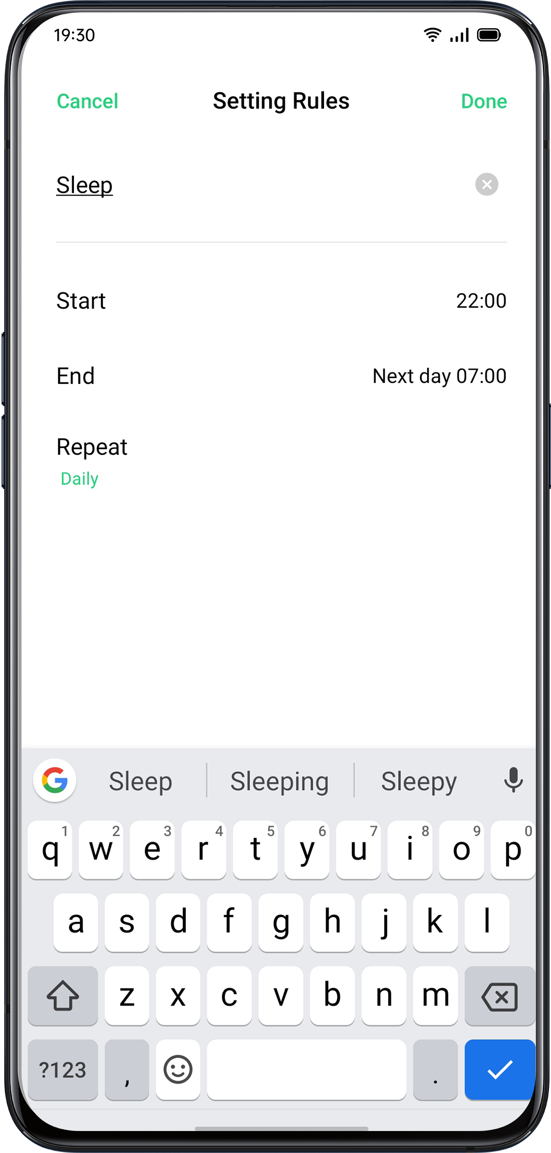
Allowed Content
You can choose to allow notifications, messages, or calls from specific contacts.
When "Ring for Repeated Calls" is activated, another call from the same contact within 3 minutes will not be muted.
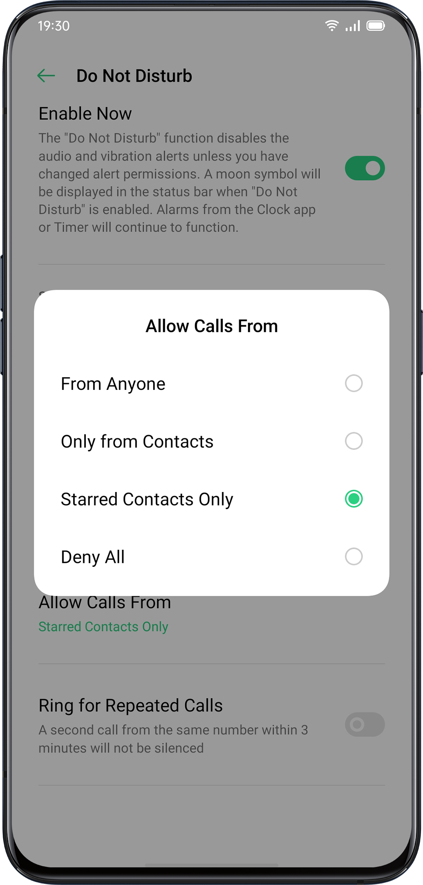

Convenient Features

Search Settings
In "Settings", enter a keyword in the searching box, you will find relevant functions. Tap a result to quickly jump to the corresponding setting page. For instance, if you search "Wi-Fi", you will see all the settings related to Wi-Fi.

Font
Change Font Size
You can also change the font size if you need a larger or smaller font.

Go"Settings" > "Display & Brightness" > "Font Size".

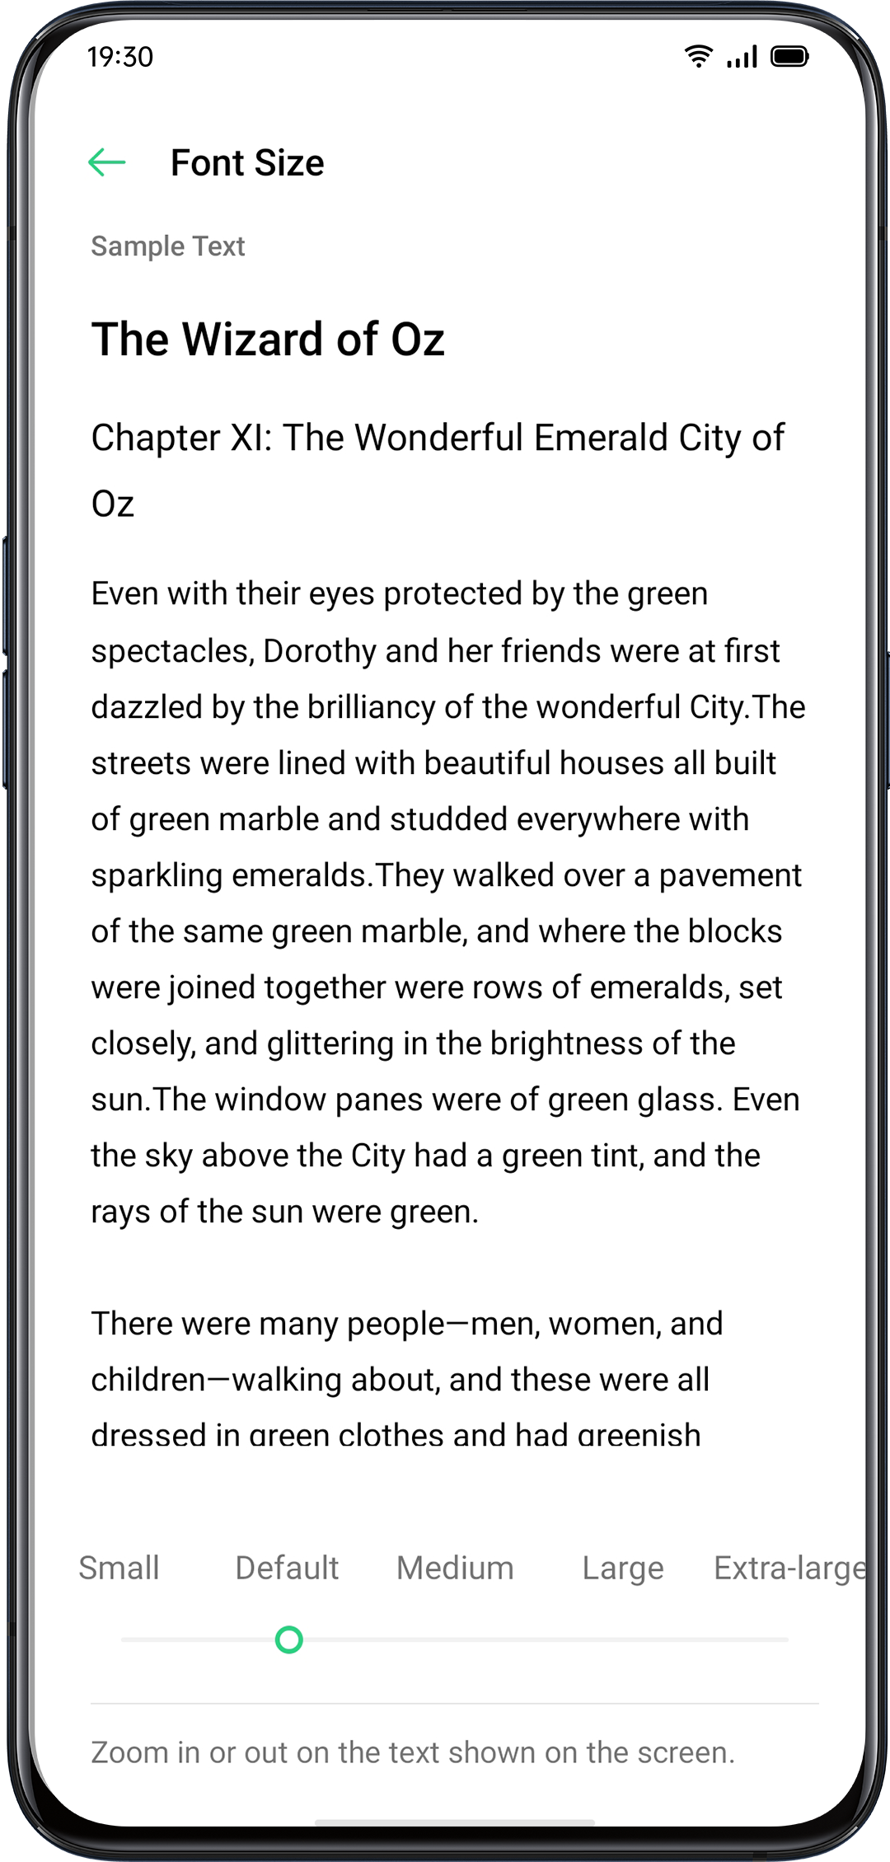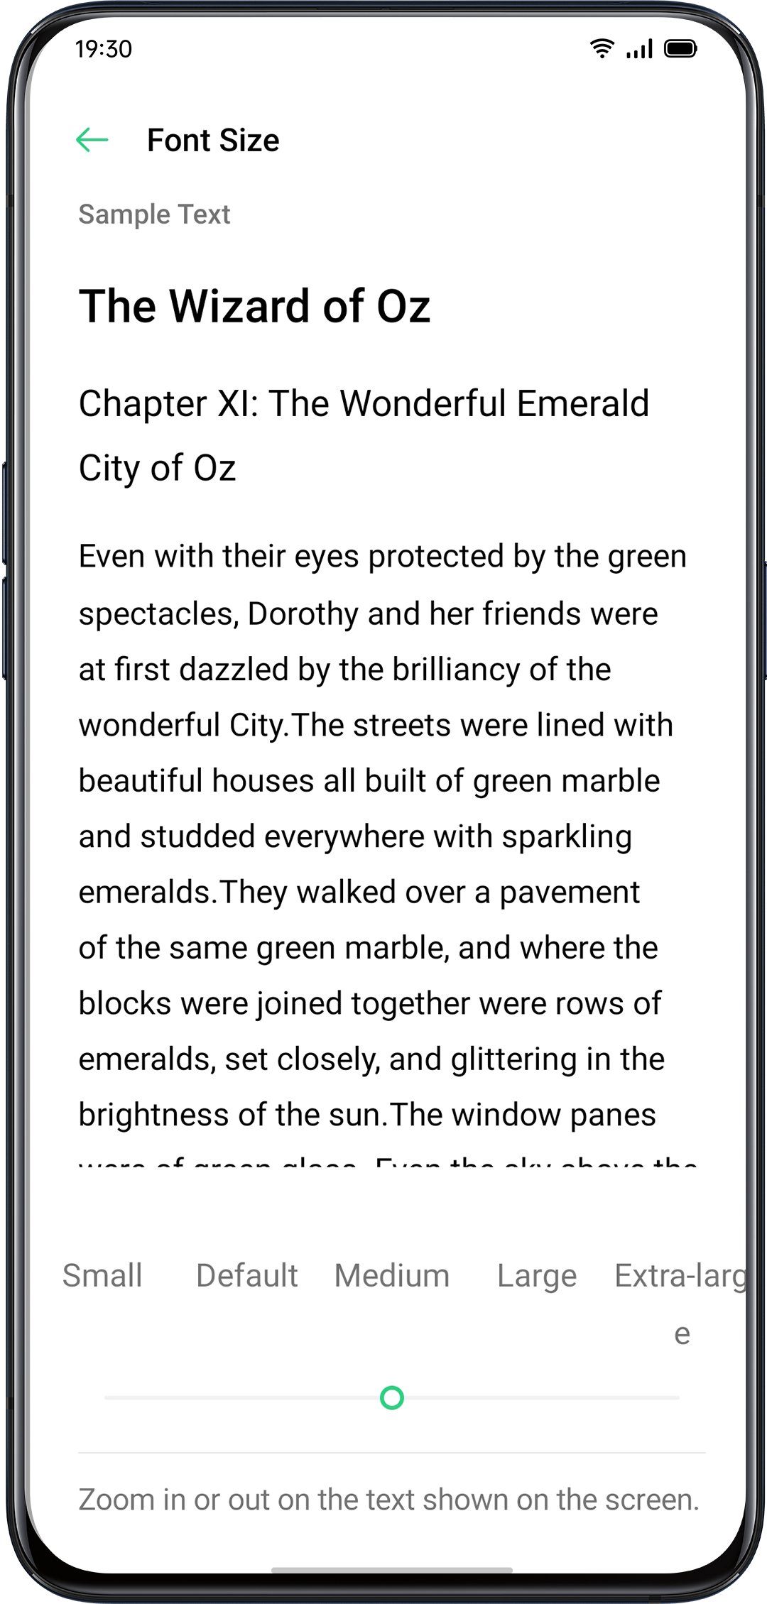

Convenience Aid
Simple gestures lead you with more precise and convenient use with ColorOS.
Go to "Settings" > "Convenience Aid". View and customize gestures such as tap, swipe, drag, and spread.
Awake Google Assistant
You can enable "Turn On Awaking Google Assistant by Pressing Power Button for 0.5 Seconds". While you can press and hold Power Button for 3 seconds to power off pages and hold down Power Button and Vol Up Button simultaneously for 10 seconds to force a reboot.
Assistive Ball
Once the Assistive Ball is enabled, you can try different gestures using the Assistive Ball. There are two ways to operate the Assistive Ball.

Gestures
- Tap to return to the upper page
- Double-tap to enter the multi-task mode
- Touch and hold to go back to Home screen
You can also personalize the gestures
for Assistive Ball based on your preferences and usage habits.

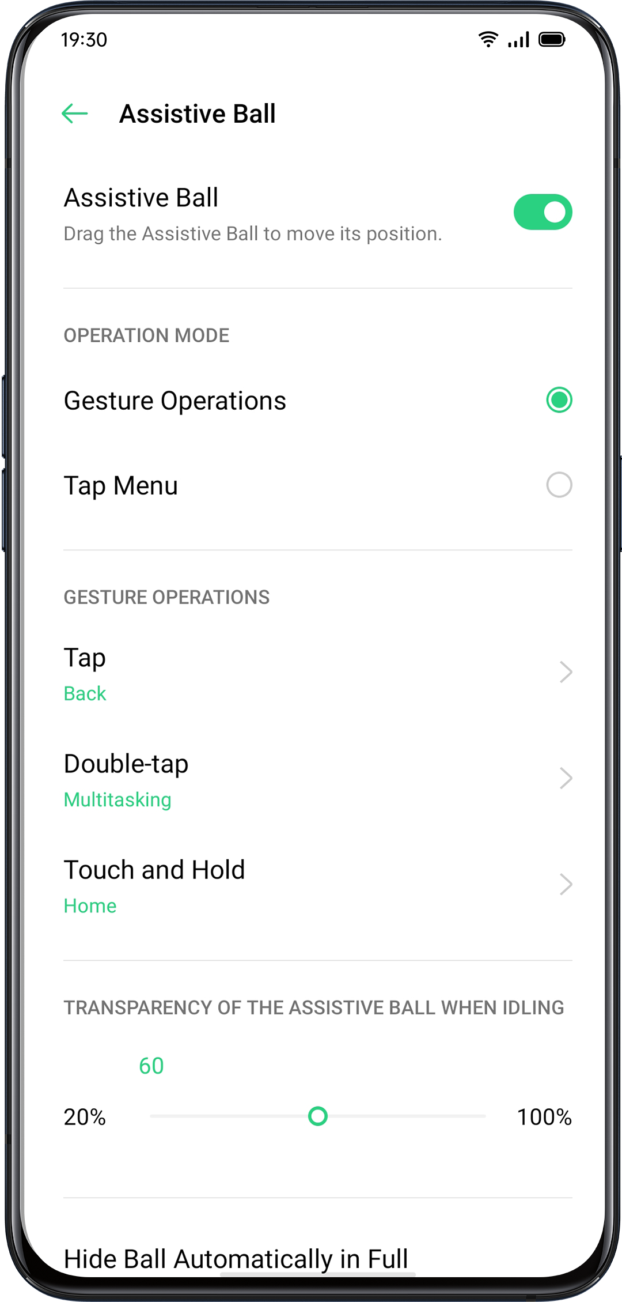

Click Menu
After you open the "Click menu", tap the Assistive Ball and you will see five buttons with different functions. Click the button to complete your action.

- Return to the upper page
- Screenshot
- Multi-task
- Lock screen
- Go back to the home screen

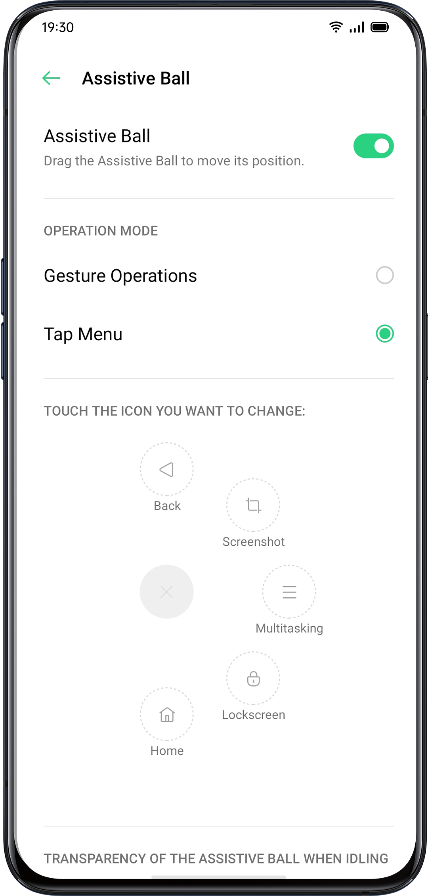

After you enable Assistive Ball, you can also customize the display.

- Drag Assistive Ball to change its location
- Adjust the transparency of the Assistive Ball
- Auto hide Assistive Ball in full screen

Screen-off Gestures
About Screen-off Gestures
When the screen is off, you can use custom gestures on the screen for quick operations.

Go to "Settings" > "Convenience Aid" > "Gesture & Motions" > "Screen-off Gestures".

After enabling Screen-off Gestures, you can choose to add the following gestures:
- Double tap to turn the screen on.
- Draw an O to enable the camera.
- Draw a V to open Flashlight.
- Music control: You can use two fingers to draw "II" on the screen to stop or resume playing music and "<" or ">" to previous or next music even when the screen is off.

Add Screen-off Gestures

You can also add your personalized Screen-off Gestures, for example, slide up to open the calculator.

Smart Sidebar
Smart Sidebar enables you to switch between apps, transfer files, reply messages, or take screenshots when playing a game or watching a video.

Go to "Settings"> "Convenience Aid"> "Smart Sidebar".

After Smart Sidebar is enabled, you will see a white vertical bar on the right side. Swipe to the left and the Smart Sidebar will show up.

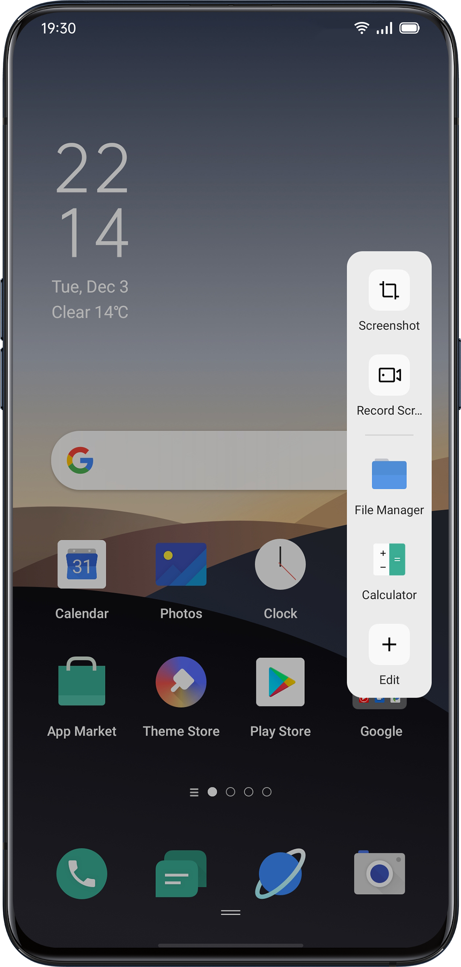

Quick tools
- Screenshot: You can capture the screenshots.
- Screen Recording: You can record the screen motions.
Quick Apps
You can switch from and to several most-used apps. For example, while viewing a video you can also text messages using the floating sidebar.

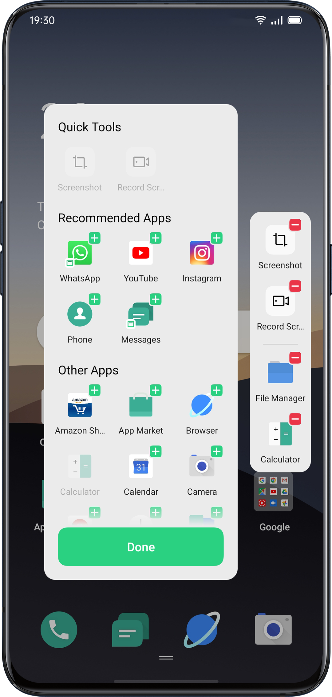

Screenshot
You can take screenshots while using the phone, the screenshots will be stored in "Photos"
You can take screenshots in the following ways.
Button Screenshot
Press and hold the Power Button and Volume Down Button.
3-Finger Screenshot
Swipe down with three fingers to quickly take a screenshot.
Go to "Settings" > "Convenience Aid" > "Gesture & Motions" > "3-Finger Screenshot".

After three-finger screen capture is enabled, press and hold at any position on the screen with three fingers and slide down to set the size of the area to be captured as desired.
Assistive Ball Screenshot
- Go to "Settings" > "Convenience Aid" > "Assistive Ball".
- When Assistive Ball is on, click "Tap Menu" to view shortcut icons.
- Tap the Assistive Ball and click "Screenshot" to take a screenshot.
Smart Sidebar Screenshot
Go to "Settings" > "Convenience Aid" > "Smart Sidebar".
Swipe out the sidebar and click "Screenshot" to take a screenshot.
Long Screenshot
After capturing a screenshot, pull up the screenshot preview floating window to capture a long screenshot. Slide the screen to the desired position, and tap Complete to save the screen as a long screenshot.

Sharing a Screenshot

After capturing a screenshot, pull down the screenshot preview floating window to go to the sharing screen. You can share the screenshot with your friends by using OPPO Share,WhatsApp, etc.

Split-Screen
The App Split-screen provides you with a divided screen that is split into two areas, with each area showing a different scene at the same time. You can watch a movie while chatting with friends within the split-screen.

Go to "Settings" > "App Split-screen".

Turn on "App Split-screen" with the following three ways.
- Swipe up with 3 fingers to enter the split-screen mode.
- Press and hold the Multitask button to enter the split-screen mode.
- Swipe down a task card, then tap Split-screen to enter the split-screen mode.

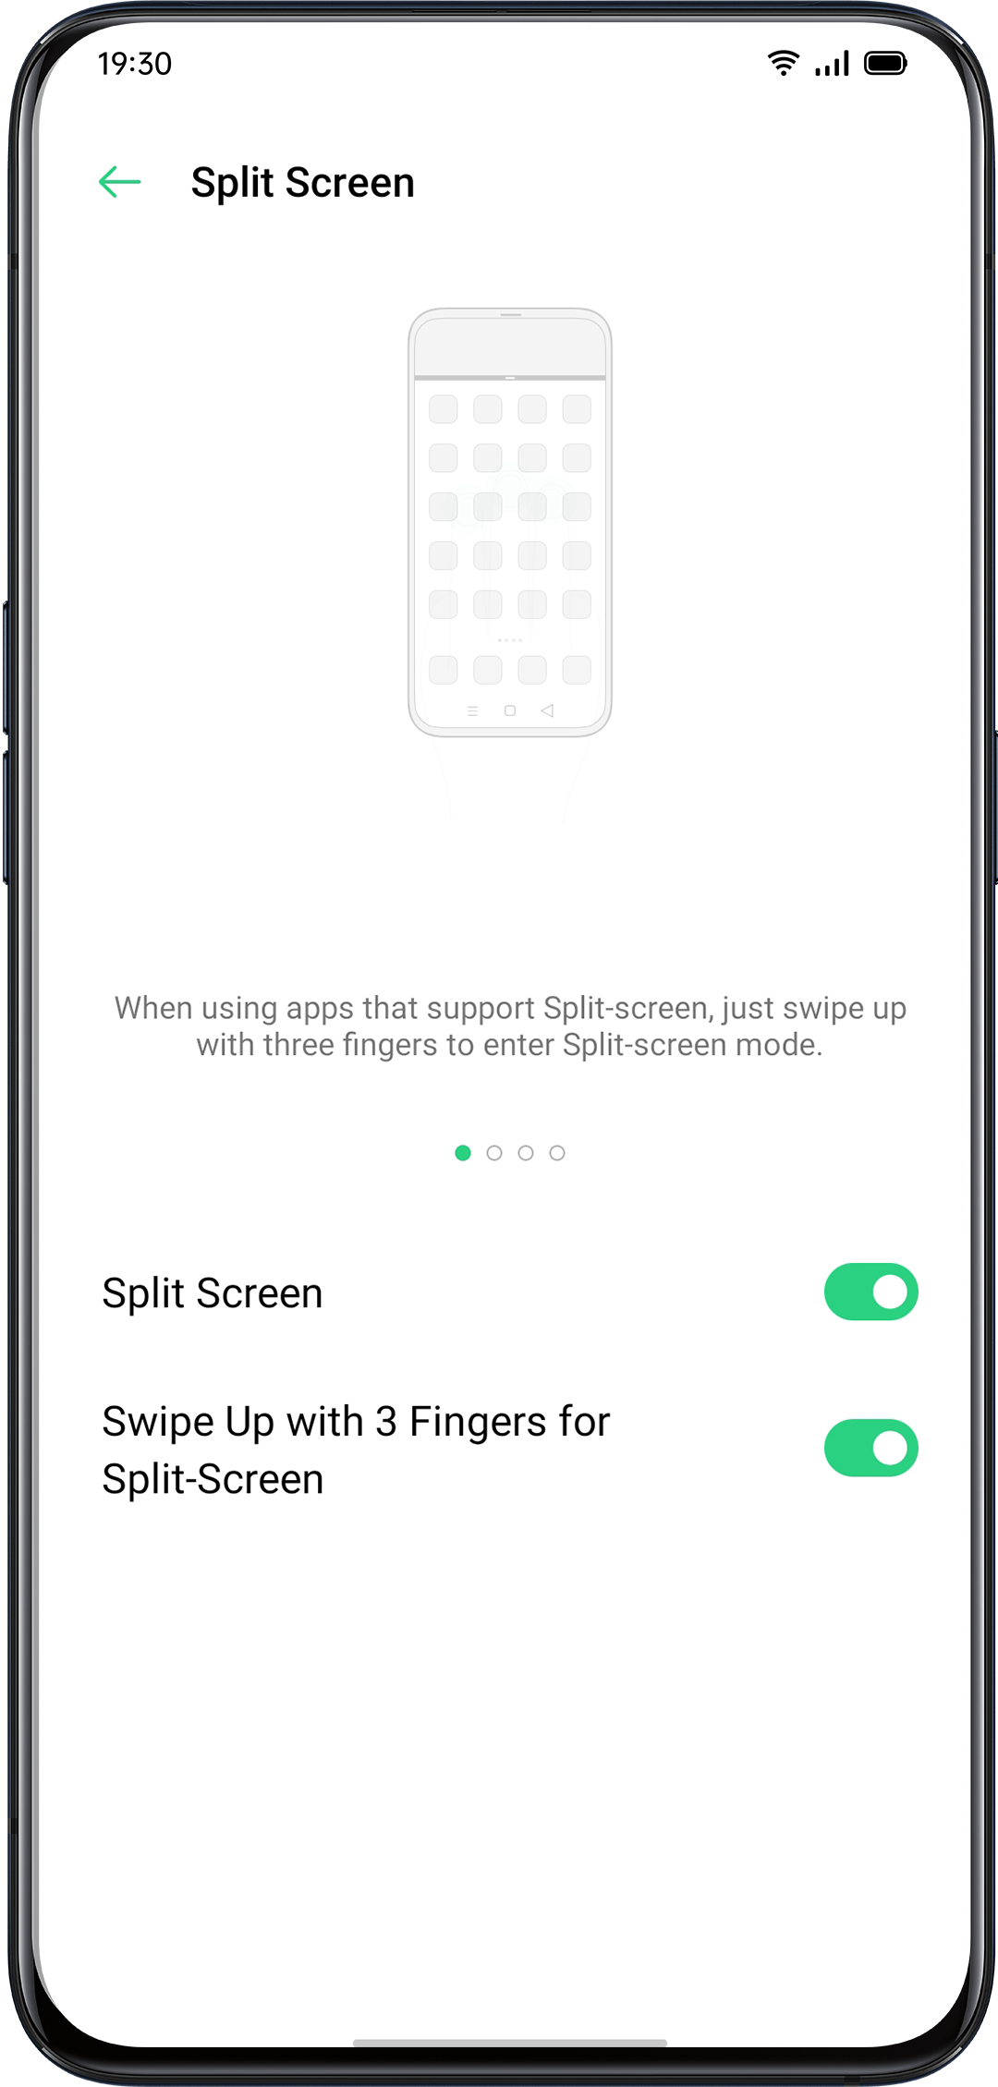
Split-Screen Adjustment
After you enter Split Screen, you can drag the borderline between two apps to adjust each screen size.

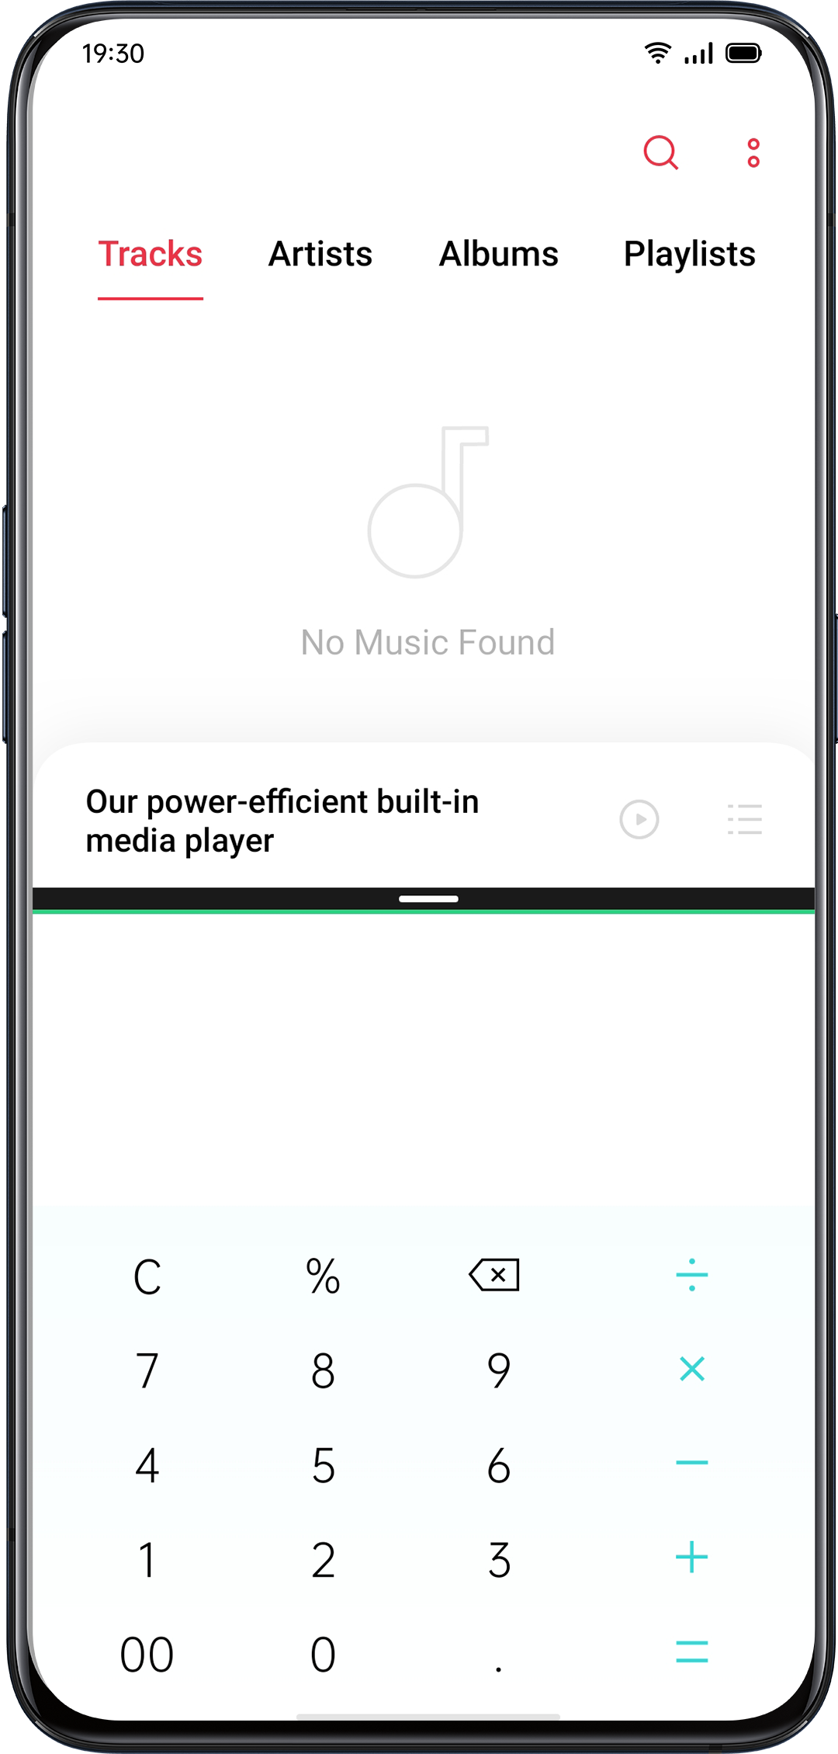
Adjust Split-Screen Location
You can move the location of the Split-screen apps the icon.the the upper or lower area, click the borderline at the middle and tap 

Exit Split-Screen
You may exit the split-screen mode in the following three ways:
- Drag the borderline to exit Split-screen. You can drag the line to the top to exit the upper Split-screen, otherwise, you may drag the line to the bottom to exit lower Split-screen.
- Click the borderline and choose .

App ClonerAfter enabling App Cloner, a copy of a particular app will be generated on the Home screen. The original app and its copy could run simultaneously without affecting each other.

Clone Apps works only if both the app itself and the phone supports it. If a cloned app does not work properly, it means that the function or operation is not supported by the app or phone.

Clone Apps currently do not support data transferring between a cloned app and a computer. At most two app clones can be operated simultaneously.

Apps That Can be Cloned:
- BBM
- WhatsApp Messenger
- Messenger
- Hike News & Content
- Facebook
- imo
- Instagram
- Skype
- Telegram
- Viber Messenger
- Zalo

Go to "Settings" > "App Cloner" > "Apps That Can Be Cloned".

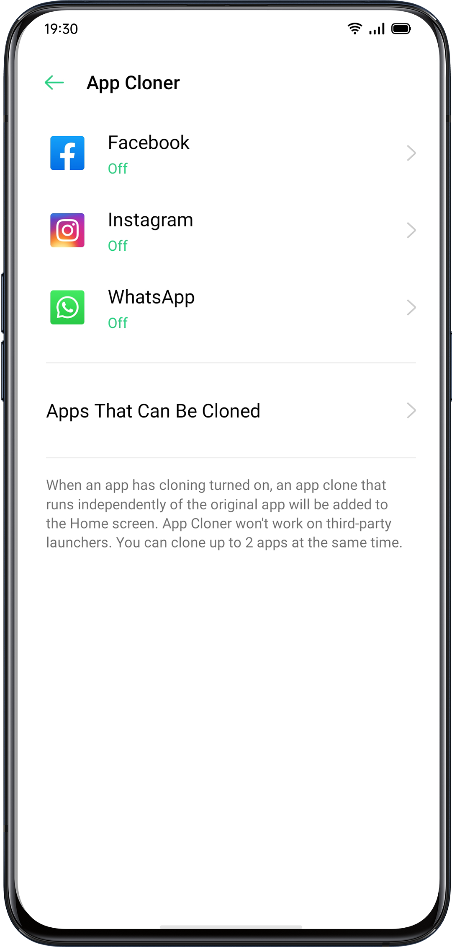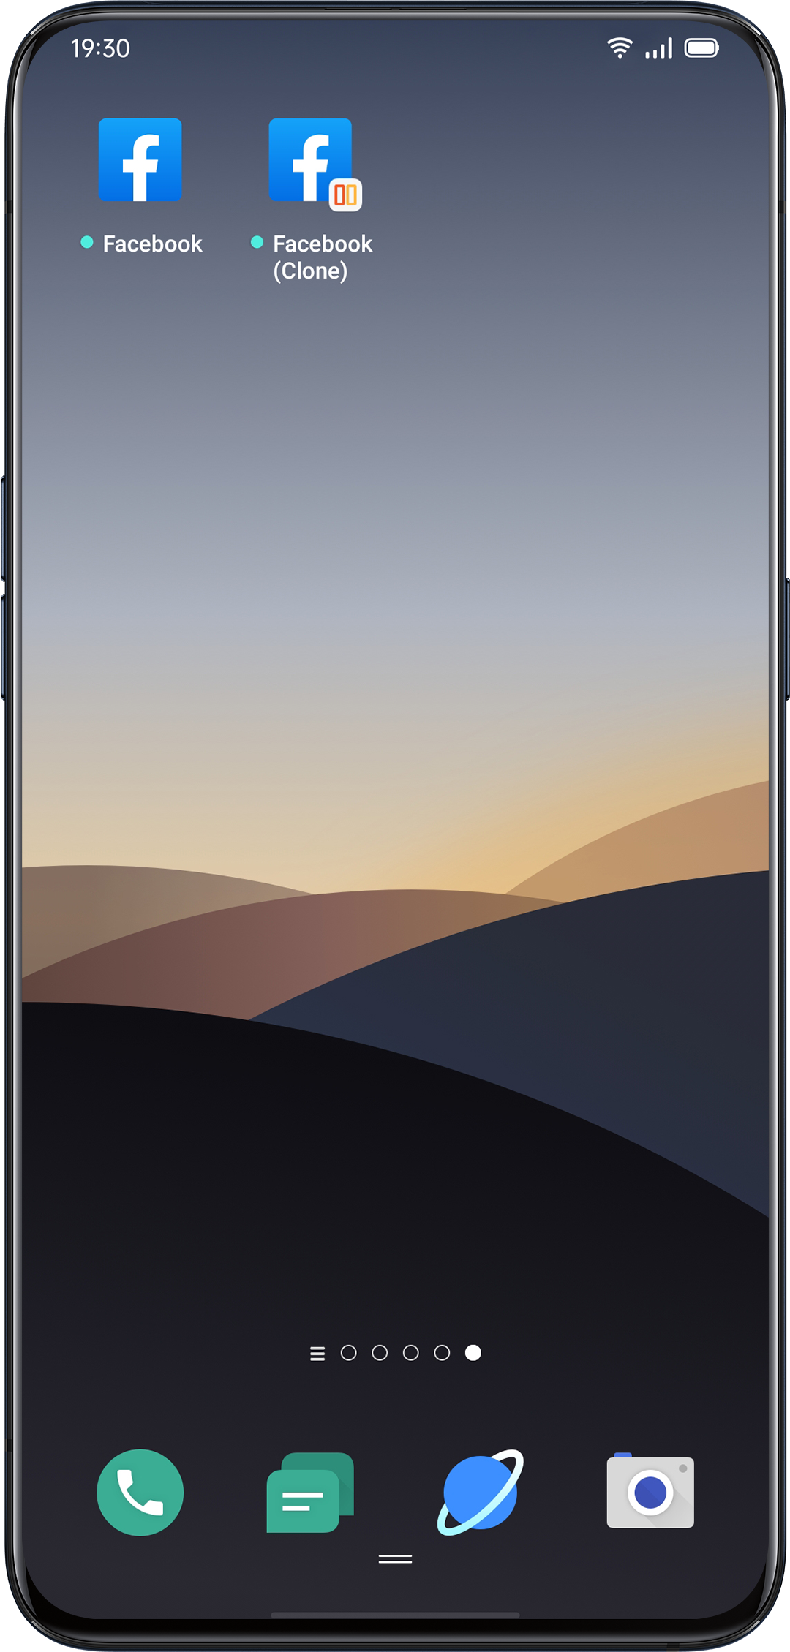

Power Saver
ColorOS 7 will detect user scenarios, and you can choose from different power saving strategies.
Save Power
ColorOS 7 will automatically detect the power consumption issues. You can tap "Save Power" to optimize and extend battery life.
Go to "Settings" > "Battery" > "Save Power" > "Extend Battery Life".
Smart Power Saver
When the "Smart Power Saver" is on, the system will identify the running status of apps and adopt a targeted power saving mode to ensure that the background apps operate smoothly.
You are recommended to use Smart Power Saver to keep your phone in smart power consumption, reducing power consumption and extending battery life.
Go to "Settings" > "Battery" > "Smart Power Saver (Recommended)".
Power Usage
Go to "Settings" > "Battery" > "Power Usage".
You can view power usage of today, yesterday and 2 days ago. You can also view apps' foreground and background activity time, and their power consumption.
Power Saver Options
Go to "Settings" > "Battery" > "Power Saver Options" > "Sleeping Mode".
This feature can sense when you might be sleeping, and then switch to Low Power Mode to make your phone more power-efficient.
High Performance Mode
Go to "Settings" > "Battery" > "High Performance Mode".
The system will operate in high performance mode, but it will increase extra power consumption.

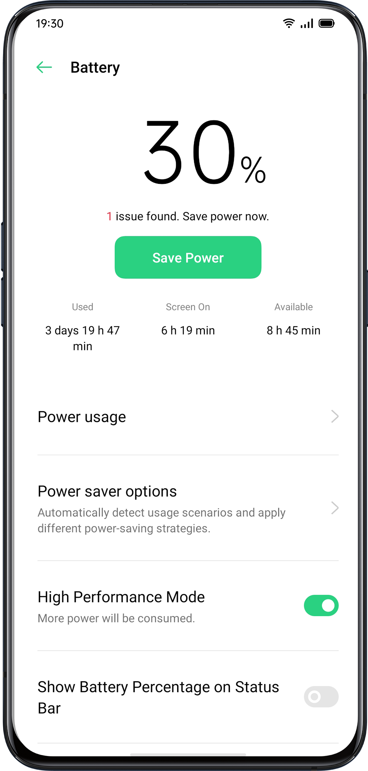

Control Center
Control Center offers you instant access to the most frequently used features such as calculators, cameras, and flashlights, allowing you to view recent and earlier notifications within simple swipes.

Swipe down from the very top of any screen (except the notch at the top center of the display) to enter Control Center.

Press and hold a certain icon to start customization. For example, you can adjust the display warmness or coolness manually by pressing and holding the icon for Night Shield mode.
Change or Rearrange Icons
For the frequently used icons or functions, you can add them to the notification bar manually. Scroll down to enter Control Center, click  from the top right corner, then press and hold to move the icons to the notification bar.

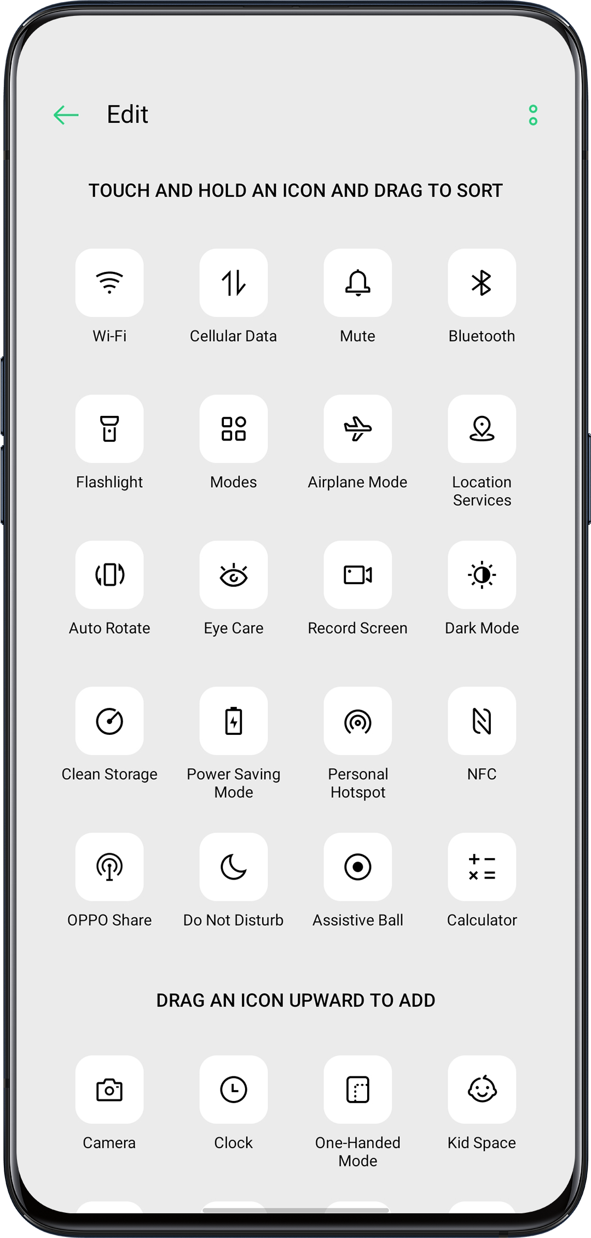
Quick Actions
Quick Actions in Control Center include:

Enable Network
- Airplane Mode: Disable cellular data immediately.
- Cellular Data: Enable or disable mobile data to connect to the network.
- WLAN: Look through websites, or download movies.
- Bluetooth: Connect to earphones, car kit system or other devices that support Bluetooth connectivity.
- Personal Hotspot: Connect to computers or other devices that share your network.
- OPPO Share: Share your photos, videos or locations with other OPPO devices around you.
- NFC: Enable NFC to finish payment or transmit data.
- Location Services: Turn on location services to allow apps and system service to access your location.

Control Volume
- Silent Mode: Mute notifications.
- Do-not-disturb Mode: Mute incoming calls and notifications, choose when not to be disturbed.

Accessibility Aid
- Assistive Ball: Switch Assistive Ball on to aid operations.
- One-hand Mode: Shrink the screen size for the users who would like to operate with one hand.
- Auto-rotate: Screen will be automatically switched either to landscape or vertical orientation while you rotate the phone.
- One-tap Lockscreen: Enable the swift screen lock.

Other Quick Actions
- Flashlight: Turn on the LED flashlight if there's a need for lighting.
- Calculator: Launch quick calculating, and complete online currency exchange.
- Quick Search: Enter the OPPO browser and search.
- Accelerate and Clean: Enter Cleanup Storage mode and start the cleanup.
- Power Saver: Turn on to save power.
- Camera: Tap to start shooting, taking selfies or recording videos.
- Clock: Enter Clock to access to the alarm clock, stopwatch, and timer.
- Screen Recording: Tap to start recording the screen.
- Night Mode: Adjust the screentone as warmer at night or dim-lit environment for eye protection.
- Multi-screen Interaction: Project the screen to a TV or other outlets via the Wi-Fi Display.
Notification Bar
You can customize your notifications so you see only what is important to you. However, you would not see what's in the Notification Bar if the screen is locked. Swipe down from the top to see recent notifications, then scroll up to see older notifications.

See Recent and Earlier Notifications
Tap to see the notifications.

Remind Me Later
Swipe left and tap and the notification will be pushed afterward set the duration of what time you want to receive the notification.
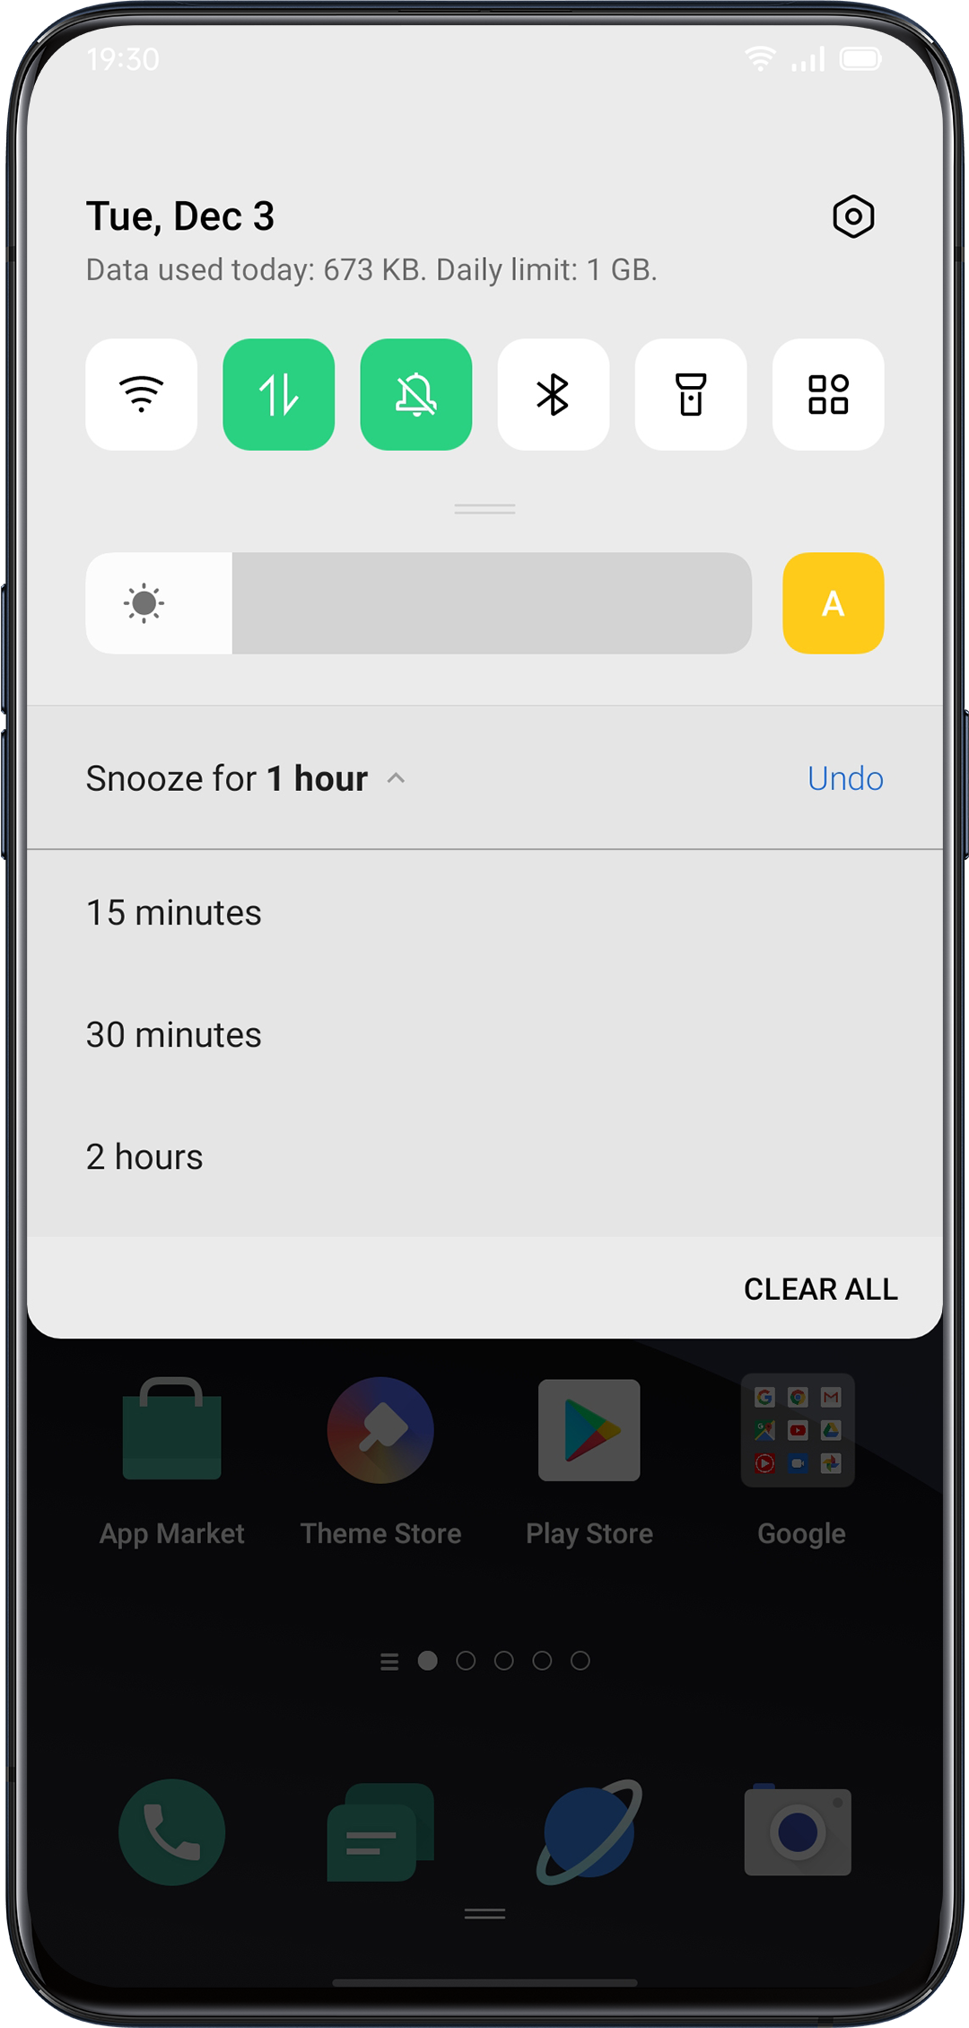

Set Notification Preference
Swipe left to manage notifications. Tap  > 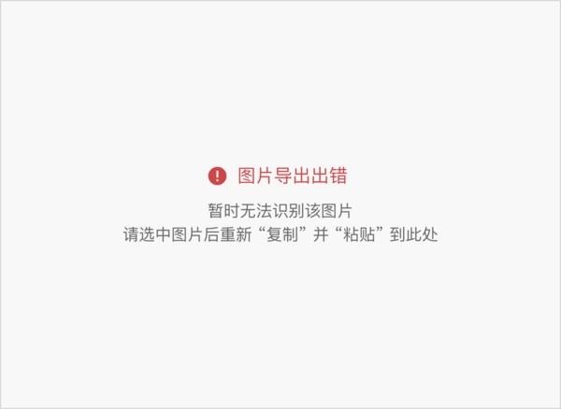to set preference for a particular notication, or manage a batch of notifications as following instructions:

Go to "Settings" > "Notification Bar and Status Bar" > "Manage Notification".

Customize notifications based on your preferences and daily usage habits. The customization includes the style of previews and type of notifications.

You can choose to:
- Show icons on the Home screen.
- Show icons on the Lockscreen.
- Show banners on the top of the screen when the phone is locked.
- Turn on ringtones and vibrations.
You may also set to allow some app notifications to show up even if your phone is in silent mode.

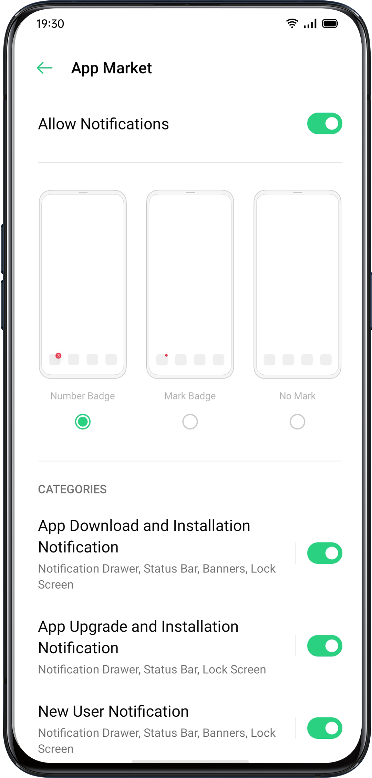

Status Bar
Status icons are displayed on the status bar to indicate time, carrier, wireless connectivity, and battery status.

You can acquire a visual presentation of the battery percentage and network speed after you prompt the switch.

Go to "Settings"> "Notification and Status Bar", and switch the sliders to green.

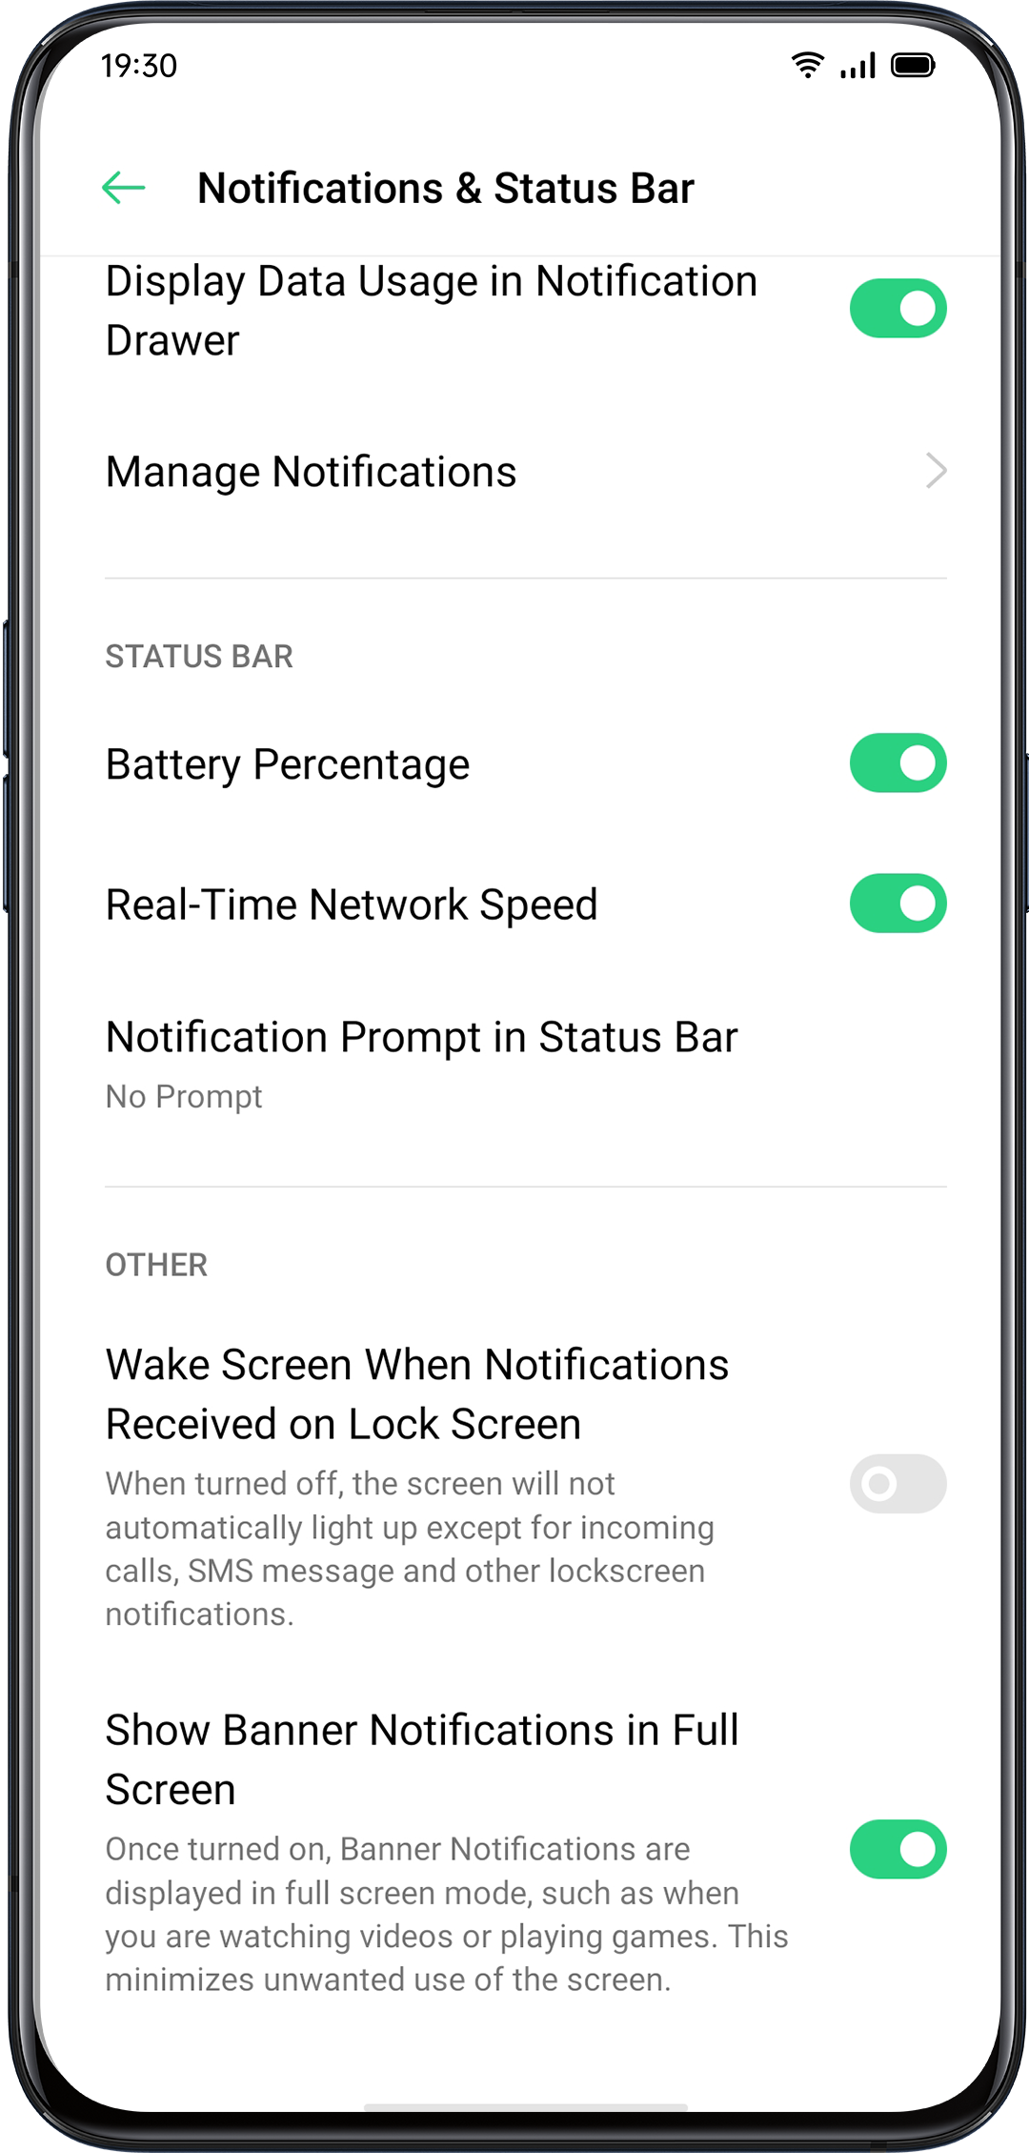

App Shortcuts
ColorOS introduces highly convenient maneuvers, as it allows icons to create simplified operations.
Create App Shortcuts
After enabling the App Shortcuts mode, press and hold the app icon to create an icon. Tap the icon you would like to use, then the app will open directly to that feature. For example, go to your Home screen and press and hold on the icon of Camera that lets you jump straight to Portrait shooting, Beauty Selfie, Video Recording, or the App Info page.

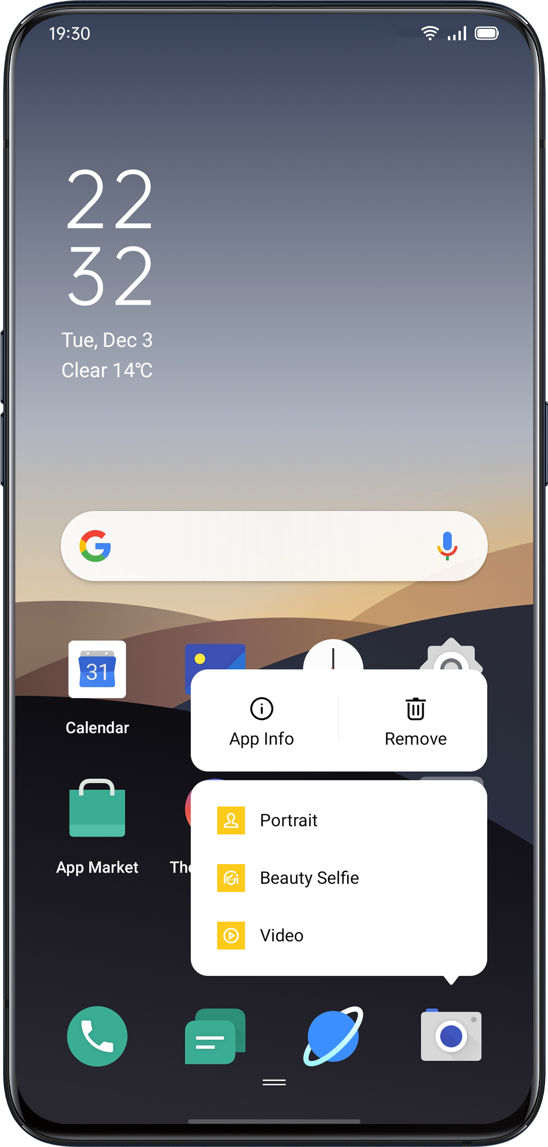

Keyboards and Input Methods
Texts are important ingredients to record and exchange information. With the help of useful keyboards, working efficiency will be enhanced while communicating with others.

Default Input Methods
Go to "Settings" > "Additional Settings" > "Keyboards & input Methods" > "Current Keyboard".

Security Keyboards

After checking "Use secure keyboard when entering a password", the security keyboard will be automatically switched on while you type passwords, in order to better protect the privacy and data safety.

Customize Keyboard Settings
To personalize the keyboard setting, go to "Settings" > "Additional Settings" > "Keyboard and input methods" > "Available Keyboards"> click on the existing input methods and customize.

Type Emojis and Stickers
It might be a bit dull to merely type with texts. Tap the Emoji button at the bottom of the keyboards, and try out something interesting such as Em and stickers (it has to be downloaded additionally) while typing.

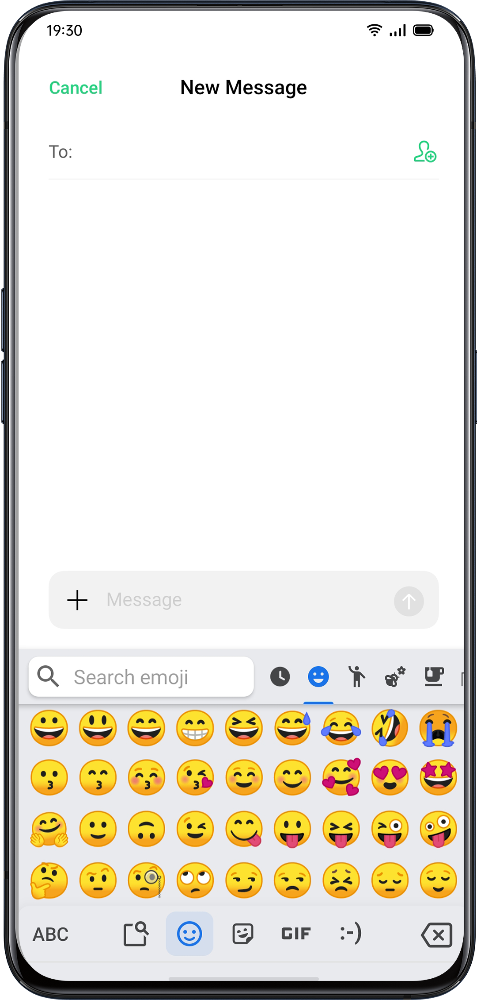
Voice Typing
While it's a bit inconvenient for you to type texts, you can use the b-in microphone to input audio-generated texts instead of typing it.

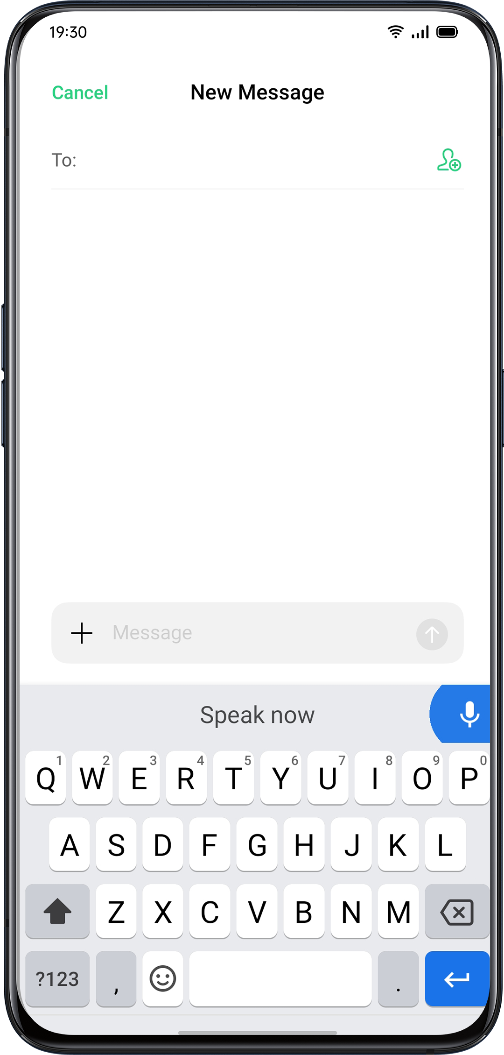
Autofill Service
You can download and install autofill apps from the App Store to help you remember what you've already filled in, and fill in the information automatically when y ou need it.
Go to "Settings" > "Additional Settings" > "Keyboard & InputMethod" > "Autofill Service".
OPPO Share
Use OPPO Share to send files wirelessly and effortlessly between OPPO devices. Mobile data will be no longer needed.

How to turn on OPPO Share:
- The receiver should open Control Center, and then turn on OPPO Share 
- Select the files to be shared and the device to share with, tap Send, then tap the detected OPPO phone.
- Tap Receive on the other device and start sharing.
Tips:
- OPPO Share requires that both the sender and receiver are OPPO phones.
- Make sure the sender and receiver are connecting to the same Wi-Fi network.
- OPPO Share will switch off within 5 minutes.

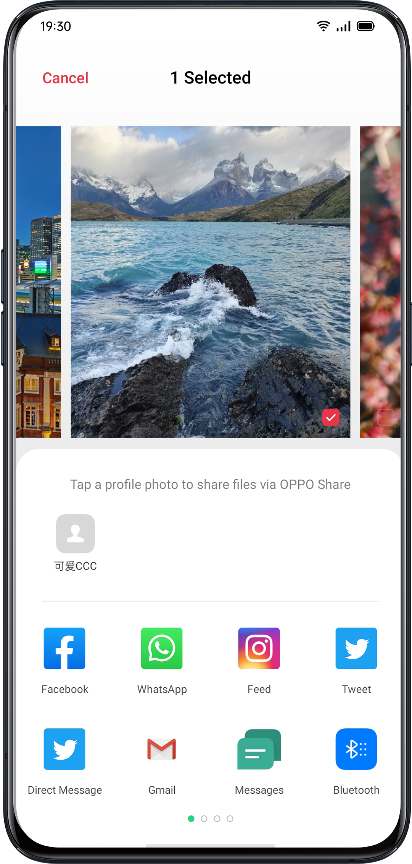

Search Settings, Data, and Files
You don't need to look through your phone in every single app to find a setting or file. OPPO allows users to optimize built-in searching engine by simply tapping a keyword.

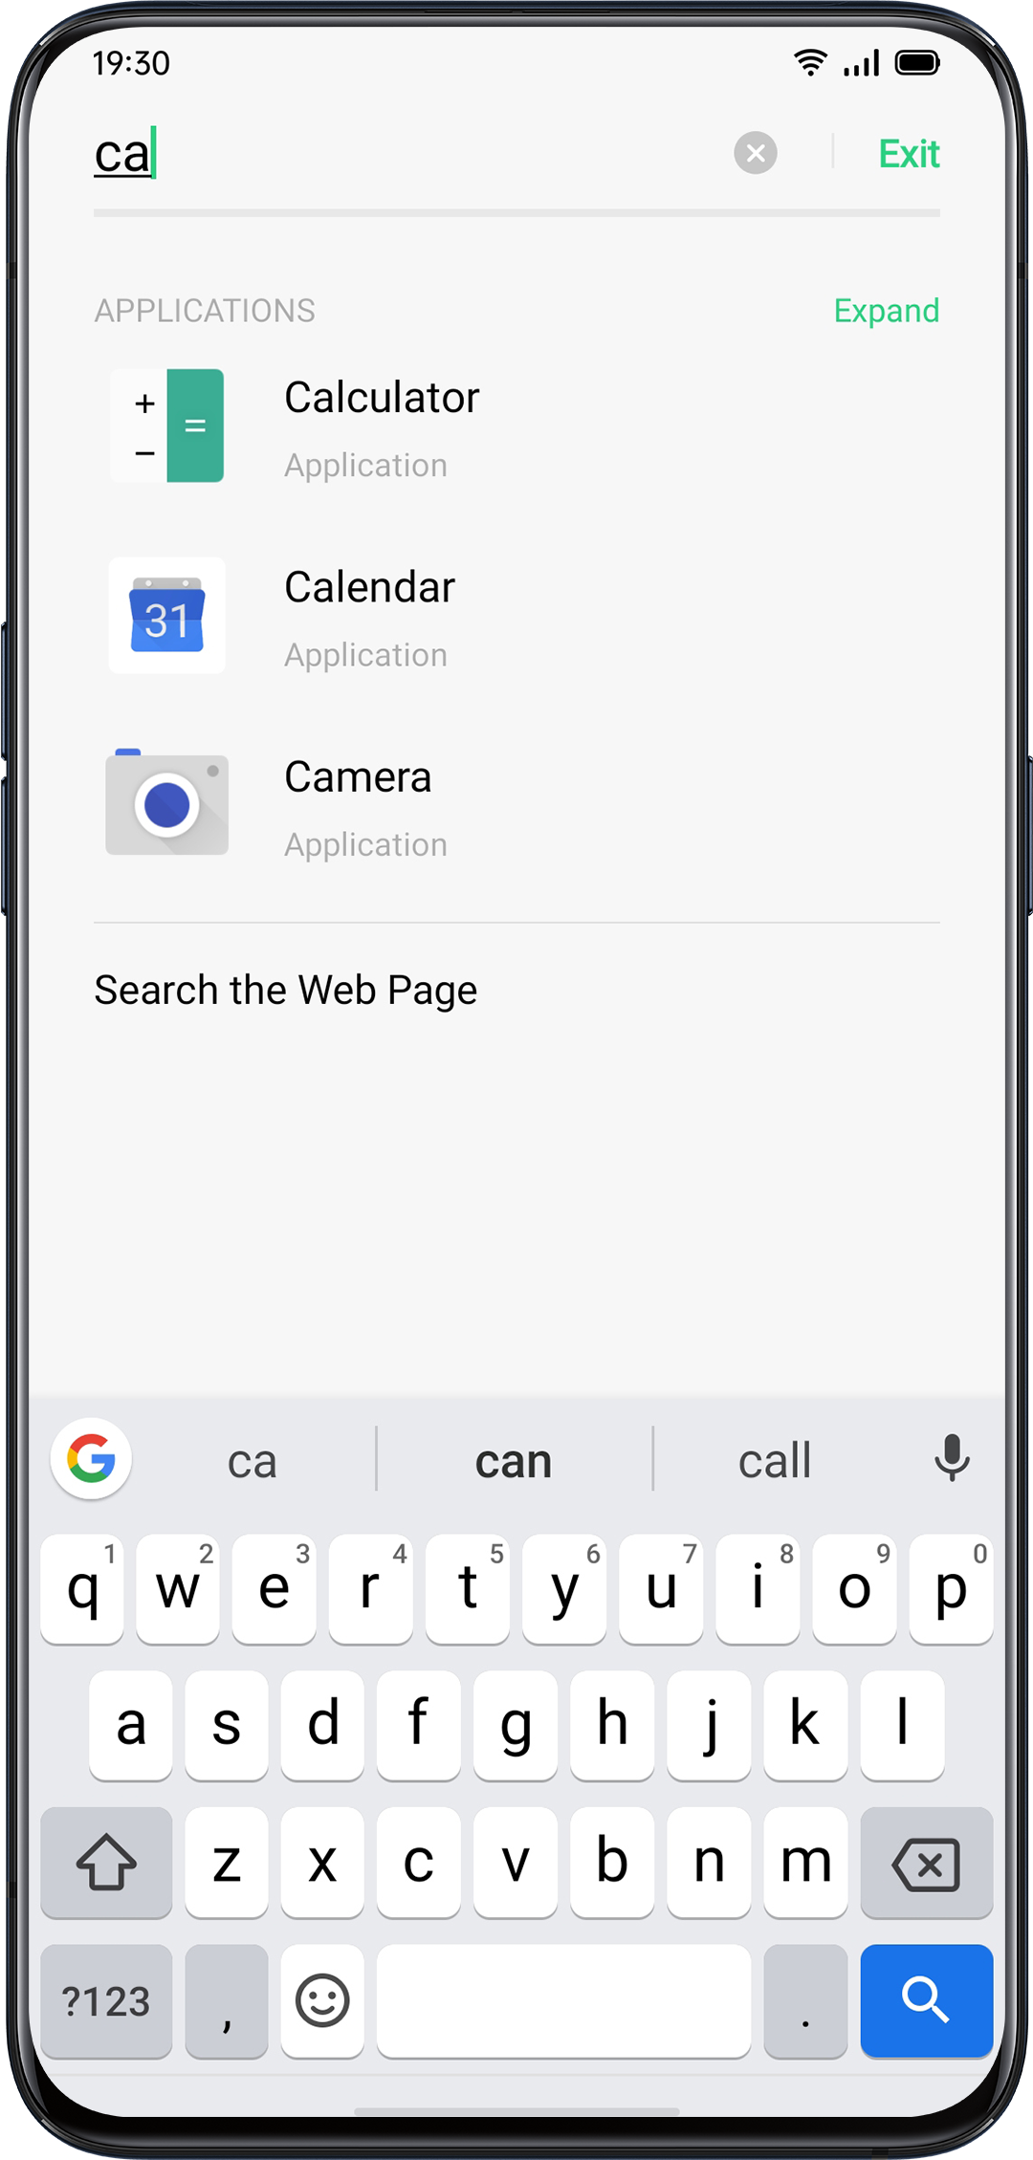

Two ways to configure searching:
- Swipe down the screen at any page to start searching
- Tap the search bar at "Smart Assistant"

Accessibility
Accessibility is aimed to optimize user experience for visually impaired users.
Go to "Settings" > "Additional Settings" > "Accessibility".

TalkBack
When TalkBack in on, it provides spoken feedback so that you can use your device without looking at the screen. This can be helpful for people who are blind or have low vision.

Turn on TalkBack
Go to "Settings" > "Additional Settings" > "Accessibility" > "TalkBack".

TalkBack Settings
Go to "Settings" > "Additional Settings" > "Accessibility" > "TalkBack" > "Settings".
You can set Speech, Other feedback, Navigation and Miscellaneous according to your needs.

To Navigate Using TalkBack
- Swipe right or left to move between items.
- Double-tap to activate an item.
- Drag two fingers to scroll.

To Turn off TalkBack
- Tap the switch. You will see a green outline. Double tap the switch.
- On the confirmation message, tap "OK". Then double-tap OK.

Accessibility Menu
The accessibility menu provides a large on-screen menu to control your phone. You can control gestures, hardware buttons, navigation, and more.

Turn on Accessibility Menu
Go to "Settings" > "Additional Settings" > "Accessibility" > "Accessibility Menu".
Tap the Accessibility button on the bottom of your screen to use this feature.

Turn off Accessibility Menu
Go to "Settings" > "Additional Settings" > "Accessibility" > "Accessibility Menu".

Note: Press and hold the Accessibility button on the bottom of your screen to switch between Accessibility Menu and Select to Speak.

Select to Speak
When Select to Speak is on, you can tap specific items on your screen to hear them read aloud.

Turn on Select to Speak
Go to "Settings" > "Additional Settings" > "Accessibility" > "Select to Speak".
Tap the Accessibility button on the bottom of your screen to use this feature.

Select to Speak Settings
Go to "Settings" > "Additional Settings" > "Accessibility" > "Select to Speak" > "Settings".
You can set Read in the background or Read the text on images according to your needs.

Use Select to Speak
First, tap the icon. Then you can:
- Tap a specific item, like text or an image
- Drag your finger across the screen to select multiple items
- Tap the play button to hear everything on the screen
- Select text that appears inside the Camera view

Turn off Select to Speak
Go to "Settings" > "Additional Settings" > "Accessibility" > "Select to Speak".

Note: Press and hold the Accessibility button on the bottom of your screen to switch between Accessibility Menu and Select to Speak.

Switch Access
Switch Access lets people with motor impairments control phones and tablets using one or more switches. Use switches to select items, scroll, enter text, and more.

Turn on Switch Access
Go to "Settings" > "Additional Settings" > "Accessibility" > "Switch Access".

Switch Access Settings
Go to "Settings" > "Additional Settings" > "Accessibility" > "Switch Access" > "Settings".
You can set Assign switches, Customize scanning, Display & sound, Switch accommodation and more according to your needs.

Turn off Access Settings
Go to "Settings" > "Additional Settings" > "Accessibility" > "Switch Access".

Customize Settings
You can set "Click When the Pointer Stops Moving", "Press Power Button to End Call" and "Touch & Hold Delay" according to your user habits.
Go to "Settings" > "Additional Settings" > "Accessibility".

Text-to-Speech (TTS) Output
You can customize TTS Output.
Go to "Settings" > "Additional Settings" > "Accessibility" > "Text-to-Speech (TTS) Out".
Tap the icon on the right side of "Preferred Engine", you can select and install voice data.
You can also customize language, speech rate and pitch according to your habits.

Accessibility Shortcuts
When Accessibility Shortcuts is on, hold down both volumes buttons for 3 seconds to turn on accessibility function. You can choose shortcut services and turn on/off "Available Even When the Screen Is Locked".

Go to "Settings" > "Additional Settings" > "Accessibility" > "Accessibility Shortcuts".

Subtitles
You can adjust subtitles on the screen to enhance the watching experience.
Go to "Settings" > "Additional Settings" > "Accessibility" > "Subtitles".

Clean Storage
Cleaning the storage when there is less abundant space for storage to download apps and restore photos. While Clean Storage will help you detect and remove unnecessary files, cookie, and cache files to free up more storage.

Check Storage
Go to "Settings" > "Additional Settings" > "Storage", and you will see the followings:
- Overall storage availability
- Storage used
- Storage left

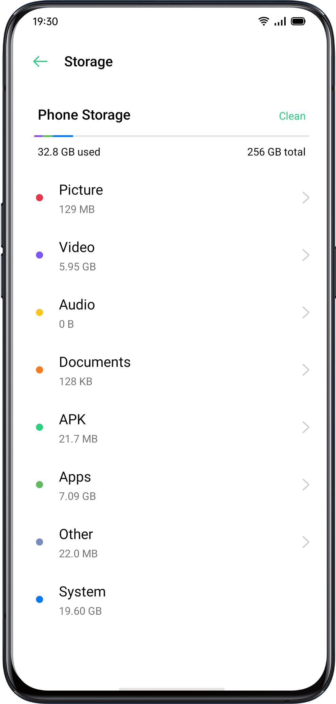

One-tap Cleanup
ColorOS will help identify useless or unimportant files if you want to clean up storage. Tap "Clean" , and the phone will automatically clean the files. Fast and steady.

Delete App Data
ColorOS also offer specialized cleanup service for some frequently used apps.

Categorized Cleanup
You can also clean storage and accelerate the system based on different categories of files and data.

- Photo cleanup
You can easily delete photos that may either be less visually aesthetic or repetitive. ColorOS assists you while cleaning up photos as it has already automatically screened them out into the categories such as screenshots, recently deletes, similars, burst shooting, blurred shots, and edited photos.

If you delete photos under the above categories, more space will be released. This action can not be undone.

- Video cleanup
You could delete unnecessary videos or video clips after viewing them. Select the video files that you intend to remove.

- Audio and documents cleanup
After ColorOS filters audio and documents, you can choose which to remove according to the size and type of audio and documents.

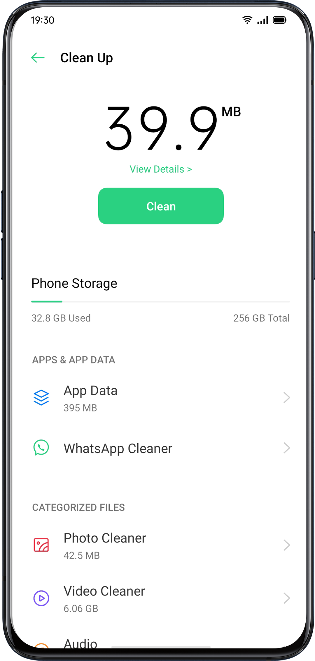

Back Up Your Phone
If you have switched to a new OPPO phone, you can transfer your data from the old phone to your new OPPO phone. It is advised that you are supposed to maintain phone backup on a regular basis. There are two ways to do it.
Use HeyTap Cloud
Go to "Settings" > "HeyTap Cloud" > Enter HeyTap ID and password.

If you have not created an HeyTap ID yet, click "Register" at the bottom right corner to finish registration with the mobile phone or email address.

After you log into your HeyTap ID, go to "HeyTap Cloud" > "Cloud Backup" > "Manual Backup", and you are able to transfer following data and files to the cloud, including:
- call log
- SMS
- Settings

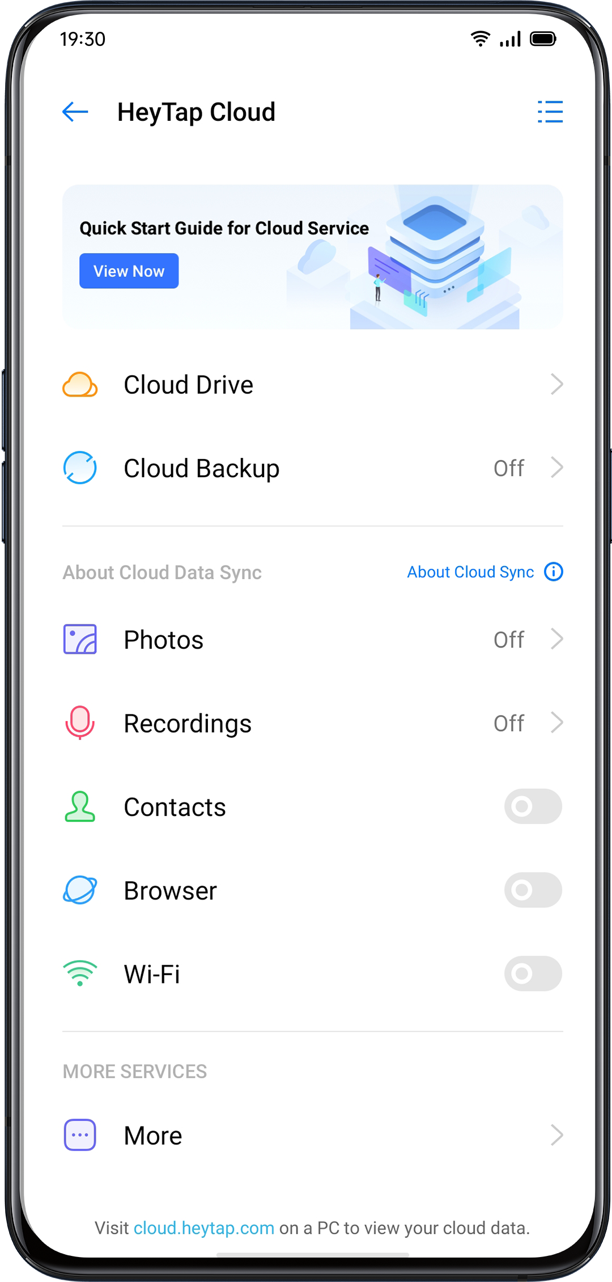
Manual Syncing
Sync to the Phone
Go to "Settings" > "Additional Settings" > "Back up and Reset"> "Back Up & Restore",tap "New Backup", then select data you want to sync.
- Contacts
- Messages
- Call History
- System data
- Apps(Excluding data)
After clicking on "Start", the data selected will be synced and restored in your phone inside a file path named "Backup". Syncing will take some time. Don't disconnect your phone during the copy backup process and avoid restarting or turning off the phone, in case of loss of data.

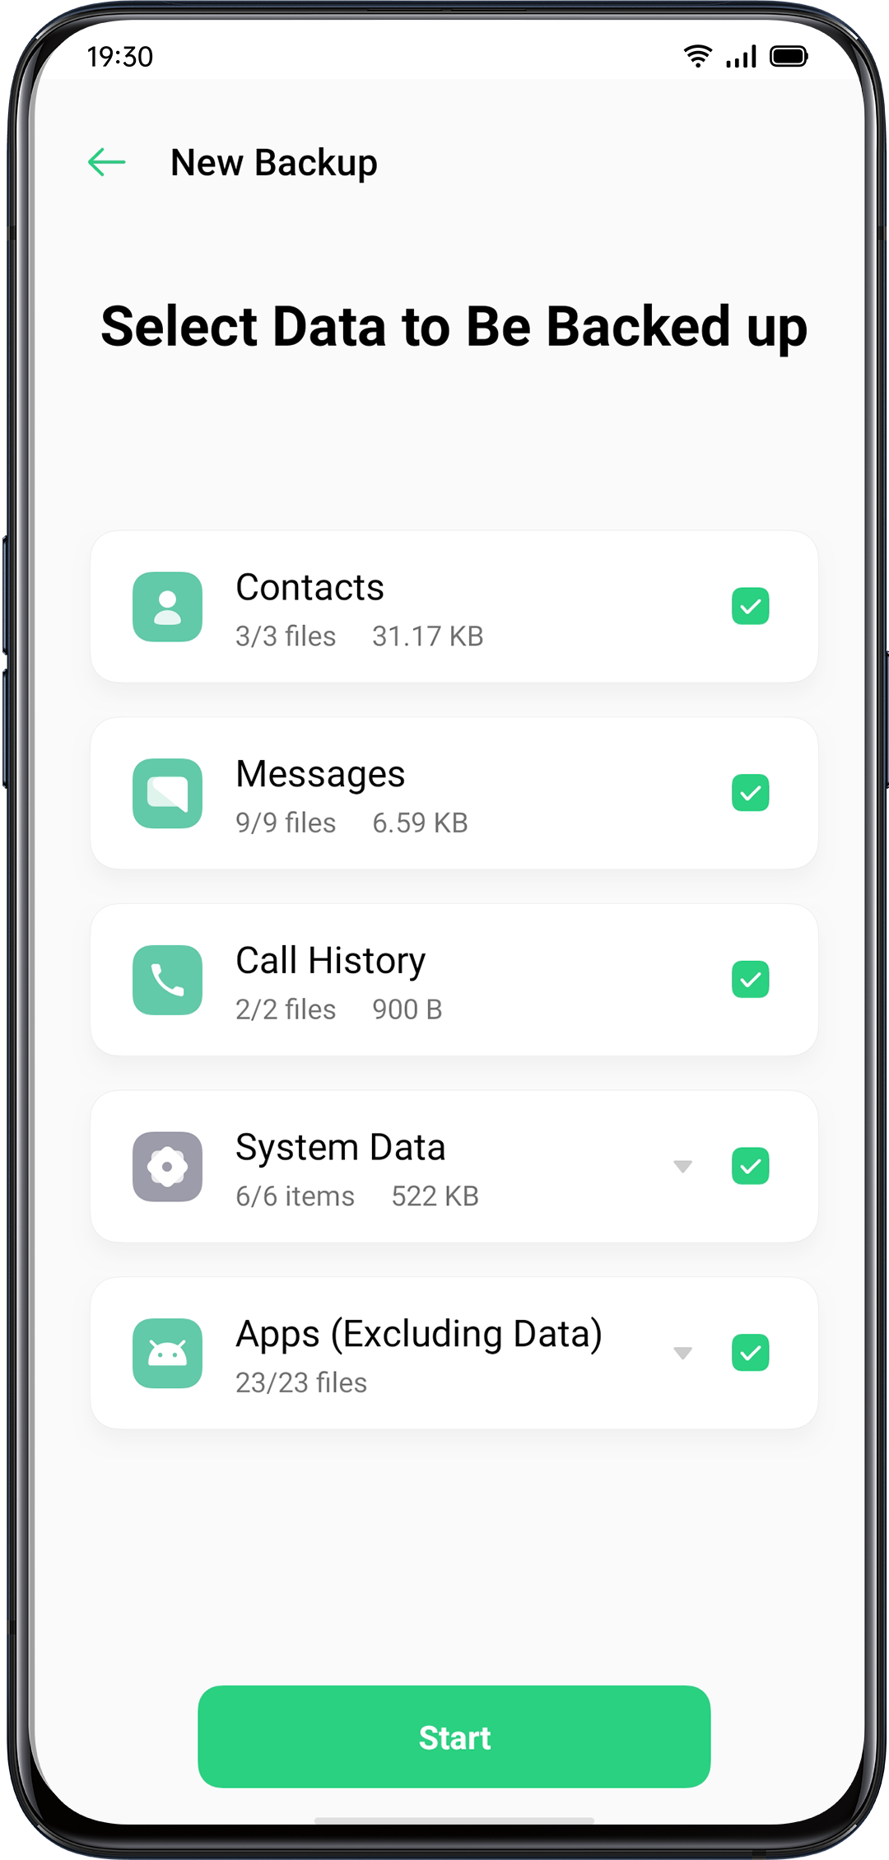

It is noted that all the local backup data will be cleared if you erase or reboot all the settings. Therefore, it is wise to copy or restore files and data before rebooting or upgrading the system.

Restore Data on Your Computer
Use USB cable to connect your phone to a computer. Follow the onscreen instruction and choose "Transfer Files". Open "Sharing Storage" at the computer, and then select the "Backup" folder and copy it to the computer. Then the backup is transferred to your computer.
Charge the Battery
You can view the percentage of battery remaining in the status bar at the top right corner of the phone. Charge your battery when your phone is low on power using the Type C USB cable and USB power adapter. Charge the battery. Connect your phone to a standard power outlet or a portable charger.

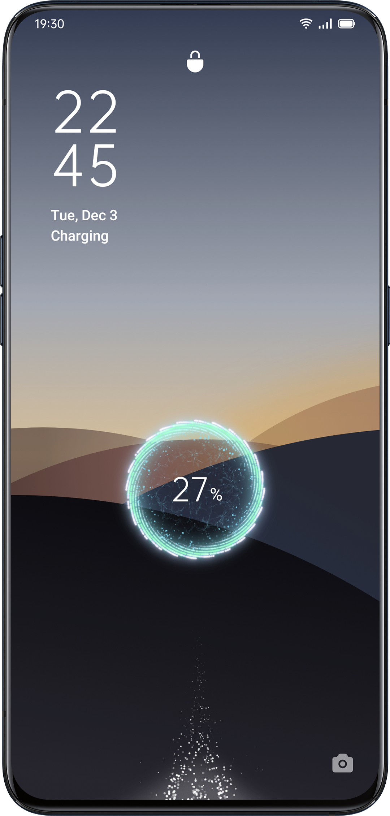

If the proportion of battery is too low, it is likely that you won't be able to turn on you phone. You should charge the battery to continue using your phone.
Restart or Turn Off Your Phone
If something isn't working right, try to restart your phone.

To restart the phone, you can:
- Press and hold the Sleep/Wake button for more than 3 seconds, and then drag the white-colored power icon up to restart or,
- Press and hold the Power Button and volume-up button at the same time for more than 10 seconds.

To turn off the phone, Press and hold the Power Button for more than 3 seconds, and then drag the white-colored button downwards.

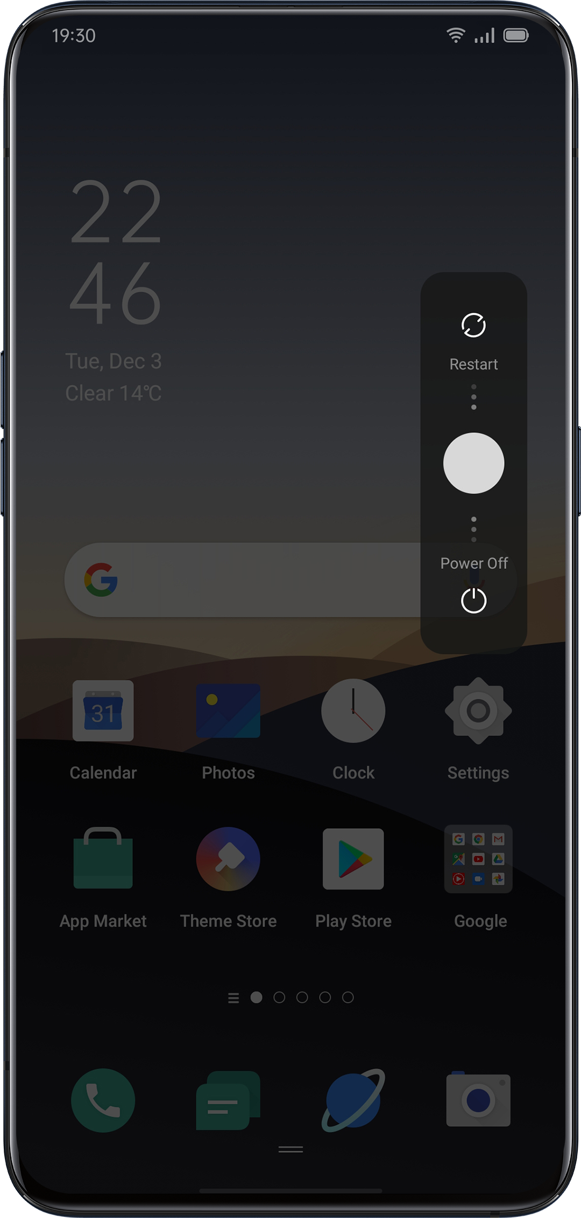

Privacy and Security
Manage the Information and Permission
Personal Information Protection
When an app reads personal information such as phone call history and contacts, the system will shield the authentic information to avoid information leakage.

Go to "Settings" > "Privacy" > "Personal Information Protection".

You can enable "Smart Protection Turn-on" to allow the system to determine on its own whether to turn on protection for new apps. You can also choose to turn on "Protect Call History", "Protect Contacts", "Protect Messages" and "Protect Events" by yourself.

Manage App Permissions
Enable "APP Permissions" to manage and set the permissions of each app, such as locating, dialing, acquiring calling history and more.

Go to "Settings" > "Privacy" > "APP Permissions".

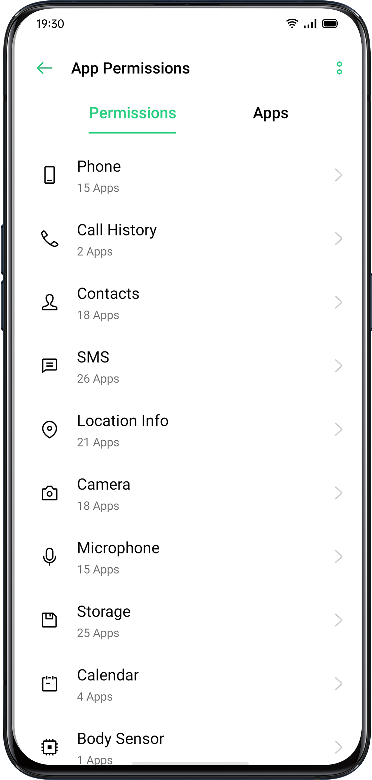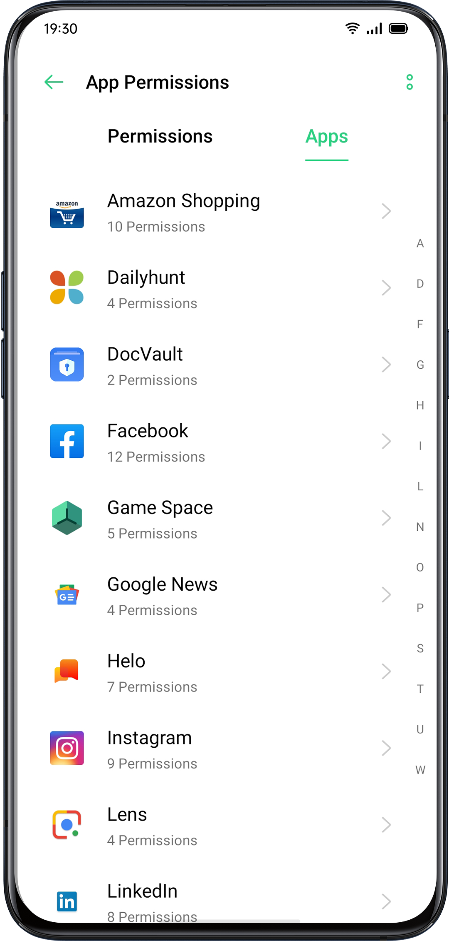

You could customize the permissions that allow some apps for particular functions, such as dialing, acquiring contacts and messages, using a camera. You can also set permissions for a single app.

Emergency SOSColorOS cares about users' personal security. "Emergency SOS" is a feature that is aimed to help you make emergency calls and send SOS messages more conveniently.

Turn On Emergency SOS:
Go to "Settings" > "Privacy" > "Emergency SOS".
After reading the terms and conditions carefully, tap "Agree".

Emergency Numbers:
Go to "Settings" > "Security" > "Emergency SOS" > "Emergency Numbers" > "Add Emergency Contact".

Police, Fire Police, and Ambulance are the 3 default emergency contacts set by the phone system. You can add up to 3 emergency contact numbers and send SOS messages with locations, pictures, and audio recordings.

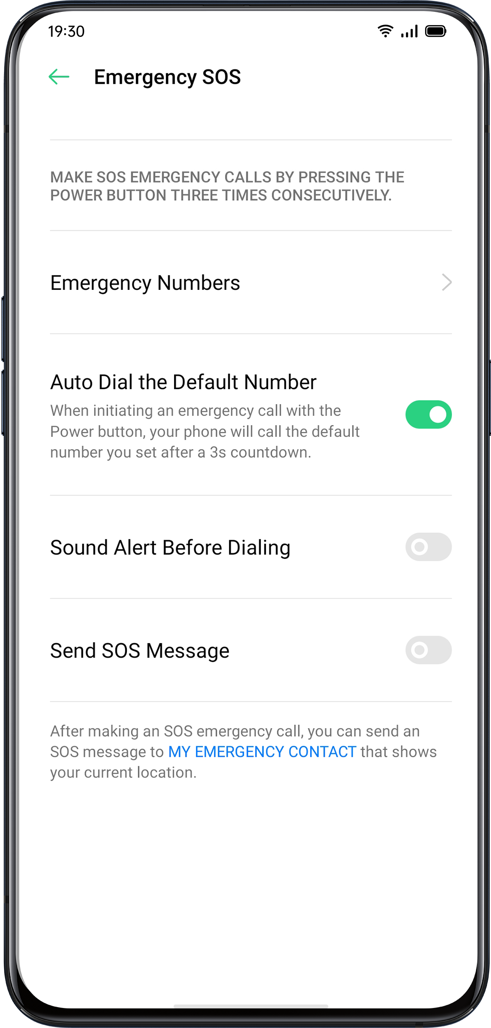
Initiate an SOS Emergency Call
- Press the Power Button 5 times in succession to initiate an SOS emergency call.
- Turn on "Auto Dial the Default Number" by pressing the Power button. An emergency call will be automatically dialed after a 3-second countdown.

Send SOS Message
When you enable "Send SOS Message", you can choose to send an SOS message to the emergency contact that indicates your current location, includes pictures of surroundings or a 5-second audio recording.

Privacy Password
A privacy password is used to protect your personal privacy. When Privacy Password is on, the passcode will be used for verification in App Encryption.

Set Privacy Passcode
- Go to "Settings" > "Fingerprint, Face & Password".
- Tap "Privacy Password" and click "Turn on Privacy Password".
- You can choose a pattern password, 4-bit, 6-bit, 4-16 bit digital password, or 4-16 bit alphanumeric password combination.
- After finishing responding to security questions, tap "Done" in the top right corner.
- You can also bind a security email address.

Modify Privacy Password
Go to "Settings" > "Fingerprint, Face & Password" > "Privacy Password".
Tap "Modify Privacy Password", enter the original password, and then set up a new password.

Reset Privacy Passcode
- If you forget your privacy password, you can reset it in three ways: answering security questions, entering verification code through the bound security email.

Tap "Forgot Password" to reset the passcode:
- Security Question: Answer the security question.
- Security Email: Enter the bound email address to receive verification code.

Turn off Privacy Passcode
Go to "Settings" > "Fingerprint, Face & Password" > "Privacy Password".
Click "Turn off Privacy Password", tap "Turn Off" and enter the original password.

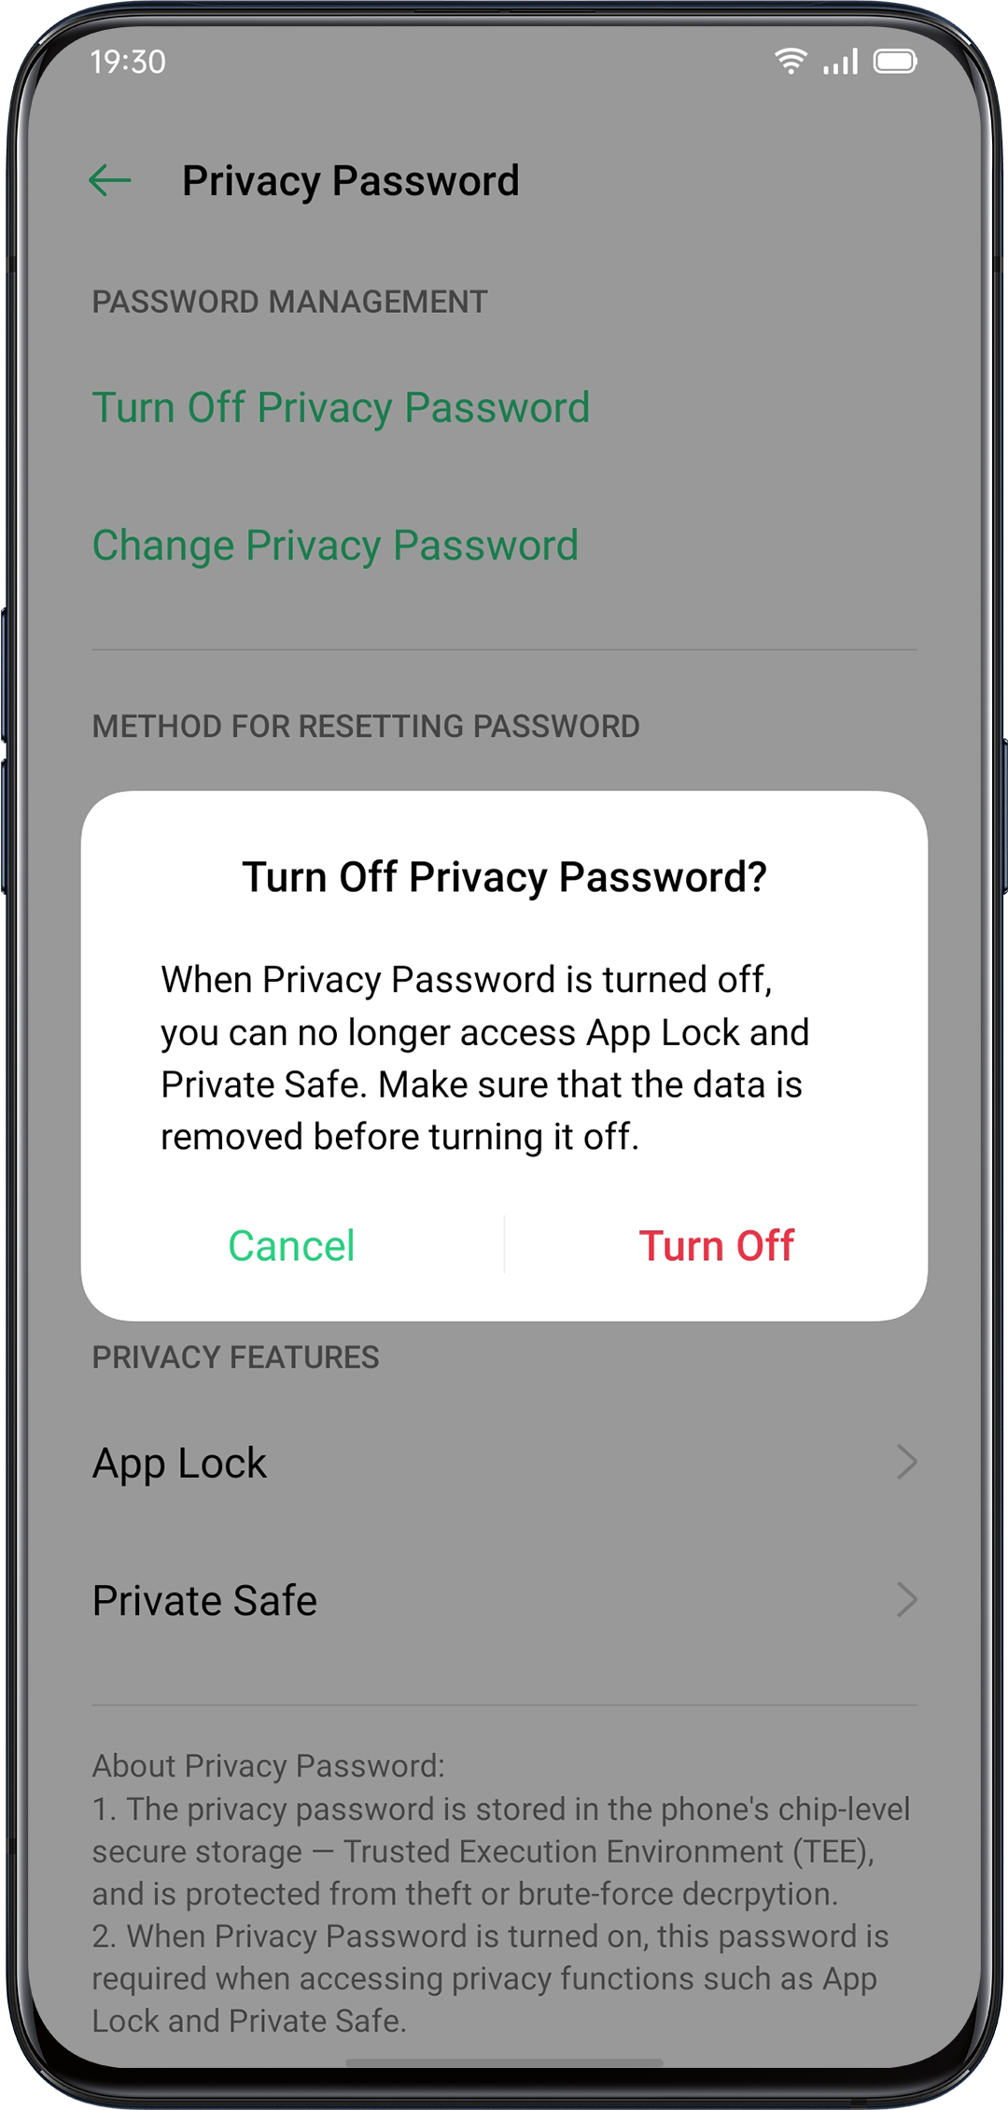

App Lock
You should set a privacy passcode before you use "App Lock".

Turn on App Lock
- Go to "Settings" > "Privacy" > "App Lock".
- Enter the privacy password.
- Select the apps that you want to be encrypted, and tap "Encrypt".

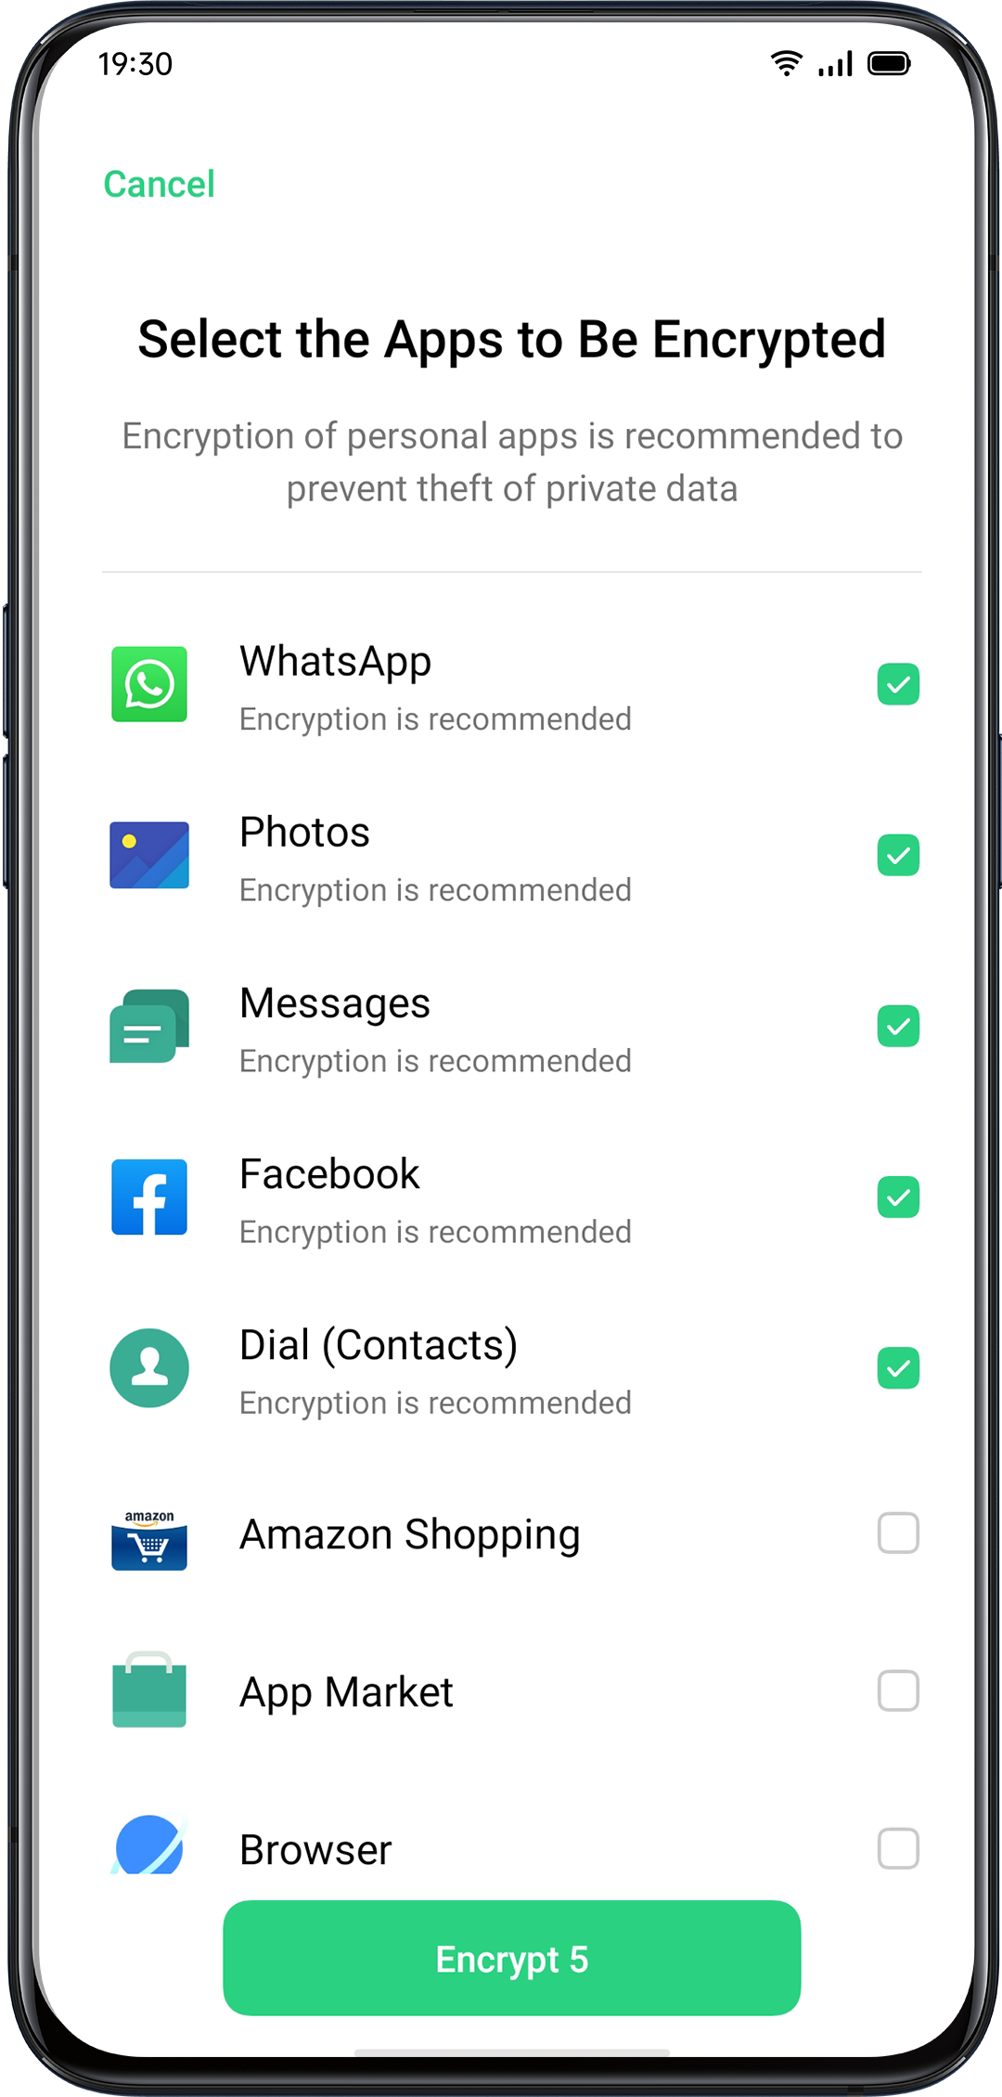

Access Encrypted Apps
- Access with a private password
If an app is encrypted, enter the correct privacy password to access the app.

- Fingerprint and facial recognition
You can also use fingerprint and facial recognition to open encrypted apps.

Go to "Settings" > "Privacy" > "App Lock".

After entering the privacy password, tap  to enter the "App Lock Settings", enable "Use Fingerprint for App Lock" or "Use Face for App Lock".

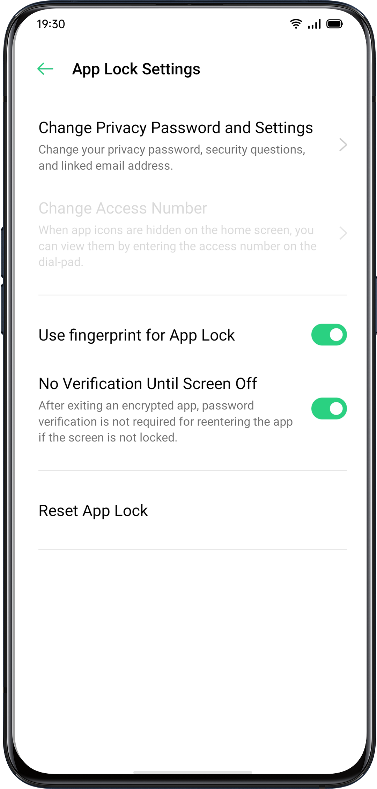
Turn off App Lock
- Go to "Settings" > "Privacy" > "App Lock".
- Enter the privacy password.
- Tap the app and turn off "Enable Password Verification".

Hide Home Screen Icons
- Go to "Settings" > "Privacy" > "App Lock" and enter your privacy password.
- Select the app icons that you want to hide in the Home screen, turn on "Enable Password Verification", then turn on "Hide Home screen Icons".
When an app icon is hidden, you can view the app by entering the access number on the touchpad. This does not require verifying the encryption passcode.

Access-Hidden Apps
Enter the access number on the touchpad to open the app. The access numbers begin with "#" and end with "#" which also contains 1-16 digits, such as # 0000 #.

Payment Protection
ColorOS provides you with a secure payment environment that ensures a safe environment for online payment.

When you use mobile payment, the system will automatically detect the current payment environment.

Payment environment checking includes:
- System Security Check
- App Security Check

Go to "Settings" > "Privacy" > "Payment Protection". Select the apps to be protected.

Harassment and Fraud Prevention
ColorOS protects users from phishing calls and messages by automatically blocking messages from the pseudo base and intercepting-suspicious calls.
Block Calls
Go to "Settings" > "Privacy" > "Block & Filter" > "Block Calls" or Go to  > Tap in the upper right corner > "Block & Filter" .

You can set call blocking rules by yourself:
- Block All Incoming Calls: You won't receive calls anymore unless there are calls from VIP contacts or white-listed numbers.
- Block Numbers that Begin with Specific Digits.
- Block Unknown Incoming Calls: Please be aware that when you turn this function on, you might miss some important phone calls.
- Block Unknown Numbers by Location-based Attribution: You can block numbers from specific locations.
- Block One-ring Incoming Calls and No-number Calls: This is for unknown numbers only.
Block Messages
Go to "Settings" > "Privacy" > "Block & Filter"> "Block Messages".
You can set the message blocking rules on your own.

Keywords for Spams
Messages from unknown numbers containing particular keywords that you have set will be recognized as spams.

Block Messages from All Unknown Numbers
All messages from unknown numbers that are not in your contact list will be blocked.

Blacklist
You will not receive any phone calls or messages from blacklisted numbers.

Add Blacklists
Go to "Settings"> "Privacy" > "Block & Filter" > "Blacklist".
You can enter numbers manually or select numbers from contacts.

Whitelist
Calls and messages from whitelisted numbers will not be blocked.

Add Whitelist
Go to "Settings"> "Privacy" > "Block & Filter"> "Whitelist".
You can enter number manually or select number from contacts.

Kid Space
In "Kid Space", you can:
- Customize usage duration that the kid is allowed to use the phone for each time
- Set apps that the kid is allowed to access
- Turn off Cellular Network

Enter Kid Space
Go to "Setting" > "Privacy" > "Kid Space".
After completing the customization in "Settings", tap "Enter Kid Space".

With Kid Space mode, users are only allowed to use the apps in the list of "Apps allowed to be accessed". Every time when the preset time is up, the mobile will be locked automatically. A passcode is then needed to unlock the phone.

Quit Kid Space
In Kid Space mode, tap "Quit Kid Space" on the bottom of the screen, and verify your identity to quit Kid Space.

Private Safe
Private Safe conceals photos, audio, documents, and other files. You can choose the files that you want to hide. Passcode, fingerprint or face are needed to access to files in Private Safe. You are unable to take screenshots after entering Private Safe.

Add Files
You can add files in the following ways.

Private Safe
Go to "Settings" > "Privacy" > "Private Safe". Verify the password, and select the files to be encrypted.

Encrypted File
Open "File Manager", press and hold the files to be encrypted, and tap "Set as Private" from "More" in the toolbar below.

Encrypted Photos
Open "Photos", press and hold the photos to be encrypted, and tap "Set as Private" from "More" in the toolbar below.

Access to Private Files
- Go to "Settings" > "Privacy" > "Private Safe" or access "Private Safe" via desktop shortcut.
- The encrypted files can be viewed after you verify with lock screen password, fingerprint or facial recognition.

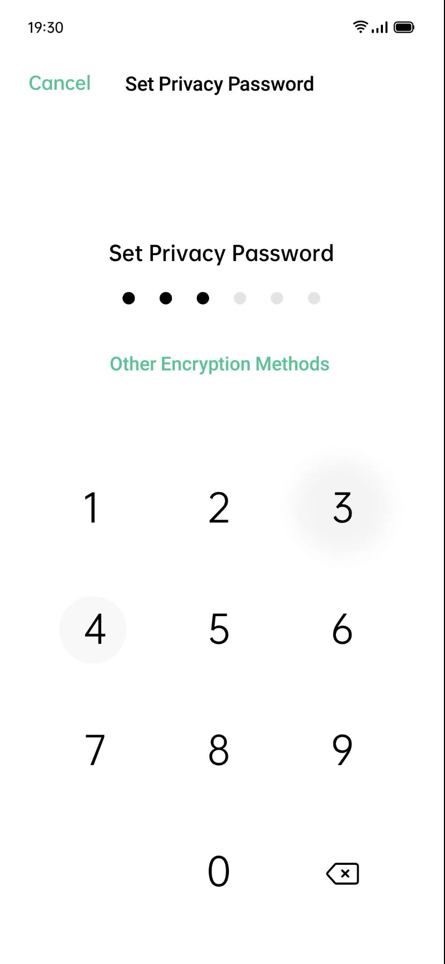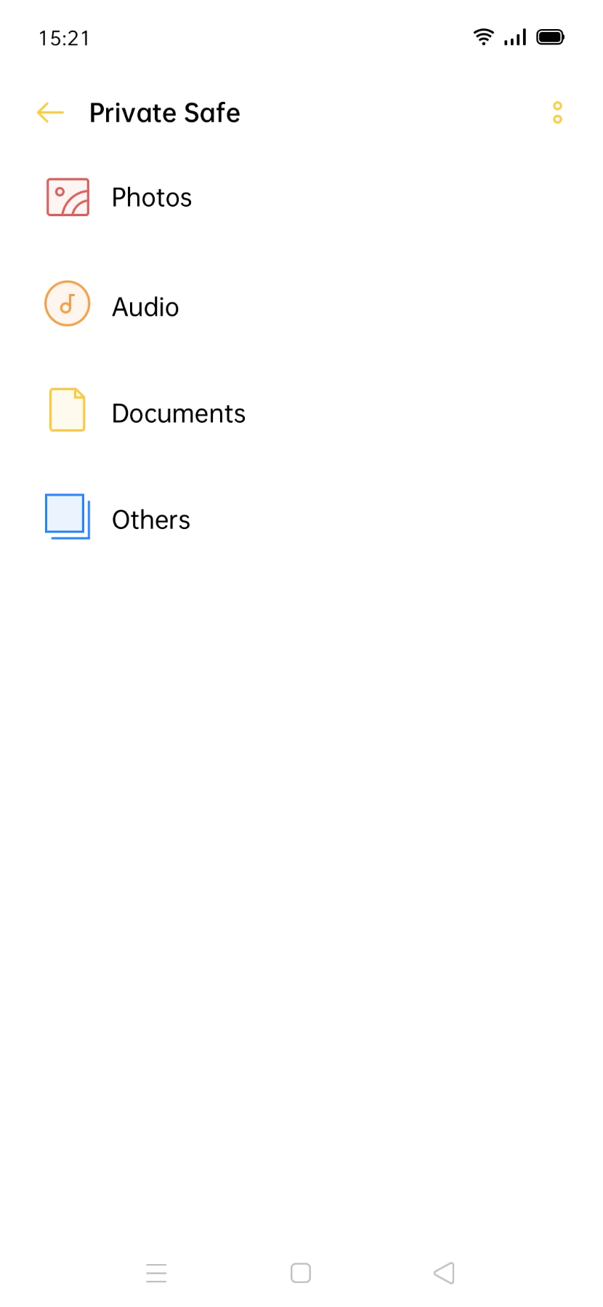

Add Private Safe to Desktop
- Go to "Settings" > "Privacy" > "Private Safe" and verify the password.
- Click the icon on the upper right corner to turn on "Home Screen Shortcut". You can access to "Private Safe" after creating a home screen shortcut.

Tools & Applications

Application Basis
Download and Install Apps
You can download and install different kinds of apps based on your needs and preferences to extend features of ColorOS and enhance user experience.
- Tap "App Market" on the Home screen.
- Search and select the app that you want to download, and tap "Install".
- After the app has been installed, tap "Open" in the app store or tap the app from the Home screen to open the app.

App Details

Select the app that you want to download and go to the introduction page to view more details, reviews, and recommendations of the app.

Switch between Different Apps
You can quickly switch to different apps and multitask with the help of applications run in the backstage.
- Swipe from the bottom of the screen to activate the multitasking interface.
- Browse all the apps in the interface and swipe left or right to switch the app.
- Tap "X" to close all the apps in operation.

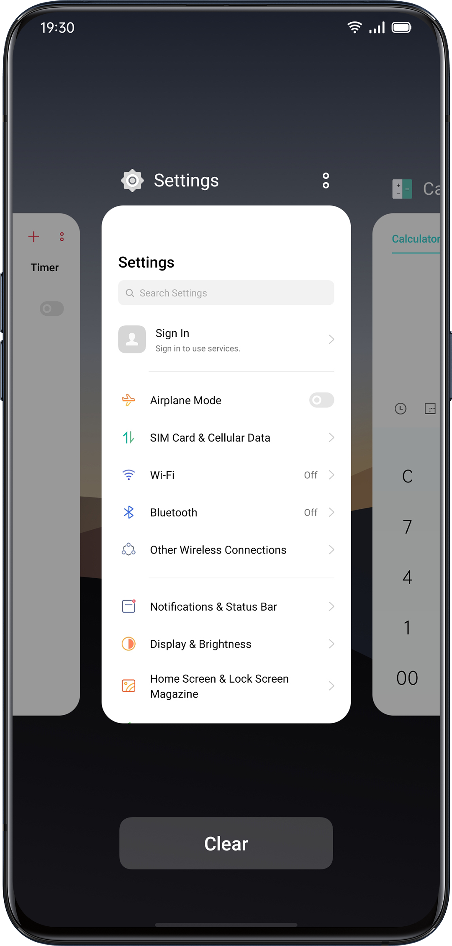
Move and Organize Apps
How to deal with apps that appear on the Home screen? You can organize and arrange them as needed.

Move Apps
Apps on the Home screen can be moved as you wish.
- Long press the app.
- Drag and drop the app to the desired page and location. Swipe either left or right to jump to another page.
- Move with the dock. The number of dots above the dock shows the number of home screens.
- Move multiple apps at the same time: Long press the blank area of the home screen to enter the editing mode. A selection box will appear at the top right of the app. Check the apps and move simultaneously.

Create Folders
Organize your apps by piling them into folders to make the Home screen seem tidier. It can be also easier to find apps.

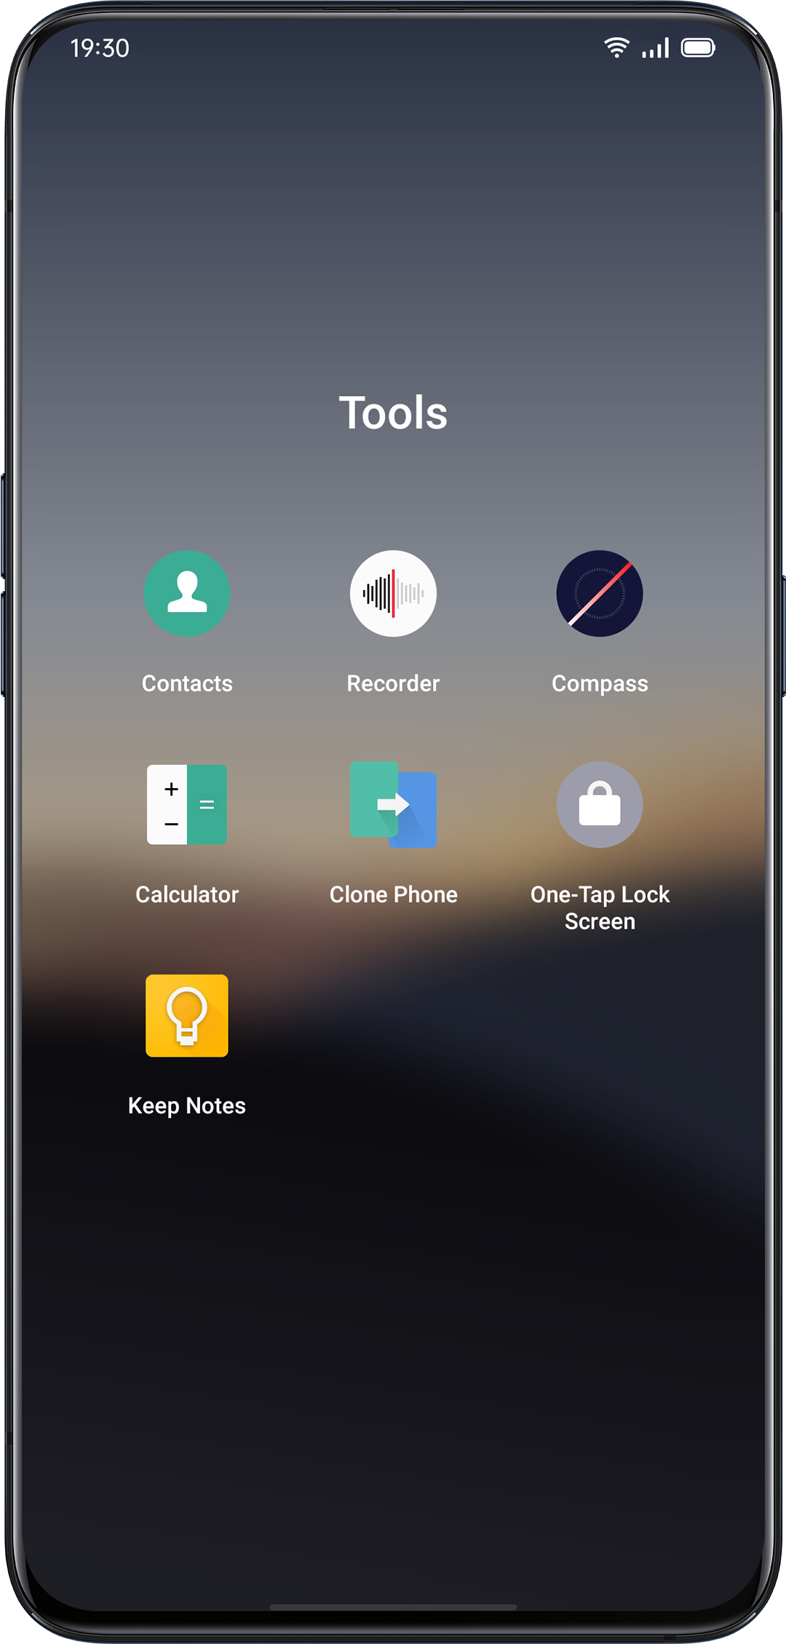
- Create a folder by moving one app icon atop another.
- Move the apps that you want to classify into the folders. One folder can include more than one page.
- To name a folder, tap the name bar to rename, then tap elsewhere outside the name bar to save the folder name.
- Delete the folder to move all apps out of the folder.

Delete Apps
You can remove unwanted apps at any time.

- Press and hold the app until a white box shows up, and then tap "Uninstall".
- A confirmation box will appear for you to ensure that you are going to uninstall the app. Tap "Uninstall" again to uninstall the app with all related data cleaned up.
Clock
Alarm Clock
If you need the phone to ring or vibrate at a particular time, you can set an alarm clock in the "Clock" app.

Create an Alarm Clock
- Open "Clock" and tap "Alarm" at the top of the interface.
- Tap  at the upper right corner to add an alarm.
- Set a time for the alarm and its label.
- Tap "Repeat" to set on what days in a week the alarm will ring.
- Tap "More", you can set different ringtones for the alarm.
- If you turn on "Snooze", the alarm will ring for the second time 5 minutes after you press the Power Button or turn off the clock, or the alarm rings continuously without being turned off.
- Tap "Save" after you complete the setting.

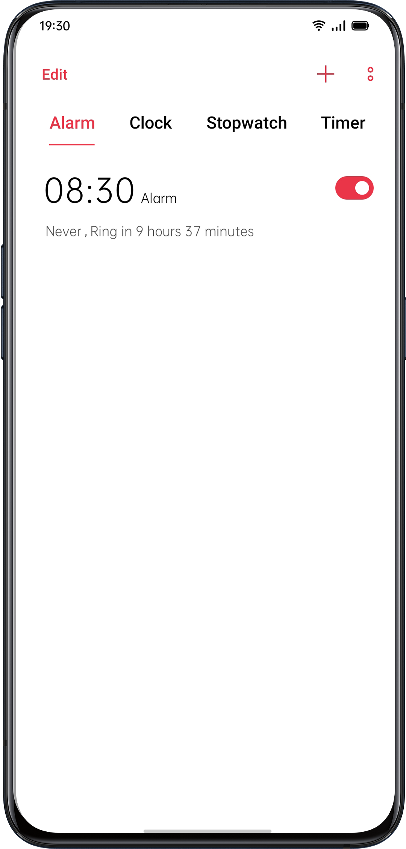

Edit or Delete an Alarm
- To edit the alarm, tap the corresponding alarm in the alarm list.
- The switch button at the right side of an alarm can be used to enable/disable an alarm.
- To delete an alarm, tap "Edit" at the upper left corner or long-press the corresponding alarm, select the alarm and confirm the deletion.
Set Vibration of a Specific Alarm
The vibration of a specific alarm will not be influenced by the vibration mode of your phone.

Turn on Alarm Vibration
Go to "Alarm" > Tap 「+」to add a new alarm > "More"> "Ringtone"> "Vibration".

Weather-Adaptive Alarm

The weather-adaptive alarm is new in ColorOS 7. Your alarm sound can now be adapted to the current weather. Start your day off right by learning about the weather conditions with a backdrop of melodious music.

How to enable: Tap an alarm, choose More, tap Ringtone, and enable Weather Adaptive.

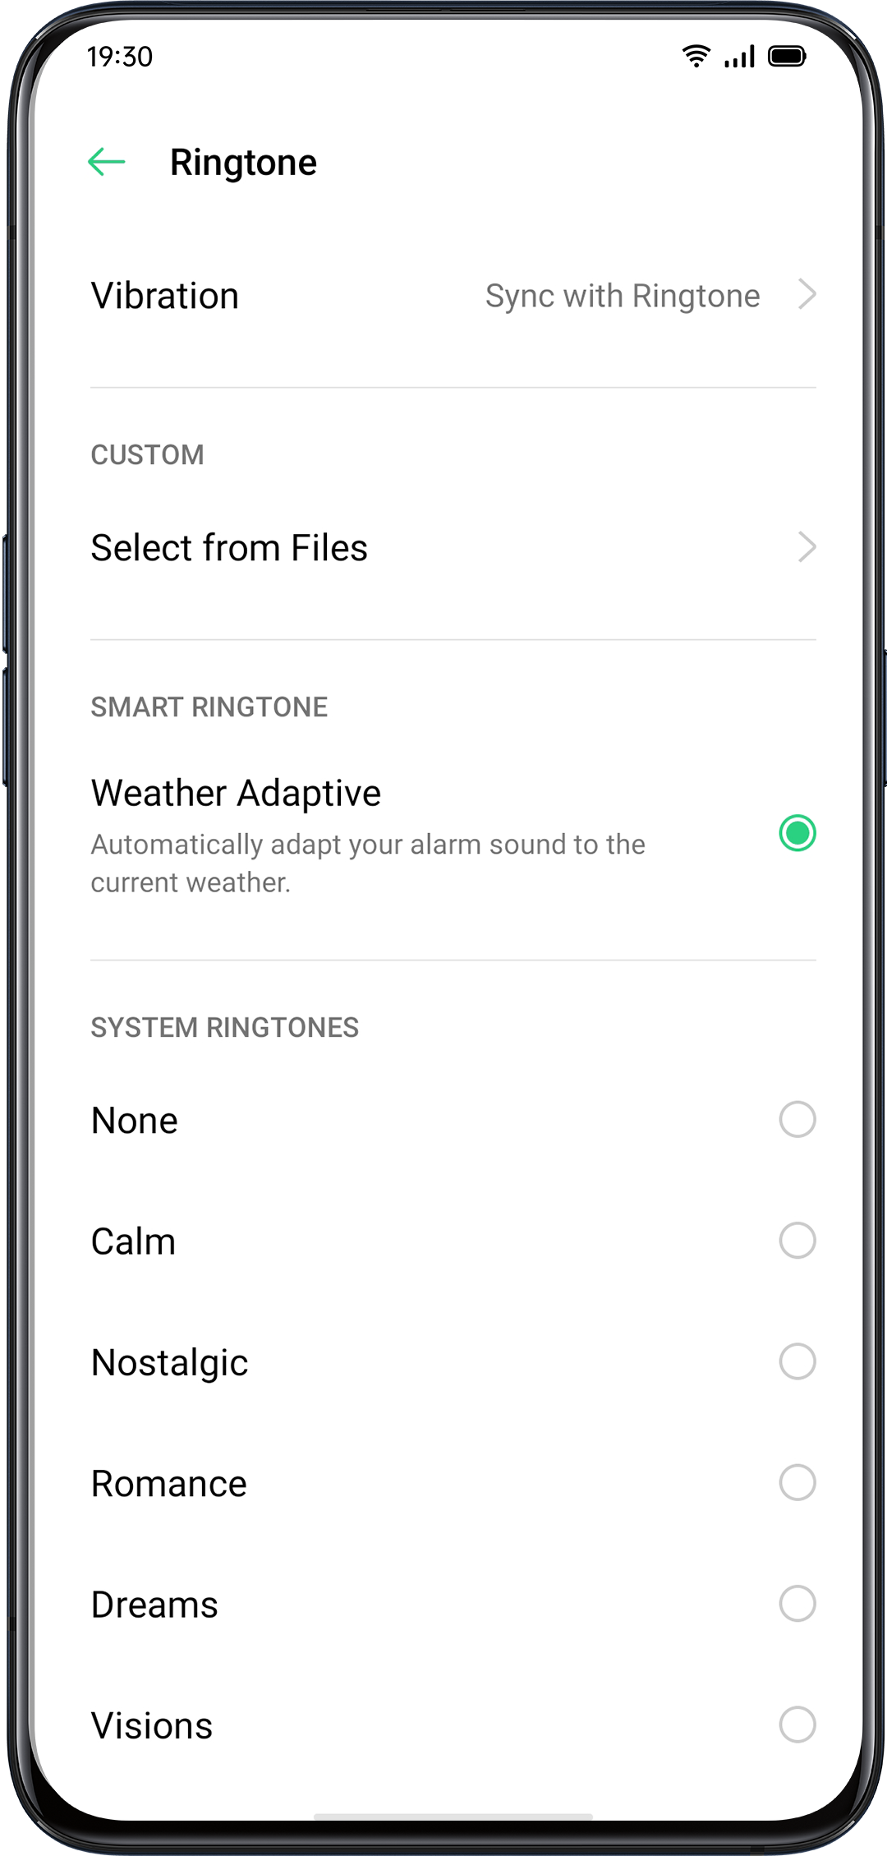

World Clock
Use the "Clock" to view the local time in different time zones.

Time Display Setting
- The 24-hour and 12-hour system
- Open the "Clock" app.
- Tap the icon on the upper right corner to enter the setting page, and tap "Date and Time".
- The phone clock will be displayed by default in the 24-four format. If the 24-hour format is turned off, it will be then displayed in the 12-hour format.

- Automatically Set Date & Time
- Open "Clock".
- Tap the icon on the upper right corner to enter settings, and tap "Date and Time".
- Turn on "Use network-provided time", and the phone will automatically calibrate the time when it is connected to the network.

- Time and Time Zone
- Open "Clock".
- Tap the icon on the upper right corner to enter settings, and tap "Date and Time".
- After turning off "Use network-provided time", you can change the time zone and time by yourself.

Add Time Zone Clock
- Open "Clock".
- Tap on the upper right corner to search different cities, countries or municipalities.
- Tap to add the local time of that location to the Clock.
- To delete the local time, tap "Edit" at the upper left corner or long-press the corresponding clock and tap "Delete".
- To add the world clock to your desktop: Long press the home screen, tap "Add Widgets" and drag the world clock to the home screen.

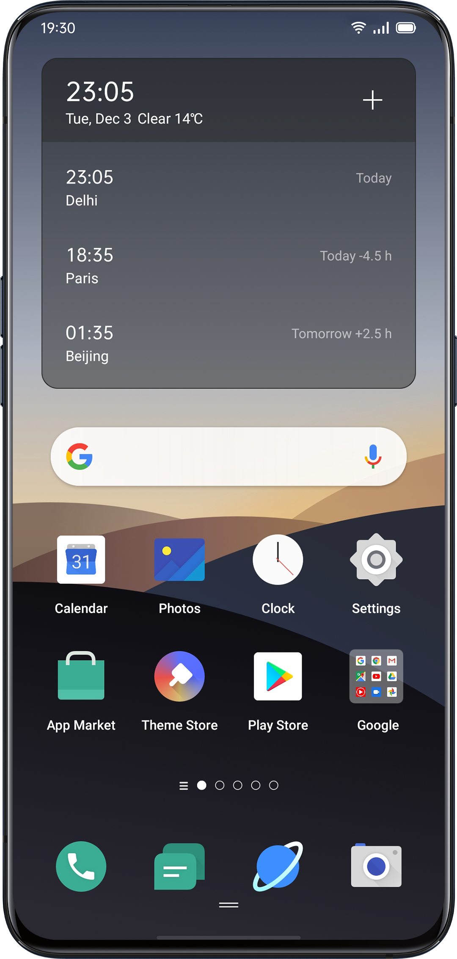

Set Dual Clock
- How to open Dual Clock
Open "Clock" and tap the icon on the upper right corner to enter settings.
- Tap "Date and Time", then tap to turn on "Dual Clock".
- After turning on the "Dual Clock", the lock screen or clock widget will display the time in two different time zones when you are away from the place of residence.

- Place of Residence
- Tap "Date and Time", then tap "Dual Clock".
- Tap "Usual Residence" to select the city of residence after authorizing the weather function to access to a network.

- Where to find Dual Clock?
- Tap "Date and Time", then tap "Dual Clock".
- Tap "Display Dual Clock on" to choose whether to enable the lock screen and the clock widget to display Dual Clock.

Stopwatch
Use Stopwatch
- Open "Stopwatch". Tap "Start" to start counting seconds. Even if you open other apps at the same time, the stopwatch will continue working.
- To record laps or split time, tap "Lap".
- Tap "Stop" after recording, and tap "Reset" to clear records.

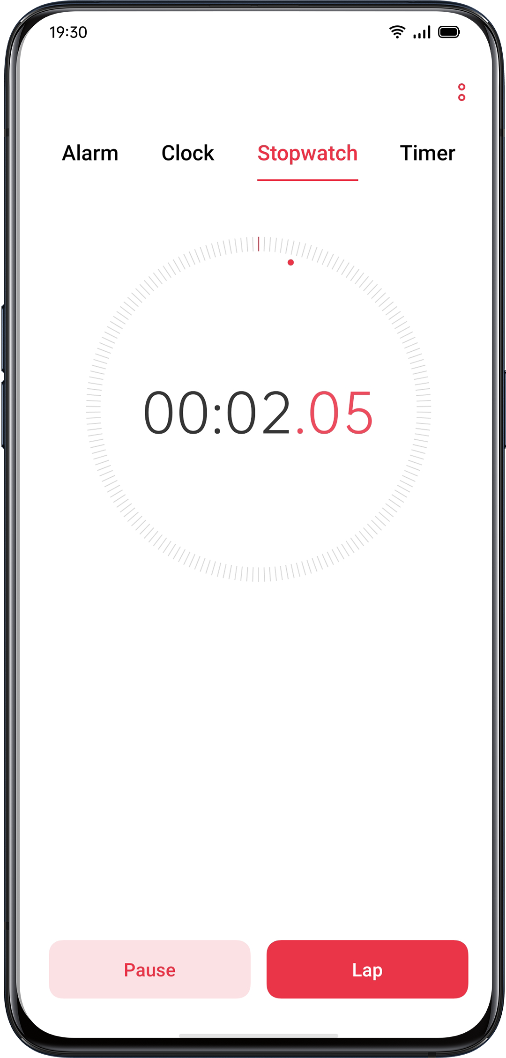
Timer
Use Timer in the Clock app to set a countdown for multiple events, making it easier to better manage the time.

Set Timer
- After setting the countdown time, tap "Start".
- You can pause the countdown by tapping "Pause", and exit the countdown by tapping "Cancel".

Preset Common Items
- System default
There are three preset timing items in the system, including Brush Teeth, Face Mask, and Steam Eggs. Select the timing item and tap to start the countdown.

- Personalized preset
You can also set up a personalized countdown item as needed. To add a timer, tap [+] below it.
For example, set a timer labeled "Study" with a "20 minutes" countdown, and tap "Save".
You can delete unwanted timers by tapping "Edit" at the top left corner and tapping the personalized timer.

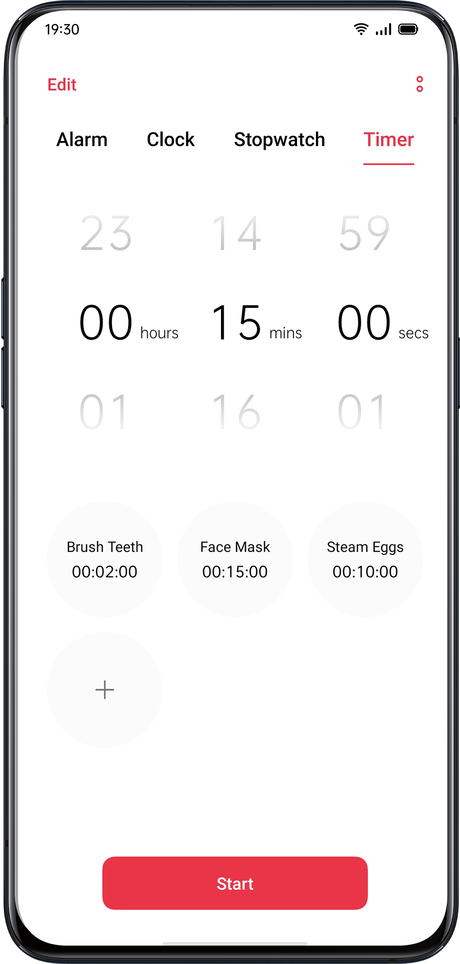

Weather
Get real-time weather information for different cities.

Authorization to Acquire Location Information
The screen shows you local weather information when the Location Info is acquired.

View Current Weather and Weather Forecast
View current weather and weather forecast for your current location or the other cities.

- View Current Weather: Open "Weather", the screen will show the local weather.
- View Hourly Weather: Pull down the screen, swipe left or right to view the hourly weather during the day.
- View Weather Details: Pull down to the bottom to view air quality, visibility, UV, humidity, and more.
- Weather Forecast: Tap "15-Day Forecast" and go to the "China Weather" page to see more weather information.

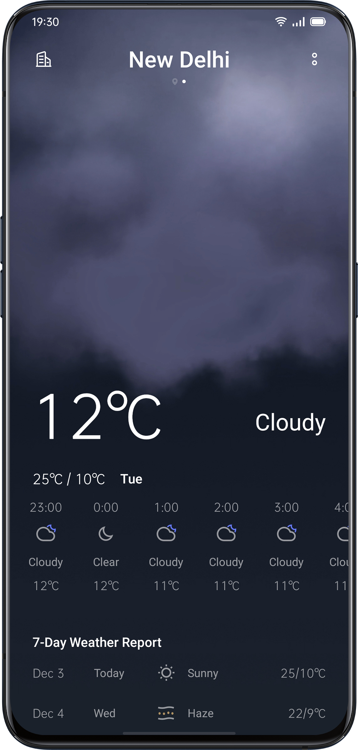
View Weather in Multi-Cities
View weather in multiple cities to better manage your trip.
- Go to the "Weather" app, click on the building icon at the top right corner, and choose "City Management".
- Click  at the top right corner, enter the name of a city, and enter the page of city weather.
- Swipe left to right to switch cities and view weather information for different cities.
- Delete a city: Go to "City Management" > "Edit", select a city, and then tap "Delete".

Calculator
In "Calculator", you can add, subtract, multiply, and divide. You can also do maths in exponential functions, logarithmic functions, trigonometric functions, etc., as well as online exchange rate, length, area, volume, speed, weight, temperature, power, pressure, and other unit conversions.

Numeric Calculation
Basic Calculation
- In "Calculator", you can perform basic calculations such as addition, subtraction, multiplication, and division.
- Tap (C) to clear the numbers in the current display.
- Slide the keypad down to see history records of calculation.

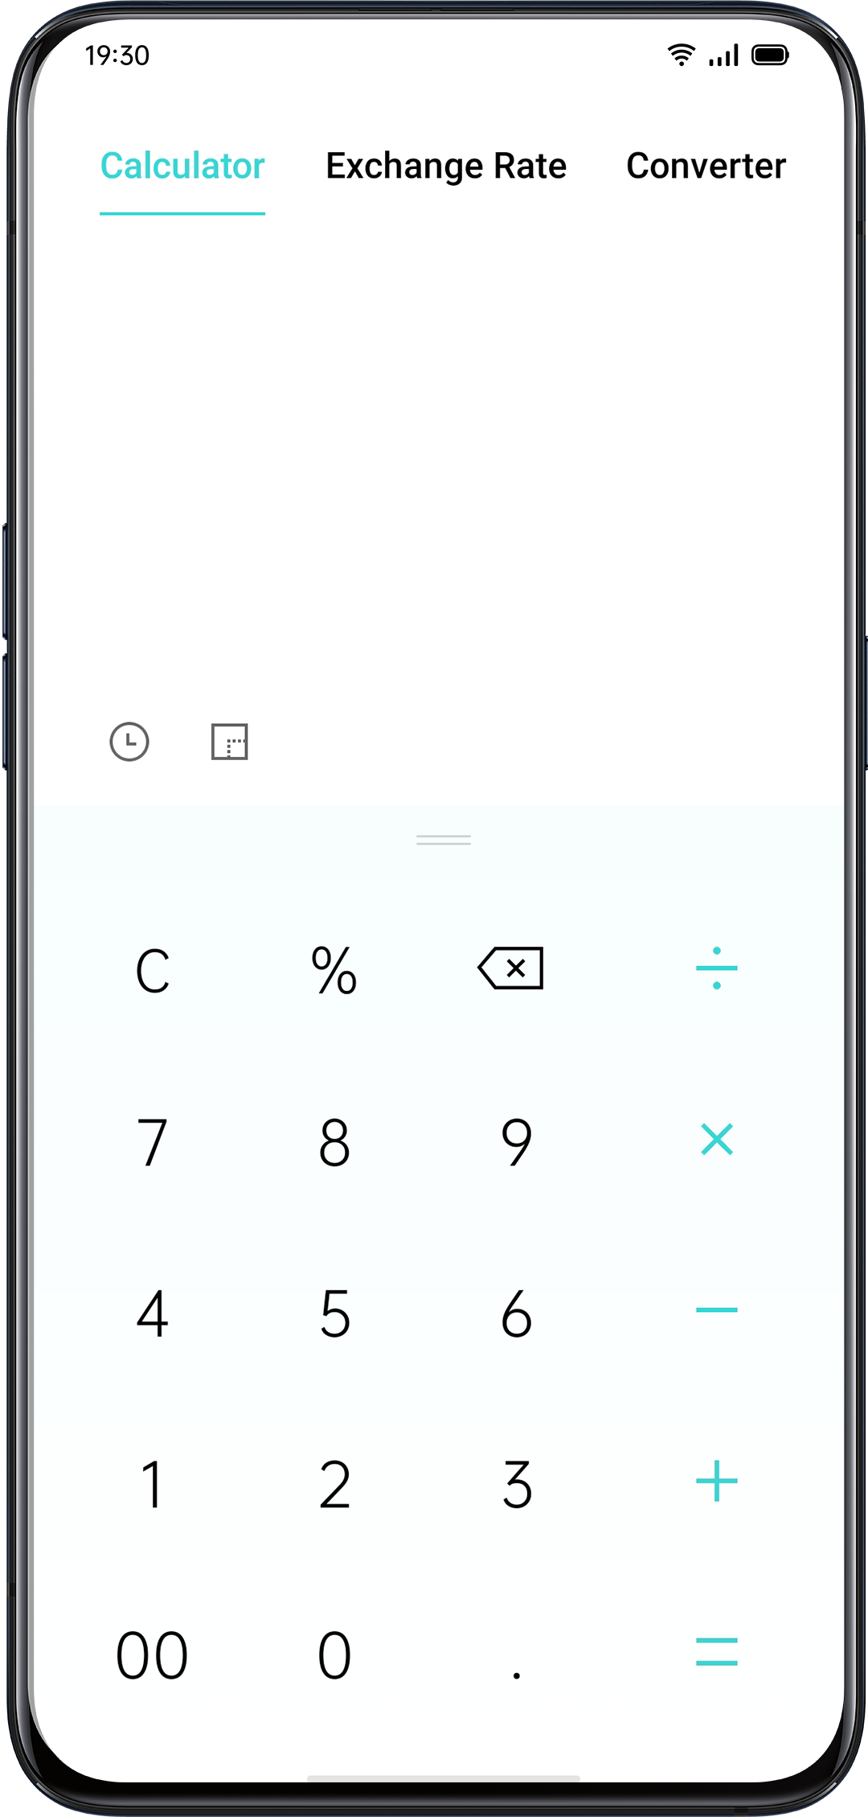

Scientific Calculation
Tap  to enter the scientific calculator mode.

Online Exchange Rate Conversion
In "Exchange Rate", you can easily convert between different currencies. The online exchange rate conversion apply the latest data from Webull.
Press and hold the calculation result to copy it to the clipboard.

More Unit Conversion
Tap "More" to make unit conversions such as length, area, volume, speed, weight, temperature, power, and pressure.

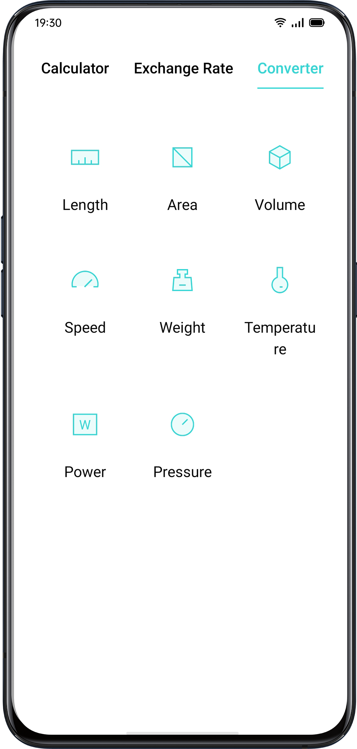

Compass
Use "Compass" to navigate, display direction, and check latitude and longitude.
Calibrate Compass
Calibrate "Compass" before you use it for the first time. Swing your phone while you stay away from the interference sources to calibrate the compass.
View the Direction of Where Your Phone is Pointing at
Use "Compass" to help you navigate the direction.
- Place the phone horizontally to have access to longitude and direction.
- View direction: The lower area around the compass will indicate the direction where the phone is pointing at.
- View latitude and longitude: The bottom of the screen will indicate the latitude and longitude of your current location.

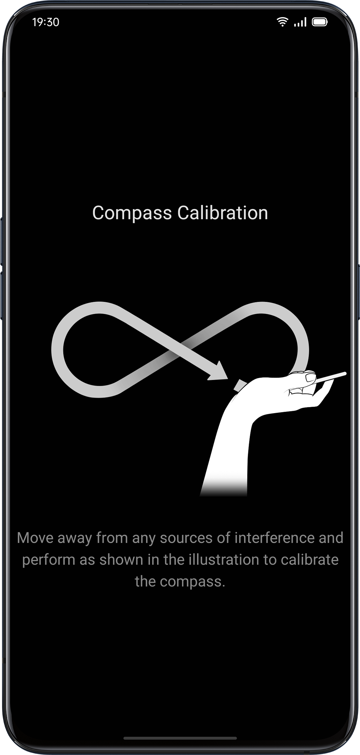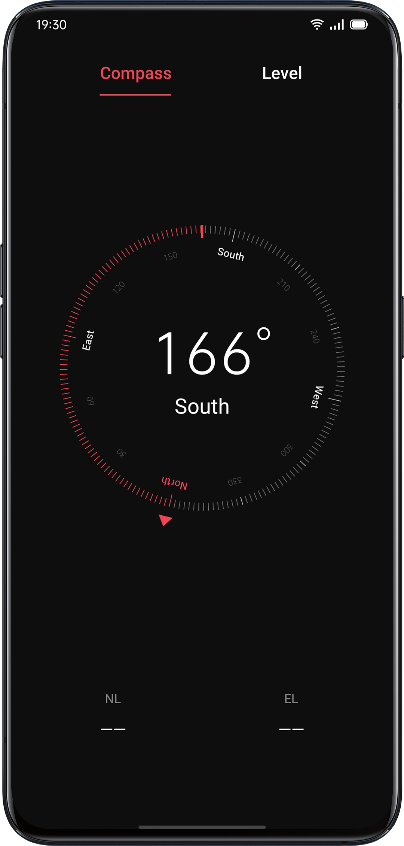
Phone Calls
Make a Call
Making a call by selecting a number in your contacts, or tapping one of your favorites or recent calls.

Dial Manually
- Enter the number in the keypad, then tap .
- Tap the input field above the keypad, tap "Paste" to paste a number to the keyboard, then tap to make a call.

Make a Call to Your Contacts
Add someone in your Contacts, make a call by searching the name from Contacts.
- Open "Call" > Go to "Contacts".
- Tap "Name Card" in the Contact.
- Select the number that you want to dial in the Name Card and tap .

Call Back
The phone keeps the recent calls, tap the number to call back directly.
- Open "Call" > "Phone" to view recent calls, tap the number to call back.
- Tap  after a number to view the detailed information about the call.

Manage Incoming Calls
You can answer, mute, reject the incoming calls, or simply respond with text messages.

Mute Calls
If you do not want to be disturbed by incoming calls, you can mute all phone calls.

- Tap "Mute" when a phone call rings.
- Press the "Lower Volume" on the left side of the phone to mute the phone calls.
- In the mute mode, you can still answer the call while you have not rejected the call.

Respond with SMS
You can reply with SMS if you reject a call.

- Go to "Call" > "Seetings" > "Reject with SMS".
- You can quickly respond to the incoming calls with a default text message. You could also customize the texts on your own.
- When your phone rings, tap "Message", and select a default response or click "Customize" to write a text message by yourself.

Call Forwarding
When you are unable to answer the call, you can transfer to another number.

- Go to "Call" > "Seetings" > "Carrier Call Settings" > "Call Forwarding".
- Select a call forwarding condition such as "When busy", "When unanswered" and "When unreachable", and enter the number to activate the call forwarding.
- Call forwarding service will be varied as it is based on by the carrier.

Call Waiting
You cannot answer the other calls if you don't hang up on the ongoing call. Turn on "Call Waiting" to get a notification when there is an incoming call.

- Go to "Call" > "Seetings" > "Carrier Call Settings" > "Additional Settings" > "Call Waiting".

Multi-Operations During a Call
Adjust the Audio
You can make some adjustments regarding audio during answering a call.
- Adjust the volume: Press the volume button on the left side of the phone.
- Mute: Click the 
- Hold: Click 
- Speaker: Click 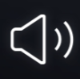

Initiate a Conference Call
Depending on the carrier, you can initiate a conference call with multiple contacts.
- During a call, tap to add calls. Then go back to the current call, dial another number, and click "Merge Calls".
- During a conference call, you can choose to talk to a specific number or hang up a number.
Use Other Apps During a Call
You can also use other apps when you're answering a call.
- During an ongoing call, go to the Home screen and open other apps.
- Click the icon 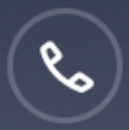 at the top of the screen to return to the call.

Call Recording
When you use ColorOS 7, you can record a call if you need to keep the audio recordings.

Call Recording
If you need to record a call, tap  before or during a call.
After initiating the call, click and the button will be switched to "Recording Standby" in green color.

Auto Recording
You can also set auto-recording rather than record calls manually.
- Go to "Call" > "Seetings", and tap "Call Recording" .
- If you need to record audio from specific numbers, tap "Record Specified Numbers" .
- Select numbers from "Calls", "Groups" or "Contacts" to add to the Auto-record list.
- Tap > "Edit" in the upper right corner to delete the numbers that you do not want to record automatically.
- Turn on "Record All Unknown Numbers", your phone will automatically record all unknown phone calls.
- Turn on "Record All Calls" to record every phone call.

Check Call Recordings
After recording the call, you can play, share, or delete the recording or set the recording as ringtone.
- Go to "File Manager" and tap "Audio" to find all saved call recordings.
- Click "Select" in the upper right corner to select recordings to be cut, copied, deleted, or set as private, etc.

Recordings Storage Limit
There is no storage limit for call recordings in ColorOS 7. Otherwise, you can also set a limit for recording storage on your own for better usage of the phone.
- Go to "Call" > > "Seetings".
- Go to "Call Recording", click "Maximum Recording" and select the items to save the call recordings.

Identification of Unknown Numbers
Go to "Call" > > "Seetings" > "Identification of Unknown Numbers" > "Online Identification of Unknown Numbers".
When "Identification of Unknown Numbers" is enabled, you can accurately identify unknown numbers from incoming calls, call history and messages and then mark them as fraud or harassment, etc. When disabled, unknown numbers can only be identified using the local phone number database.

MessagesSend and Receive SMS
Start Conversation
You can talk to one or more than one contact in "Messages".

- Go to "Messages", click  at the top right corner.
- Enter recipient number directly, or click  at the right side of the input field to select contacts from "Calls" "Groups" and "Contacts". You can add multiple contacts at one time.
- Enter SMS Messages at the bottom of the screen, and then click  to send the messages.

Search Messages
Messages will be automatically saved to the message list, which it will be more convenient for you to search for messages at any time.

- In the message list, you can tap the name of a contact to view conversation history.
- If there are too many messages on the list, you can type keywords in the search bar to find corresponding content.

Message to Call
You can make a call to the recipient from a text conversation by tapping the number at the upper left corner.

Send Pictures, Videos, and Audios
You can send pictures, videos, and audio messages via SMS and MMS.

Send Pictures
- Tap in the bottom left side of the screen, and click  to select pictures from "Photos".
- Click  to take photos.
- You can view or delete pictures in the input field after selecting pictures to be sent.
- Click to send pictures.

Send Videos
- Tap in the bottom left side of the screen and click .
- Click "Select Videos" to select the videos stored on your phone.
- Click "Take Video" to shoot the video clips.
- You can play or delete videos in the input field after selecting the videos.
- Click to send videos.

Send Audios
- Tap in the bottom left side and click .
- Tap "Record Audio".
- Click the red button at the bottom of the screen to start recording. Tap ✔ after recording.
- You can play or delete videos in the input field after you select the audios.
- Click to send audios.

View Pictures, Videos, and Audio Messages
- Video messages can be viewed directly from the message list. Images and audio messages will be displayed as the website links.
- Tap a message and open the link to view the picture or listen to the audio message.
- Click "Save" to download the image or audio.

Send a Namecard
You can share a contact name card to a recipient in "Messages".

- Tap in the bottom left side and tap .
- Select "Text" (name and number), select a contact from "Calls", "Groups" or "Contacts", then click "Add". Click to send the text name card.
- Select "vCard "(full version of the name card) , select a contact, and then tap "Add". Click to send vCard.
- Click vCard will be displayed as a website link. You can view and download the vCard in the browser.

Delete and Block Messages
Delete Messages
You can delete messages either one by one or delete them in batches.
1. Press and hold a message to copy, share, delete, or add to Favorites, etc.
2. Long press a message to repost, delete or add to Favorites in batches.

Delete Conversation
You can delete the conversation with contacts.
- In the message list, find the conversation that you want to delete.
- Press and hold the texts, and tap "Delete Conversation".

BrowserBrowse the Web
View a Website
When you use the OPPO browser, the following operations can help you navigate the website link.
- Open a Web page: Search or enter an URL, or view the Bookmarks/History.
- Refresh the Web: Click the refresh icon next to the search box.
- Swipe Screen to Navigate: Go to "Settings" > "Swipe Screen to Navigate" to swipe left to go back to the previous page or swipe right to move forward to the next page.

Switch Browser ID (UA)
If you want to view the PC version of the web, you can change the Browser identification (UA).
- Go to "Settings" > "Browser Identification (UA)".
- Web pages are unable not be automatically adapted to the mobile display after switching to the PC version of UA

Share the Web Page
Tap "Share" to share the current web page with your friends.
- Tap "Share" at the bottom of the browser.
- Copy the URL to the clipboard or share the link directly to Messages, Gmail, Facebook, etc.

Pictureless Mode
Viewing pictures via a cellular network may consume data. Enable the "Pictureless Mode" to save data.
- Tap "Pictureless Mode" at the bottom of the browser.
- In Pictureless Mode, images will be displayed when Wi-Fi is on, while they will not be shown under cellular networks.
Browse Tabs
You can use browse tabs while viewing multiple websites.

Add New Tabs
Tap "Multi-Window" and tap to add a new tab.

View Tabs
- Tap "Multi-Window" to view all tabs that are in display, which are shown in the shape of cards.
- To view a single tab, tap the card.
- Tap the Back button to view the current website.

Close Tabs
- Tap the tab icon at the bottom to view all open tabs.
- To close the tabs, tap  in the upper right corner, or swipe either left or right on the tab.
- To close all open tabs, tap "Close All" on the left of the browser.

Search
In the OPPO browser, enter a URL or keywords to search websites or information.

Quickly Access Copied Content
- Go to "Setting" > "Quickly Access to/ Search of Copied Content".
- Search keywords or copy an URL, the browser will show the latest content in the clipboard. Tap "Search" and go.

Find in the Page
- Long press anywhere in the blank area, then tap on the option that pops up as "Find in the Page".
- Tap "Find in the Page" and search the keywords. The related content will be highlighted in blue color.

Search Engine
- Go to "Settings" > "Search Engine" to select the search engine that you want to use with.
- OPPO browser provides four search engines: Goggle, DuckDuckGo, Yahoo, and Bing.

AD Blocking
If you don't want to see ads while browsing webpages, you can enable "AD Blocking".
- Go to "Settings" > "AD blocking", enable "AD Blocking" and "Blocking Reminder".
- While viewing a webpage, long-press the blank and click "Block AD" to add the webpage to "Blocking Management".
- Go to "Blocking Management", and tap "Edit" at the upper right corner to delete blocked sites.
Private Browsing
You can customize OPPO browser settings to protect privacy.

Clear Data
Go to "Settings" > "Clear Data".
You can choose to clean input data, history, cached webpages, cookies or other data.

Traceless Browsing
- Go to "Settings" > "Traceless Browsing". Your browsing will not generate any viewing data.
File Manager
There may be many files on the device. "File Manager" helps you find files efficiently and conveniently.
Quick File Sorting
File Manager will automatically detect and sort files. Files will be displayed as "Audio", "Video", "Photos", "Document", "APK","Downloads","Cloud Drive" and "Recommended Apps".

Quick File Sorting can be accessed in the quick-sort entry on the Home page, where files are managed through a simple-and-easy interface. For example, all images are displayed in "Photos".

Tap "Recents" to see recently used files.
Folder Manager
Tap "Phone Storage" to manage files through a hierarchical view in the folder.

ColorOS will automatically identify if a file is created by the app and its file type. The folder attribution will be marked at the right of the file name.

For example, the "Recordings" folder will be marked as "Recordings" where there are all audio files recorded by the "Recording" app.

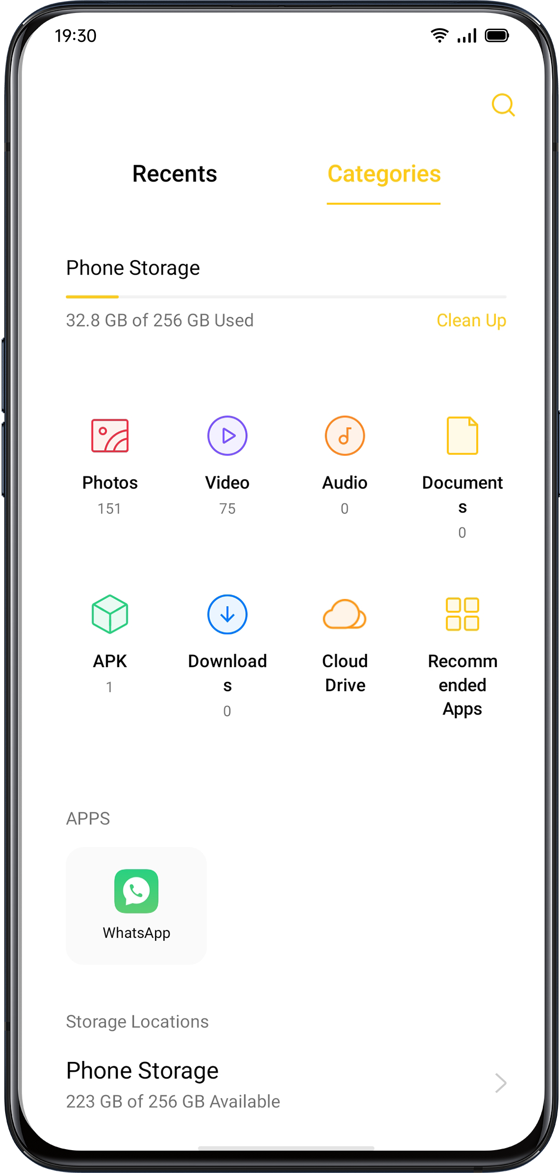

Set as Private
You can set a file as private, private files will not be displayed in File Manager. You must go to "Private Safe" to view it.

Long press to select the file. Click "More" > "Set as private".

To access the private safely, press and hold "Recents" or "Categories" , or you can add a shortcut to Private Safe to your desktop to access it later.

You need to set a privacy password before using Private Safe for the first time.
Go to "Settings" > "Fingerprint, Face & Password" > "Privacy Password".

Phone Manager"Phone Manager" is a security and optimization center. It provides useful tools such as Virus Scan, Clean Storage, Privacy Permissions, etc.

Examine and Optimize
After entering the "Phone Manager", the system will automatically detect and score the overall operation status.
Tap "Optimize" at the bottom of the score to optimize the system.

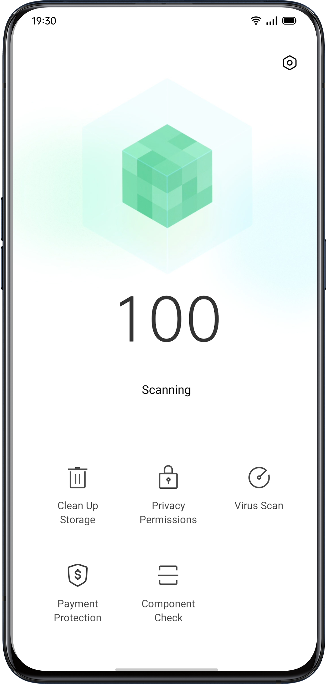
Clear Up Storage
"Clean Up Storage" is an efficient and instant method to clean up the storage of your phone.
You can also access through "Settings" > "Additional Settings" > "Storage" > "Clean ".

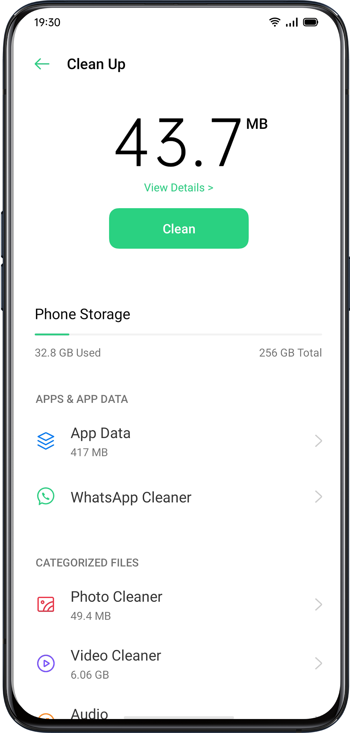

The system will automatically analyze the file type, and categorize the apps cache, advertising cache, redundant installation packages, and uninstall the residues for system optimization.

Privacy Permissions
Tap "Privacy Permissions" to view and manage permission for each app. For example, some apps need to have access to "Use Camera" .
Proper control of the app permissions is able to optimize power consumption and also avoid privacy disclosure and financial loss.

Virus Scan
Tap "Virus Scan" to initiate automatic virus scanning and detect the alleged malicious apps and files. If found, tap the icon below to clean the malicious apps and files.
Go to "Phone Manager" > "Settings" > "Virus Scan Engine". You can choose different antivirus software to scan the virus.

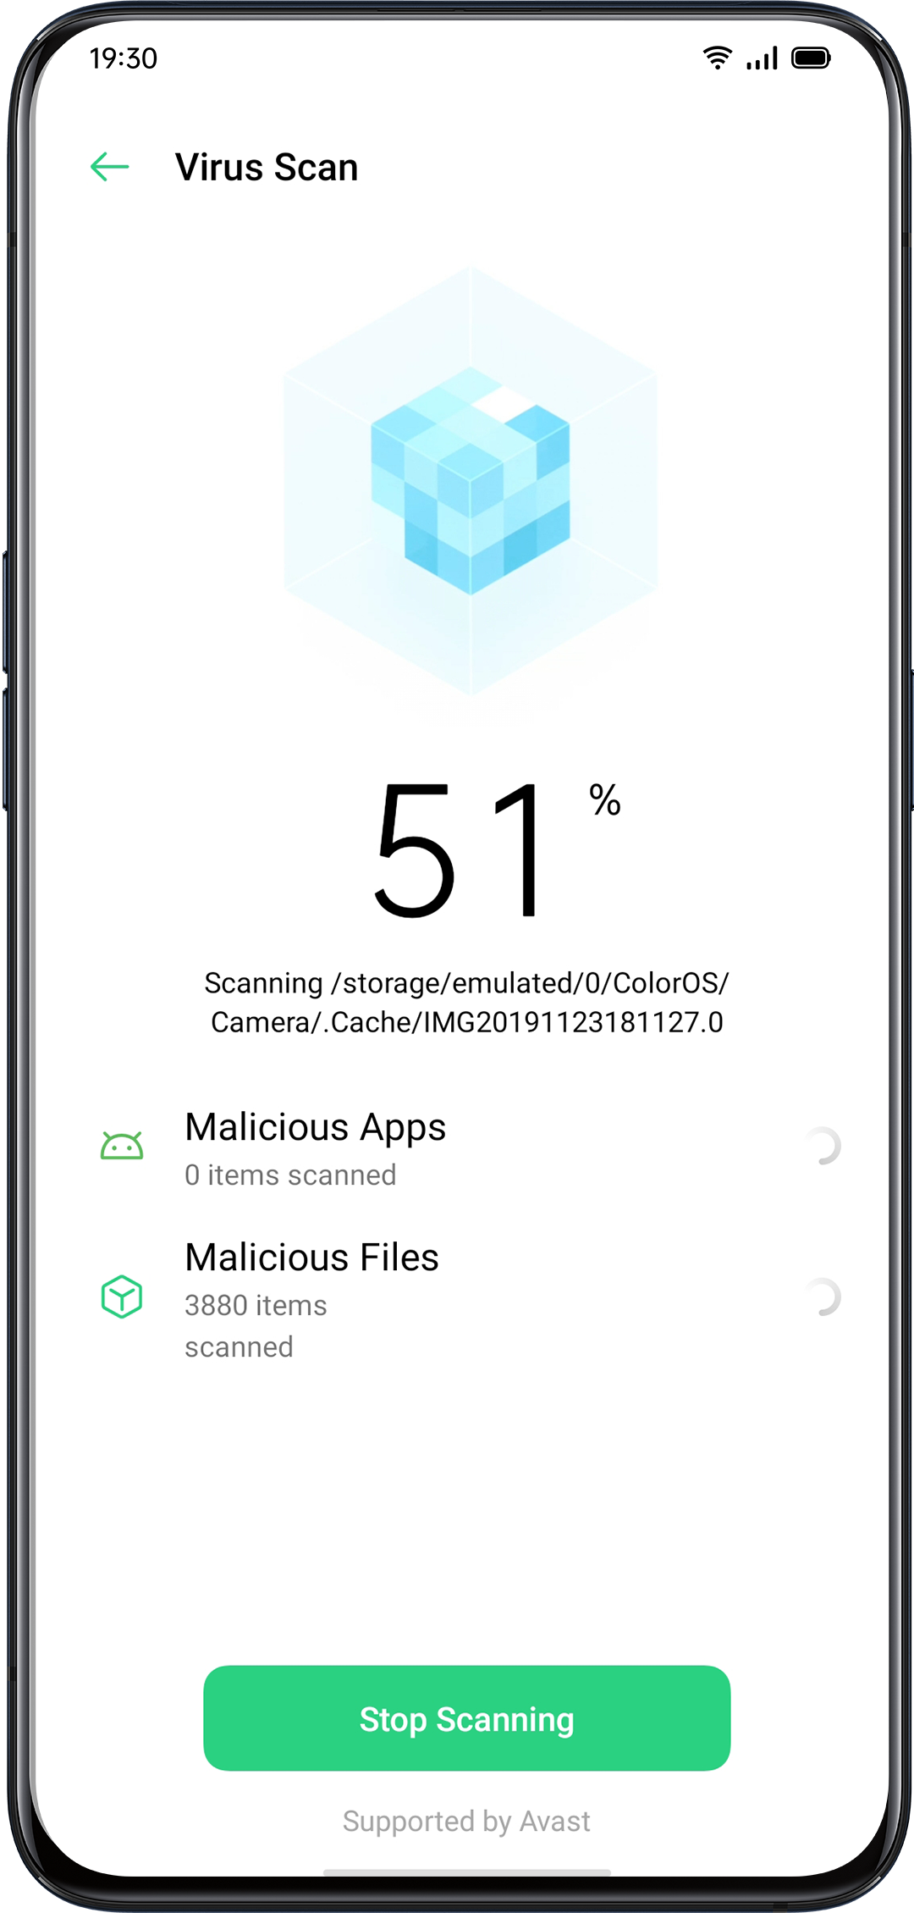
Payment Protection
Payment Environment Check
Tap "Payment Protection" to initiate an automatic system security check. For instance, the payment environment check will identify whether the system has been updated with the latest security patches, whether the current network connection is reliable, whether there are malicious applications, etc. Make sure to pay or manage your personal property only when there's a secure payment environment.

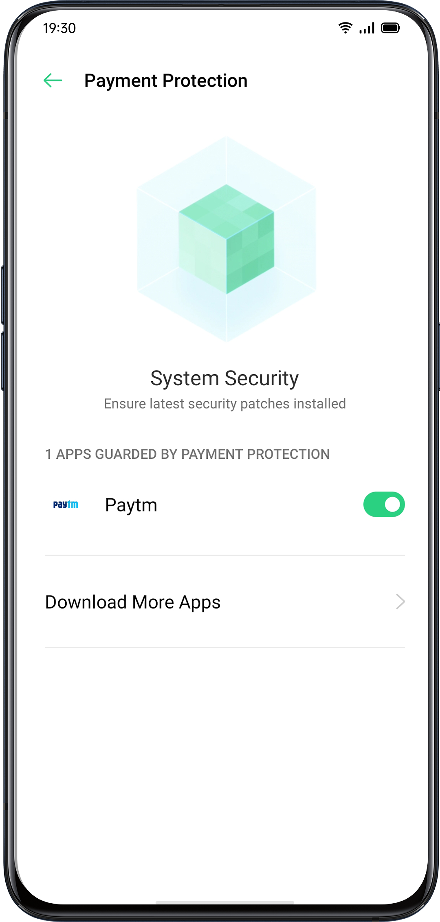

Apps Guarded by Payment Protection
"Payment Protection" will secure mobile payments, internet banking, stocks, and other apps to prevent third-party apps from detecting the safety status of your phone, which may ensure your payment process to be private and guard your personal property.

Component Check
"Component Checkt" is equivalent to the safety examination center of a mobile phone, as a way to detect the potential security risks as well as the breakdown in both software and hardware.

Run Test
- Tap "Start Check" to start the test.
- During the detection, you can choose to skip some items.
- After the test, a test report will be generated indicating if the phone's current hardware and software are functioning well.
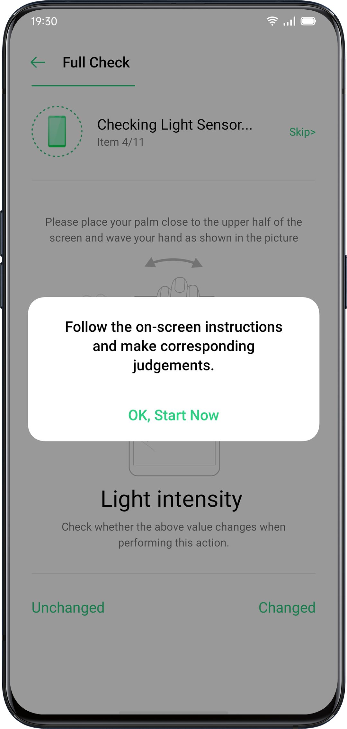

Test Records
Click "Records" to view the previous test report.
Theme StoreIn the "Theme Store", you can download and change themes, wallpapers, ringtones, as a way to customize your phone.
Purchase / Download Resources
You can search the theme name, style, color and designer in the search box at the top. Otherwise, you can view the available items in the Store.

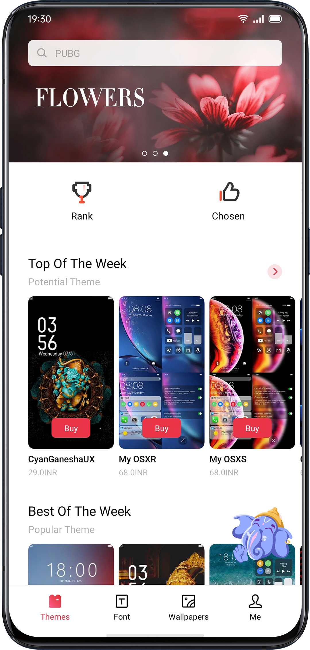
Set the Theme
Enter "Theme Store" > "Me" > "My Resources" to view the themes that you currently have.
Themes are divided into "System Themes" and "Downloaded Themes".

A full set of "Themes" may include diverse elements from the lock screen, interface, home screen wallpaper, to icons and others. If you want to merely change some of the elements, enter a theme and choose "Apply the Theme to".

Set Wallpaper
Enter "Theme Store" > "Me" > "My Resources" > "Wallpapers" to view wallpapers that you currently have.Wallpapers are divided into "System Wallpapers" and "Downloaded Wallpapers".

Tap "Apply" to set the wallpaper as "Lock Screen Wallpaper" "Home Screen Wallpaper" or both of them.

You can also set images in "Photos" as the wallpaper.
Go to "Photos" or "File Manager", select a picture and click "More" to set it as wallpaper.

App Market
"App Market" is an official platform to install and manage various apps. You can download apps that you need in App Market.

Apps in App Market are free of charge. However, some of the app developers may set a restriction for some specific functions in the app and charge it. It should be noted that it is the developer who charges the fee.

If you remove App Market accidentally, go to https://store.oppomobile.com/ to reinstall.
You will see some recommended apps on the home page, namely "Home". Enter the keywords in the search box at the top to search for some related apps.
Banner
You will see the latest updates recommended by App Market shown up in the banner.
Games
Selections
View, reserve, and install recommended games.

Categories
You can search games in different categories based on your preferences, such as action, adventure, arcade and more.
Apps
Selections
View, reserve, and install recommended apps.

Categories
You can search apps in different categories based on your preferences, such as Beauty, Business, Comics and more.
Top
App Market also provides you with the top downloaded apps to give firsthand updates, including "Updated" "Trending" "New" "Hot Search".

My Information
Tap "General" at the bottom to view personal information, help, feedback, and more.
Manage Personal Info: You can edit your name, alias, date of birth and more.
Manage Apps: You manage installed apps and view app updates.

Music Party
"Music Party" allows you to play music using more than one device simultaneously.
Create a Party
- Enter "Music Party" > "Create a Party".
- Select the connection mode from "Connect via personal hotspot" or "Connect via Wi-Fi", and then tap "Next".
- You will then receive a QR code, allowing your friends to join the party by simply scanning the QR code. Tap "Done" to finish pairing.
- Tap "Add Songs" to select songs from your devices.
- Tap the icon in the upper right corner to view the party QR code, and then manage the playlist or exit the party mode.
- Tap to view the devices that have joined the party mode.

T83
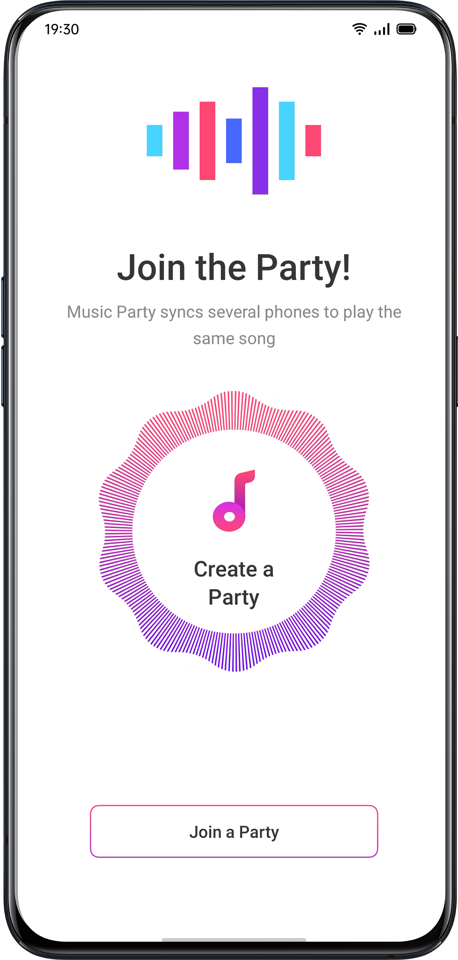
Join a Party
If you want to join a music party, enter the "Music Party", tap "Join a Party" and scan the QR code to join the party. Tap in the upper right corner to exit the party.

RecorderYou can use the built-in microphone to record various audios, including daily conversations, lectures, interview or calls.
Standard Recording
Tap the Red Dot at the bottom of the main interface of Recorder.
If switch to other apps while recording, the recording will continue in the backstage. To return to "Recorder", tap the red bar at the top of the screen or slide down to open the notification center and tap the ongoing recording task.

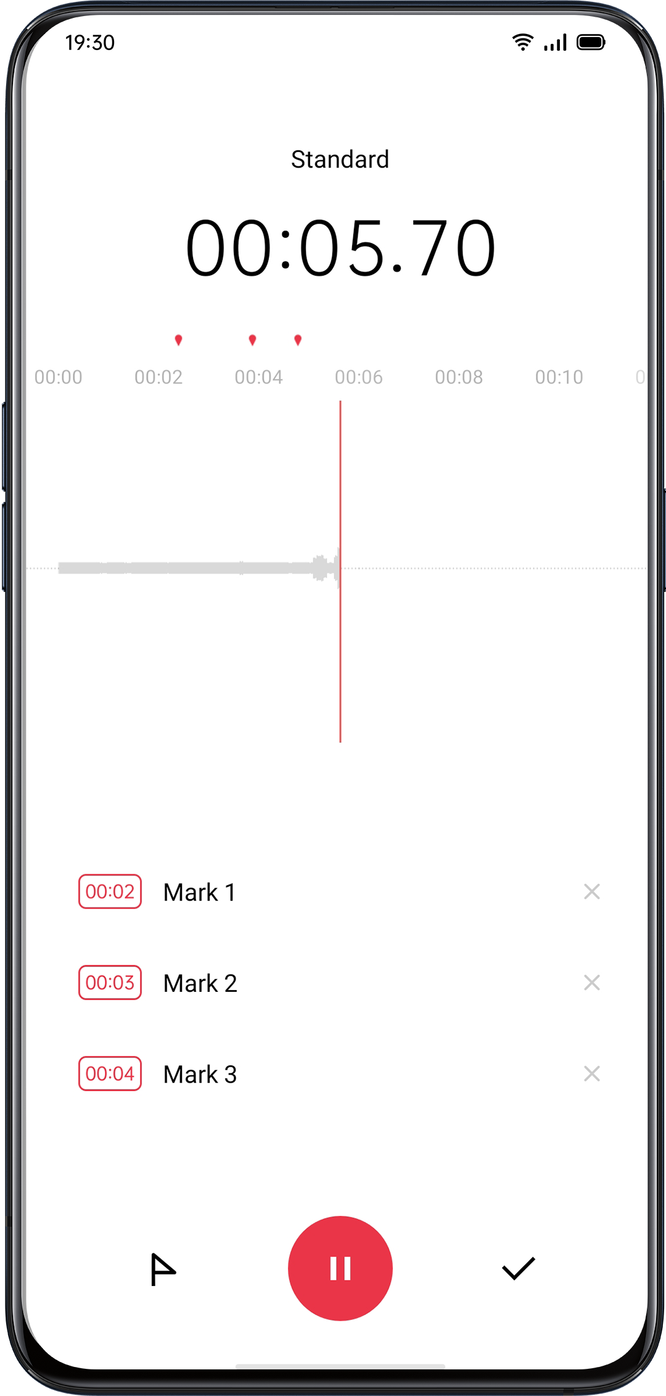
Meeting/Interview Recording
You can also choose to record in either "Meeting Recording" or "Interview Recording" mode. These modes are optimized for special usage scenarios to create better recording results.
- Meeting Recording: It is suitable for conferences where there are multiple participants. The enhanced vocal recording effects can be used to record clearer voices of people.
- Interview Recording: It is suitable for dialogue scenarios. Place the top of the phone toward the interviewer and the bottom to the interviewee, to use the microphones at both ends to record the conversation.

Audio Manager
- The recorded audios will be stored in "File Manager" > "Audio", the default name of the recording is referred to as "REC+ Recording End Time".
- Long-press an audio file to share, rename, cut, and more.

Mark Recording
- Tap the name of a recording to enter the detailed playback interface with waveform and progress.
- Tap "Flag" on the left side of Play/Pause to mark the important time points.
- The default name of the marked recording is set as "Mark + Number". To rename the mark, tap the icon on the right.
Screen RecordingColorOS has a built-in screen recording tool that allows you to record videos, game graphics, and operation steps, which can be shared on social media with your friends.

Start Screen Recording
From Control Center
- Slide down from the top notification bar to open the Control Center.
- Click in the upper right corner.
- Tap  and the recording will start automatically within three seconds.
- You can tap and drag up to the notification bar for easier access to screen recording.

Start Screen Recording in the Entry of Smart Sidebar
- Go to "Settings" > "Convenience Aid" > "Smart Sidebar".
- Swipe smart sidebar and click "Screen Recording" to start recording the screen.
Screen recording will be automatically stopped and saved when the video file reaches the maximum size of 5GB. Meanwhile, the screen recording process will be also terminated if you lock the screen, make a call or shut the phone down. The recordings will be saved to "Photos" in MP4 format.

Screen Recording Settings
Go to "Settings" > "System Apps" > "Screen Recording".

- Video Resolution: You can switch video resolutions between 480P and 720P. If to set the video resolution as 480P, the file can be smaller, though the quality can be lower.
- Record Screen Taps: Taps on the screen will be recorded to show the detailed operations, as a way to better illustrate how you operate on the phone.
- Front Camera: Your face will be recorded and shown up on the screen in the form of a small circle, which fits well for those who live-broadcast the game playing.
One-Handed ModeYou are able to zoom in the screen to fit one-thumb operation when you enable the one-handed mode. The one-handed mode allows you to text with a single hand, especially when you have to carry something heavy or take the public vehicles.

- Slide down the screen to open "Notification Center", tap  to unfold all icons.
- Tap to activate One-Handed Mode.

After the One-Hand Mode is turned on, tap the buttons on both sides to switch between the screen near the lower left or near the lower right corner. Tap the button at the top of the screen to exit One-Handed Mode.

Focus ModeImmerse yourself in your work or studies with Focus Mode. In Focus Mode, your phone plays soothing ambient noise and blocks calls and notifications to help you stay focused on the tasks at hand.

Entering Focus Mode
Go to the Control Center, and choose Modes > Focus Mode.

Setting the Focus Period
You can set the focus period ranging from 5 minutes to 180 minutes at the center of the screen. During the focus period, all applications are hidden and disabled, and all messages and notifications are blocked.
Selecting the Focus Atmosphere
You can select one of four soothing environments, Ambient Sounds, Wheat Field, Waves and Summer Night, listed beneath the focus period.

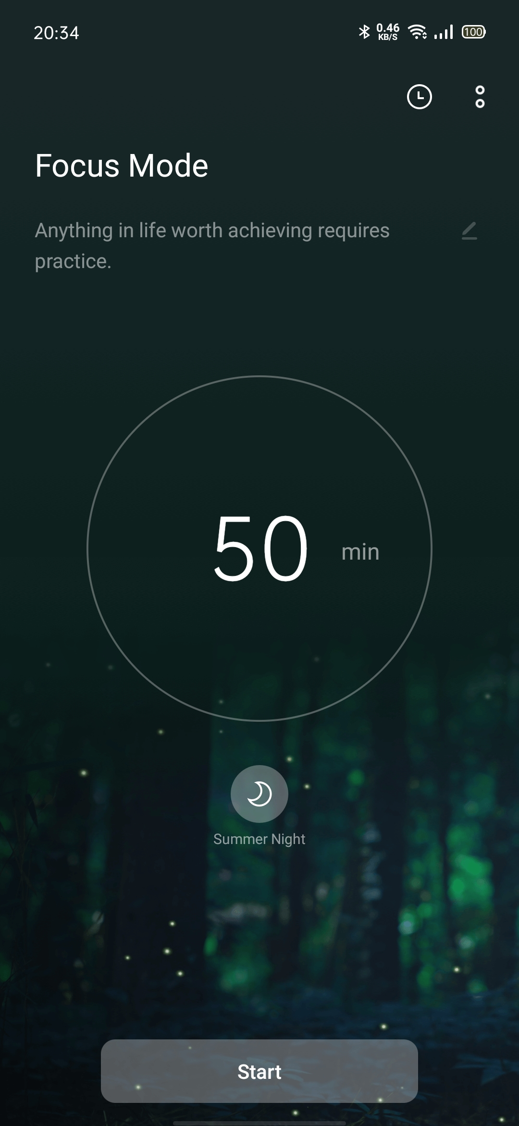
Customizing Focus Schemes
You may tap the icon on the top of the screen to customize a focus scheme and encourage yourself to stay focused.
Viewing Focus Statistics
Tap the icon in the upper right corner to view Focus Statistics, including the length of time and number of times spent focusing today, and the length of time and number of times spent focusing in total.

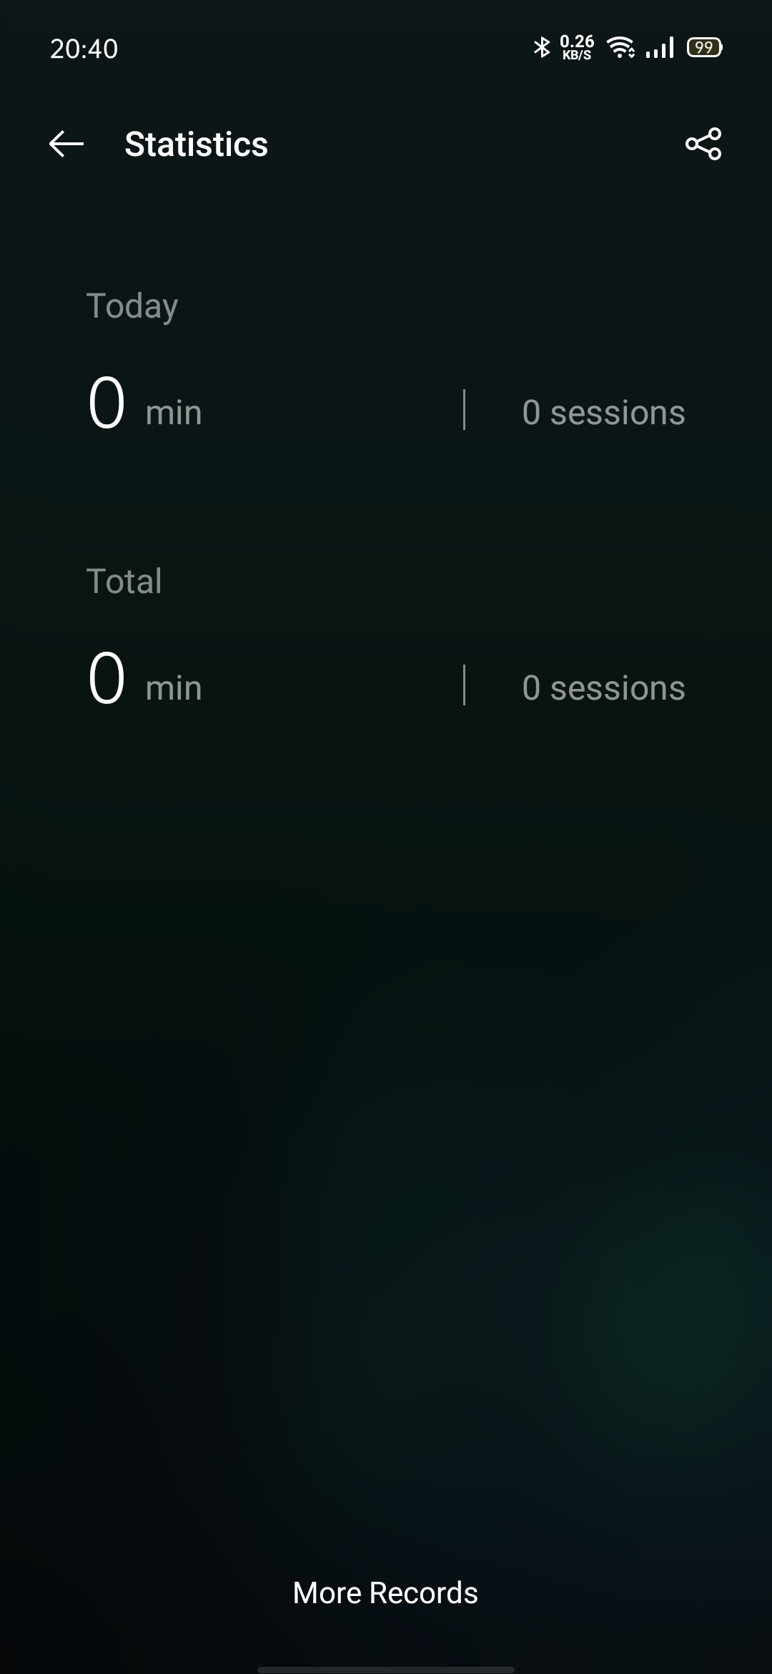
Incoming Call Alerts
In focus mode, if you don't want to miss important calls, you can tap the [] icon in the upper right corner, choose Settings, and enable Incoming Call Alerts, so that you can answer incoming calls normally.
Screen-Off Timer
You don't need to press the power button each time you want to check the focus timer during study or work. Tap the [] icon in the upper right corner, choose Settings, and enable the Screen-Off Timer. Then, the current focus timer is displayed when the screen is off (but is not displayed when the battery level is low).

Smart Driving
Driving Mode
"Driving Mode" can help you pick up the incoming calls and messages more easily during driving, which may reduce distraction.

- Add "Driving Mode" to the control center, then enable/disable the Driving Mode.
- Go to "Settings" > "Smart Services" > "Smart Driving" > "Driving Mode".
- Go to "Settings" > "Smart Services" > "Smart Driving" > "Automatically Turn On When Connected to Bluetooth Car Kit". Bluetooth car kits previously connected to your phone will be recognized automatically if turn on Smart Driving. If you're not driving, you can turn it off manually in the notification bar or Settings.

Do Not Disturb
When "Riding Mode" is turned on, everything except incoming calls will be muted by default.
Go to "Settings" > "Smart Services" > "Smart Driving" > "Driving Mode" > "Do Not Disturb".

Allowed Calls
You can customize to whom you allow their calls, including the calls "From Anyone" "From Contacts Only" "From Favorite Contacts Only" or "Decline All Incoming Calls".

Ring for Repeated Calls
Turn on the "Ring for Repeated Calls" function to allows the repeating calls from the same number calls within 3 minutes.

Auto SMS Reply After Rejecting a Call
When "Auto SMS Reply After Rejecting a Call" is turned on, the system will automatically respond to the caller with an SMS after rejecting the call. You can also customize content in the replying texts.

Block Incoming In-app Voice and Video Calls
When Driving Mode is on, voices and video calls from WeChat and Messenger will be blocked.

Block Banner Notifications
When "Block Banner Notifications" is on, notifications will be silenced and banner reminders won't be displayed on the home screen anymore. However, the reminders for the alarm clock, timer, and other features will continue to be displayed.

Riding Mode
"Riding Mode" can help you block out disturbance and handle the incoming calls to reduce distraction. For your safety, make sure to abide by the relevant laws and regulations and cycling guidelines when you are cycling.

Go to "Settings" > "Smart Services" > "Smart Driving" > "Riding Mode".

Do Not Disturb
When "Riding Mode" is turned on, everything except incoming calls will be muted by default.
Go to "Settings" > "Smart Services" > "Smart Driving" > "Riding Mode" > "Do Not Disturb".

Allowed Calls
You can customize to whom you allow their calls, including the calls "From Anyone" "From Contacts Only" "From Favorite Contacts Only" or "Decline All Incoming Calls".

Ring for Repeated Calls
Turn on the "Ring for Repeated Calls" function to allows the repeating calls from the same number calls within 3 minutes.

Auto SMS Reply After Rejecting a Call
When "Auto SMS Reply After Rejecting a Call" is turned on, the system will automatically respond to the caller with an SMS after rejecting the call. You can also customize content in the replying texts.

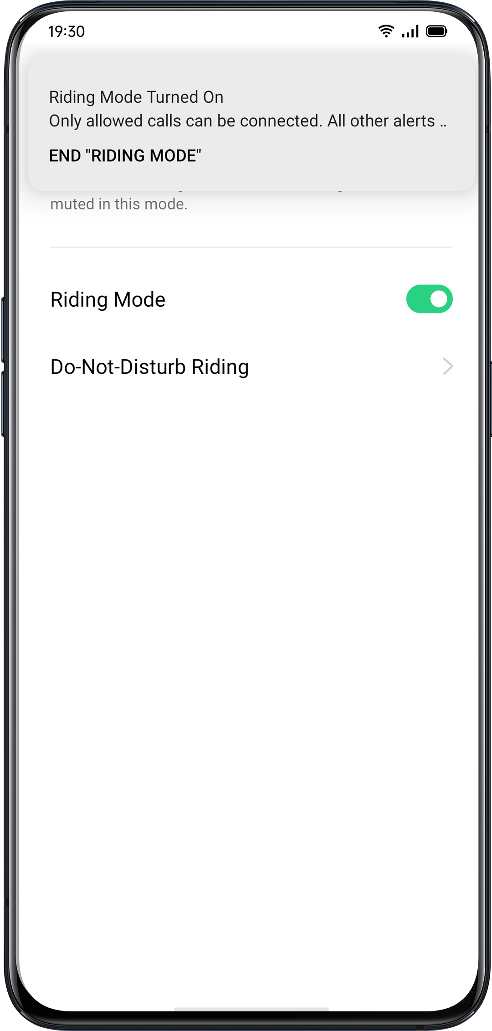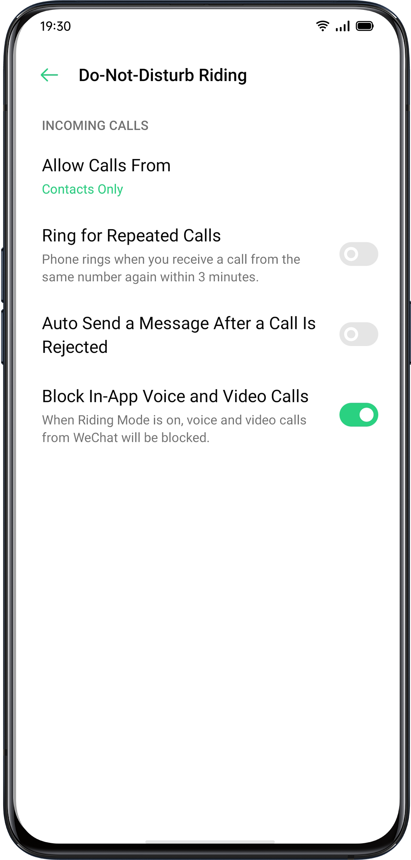
Clone Phone
Clone Phone allows transfering all data stored on your old phone (including Settings, Photos, Contacts, Apps) to your new phone within several simple taps.

Import from an Android Phone
The old phone needs to install a "Clone Phone". Be aware that both devices are sufficiently charged. If the old phone does not install the Clone Phone app, tap https://i.clonephone.coloros.com/download to install.

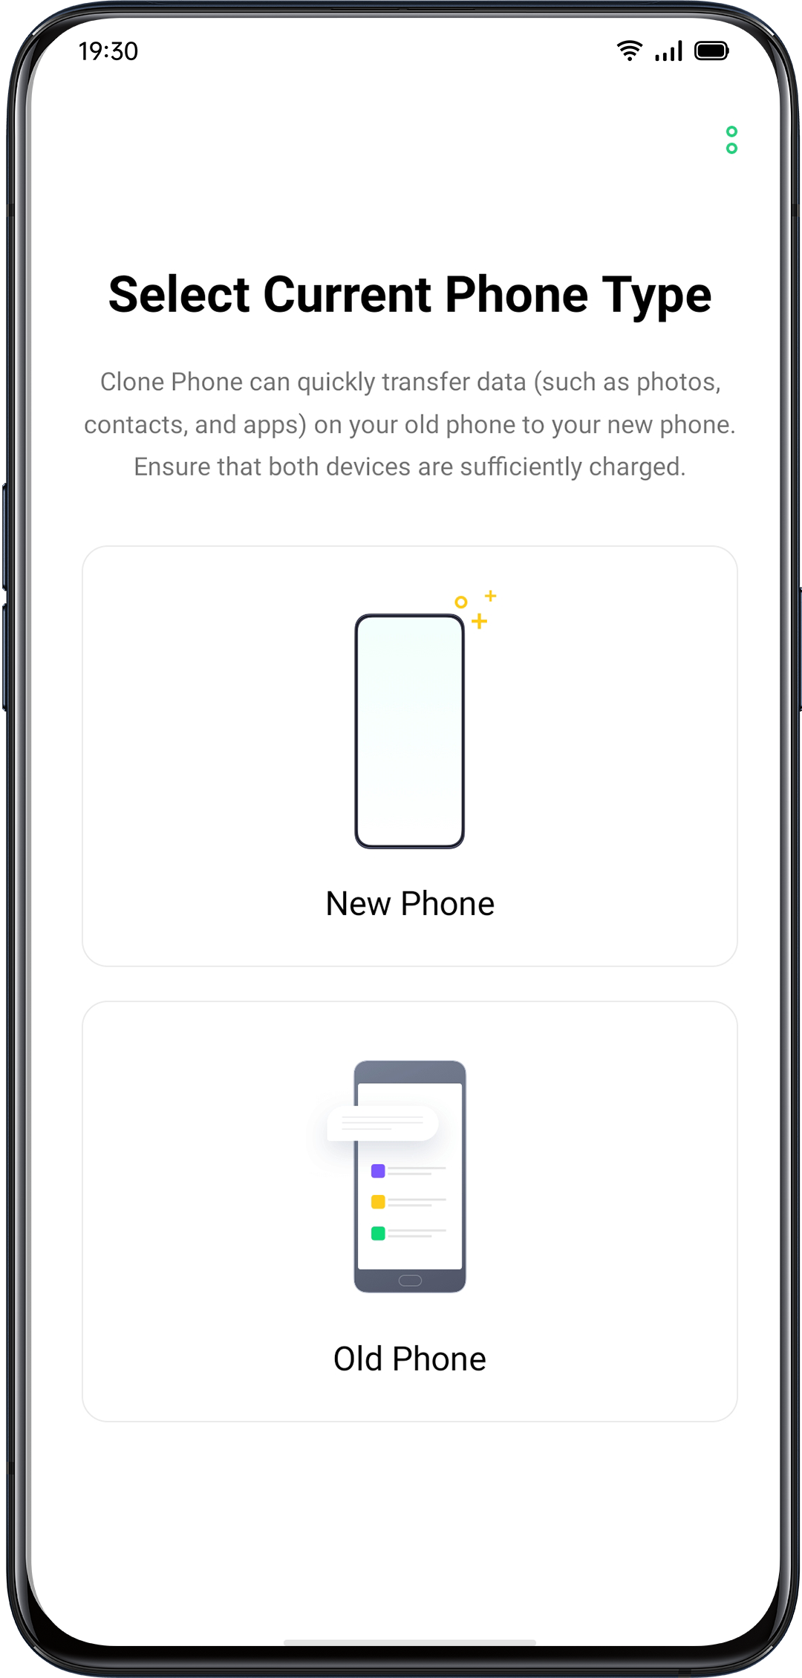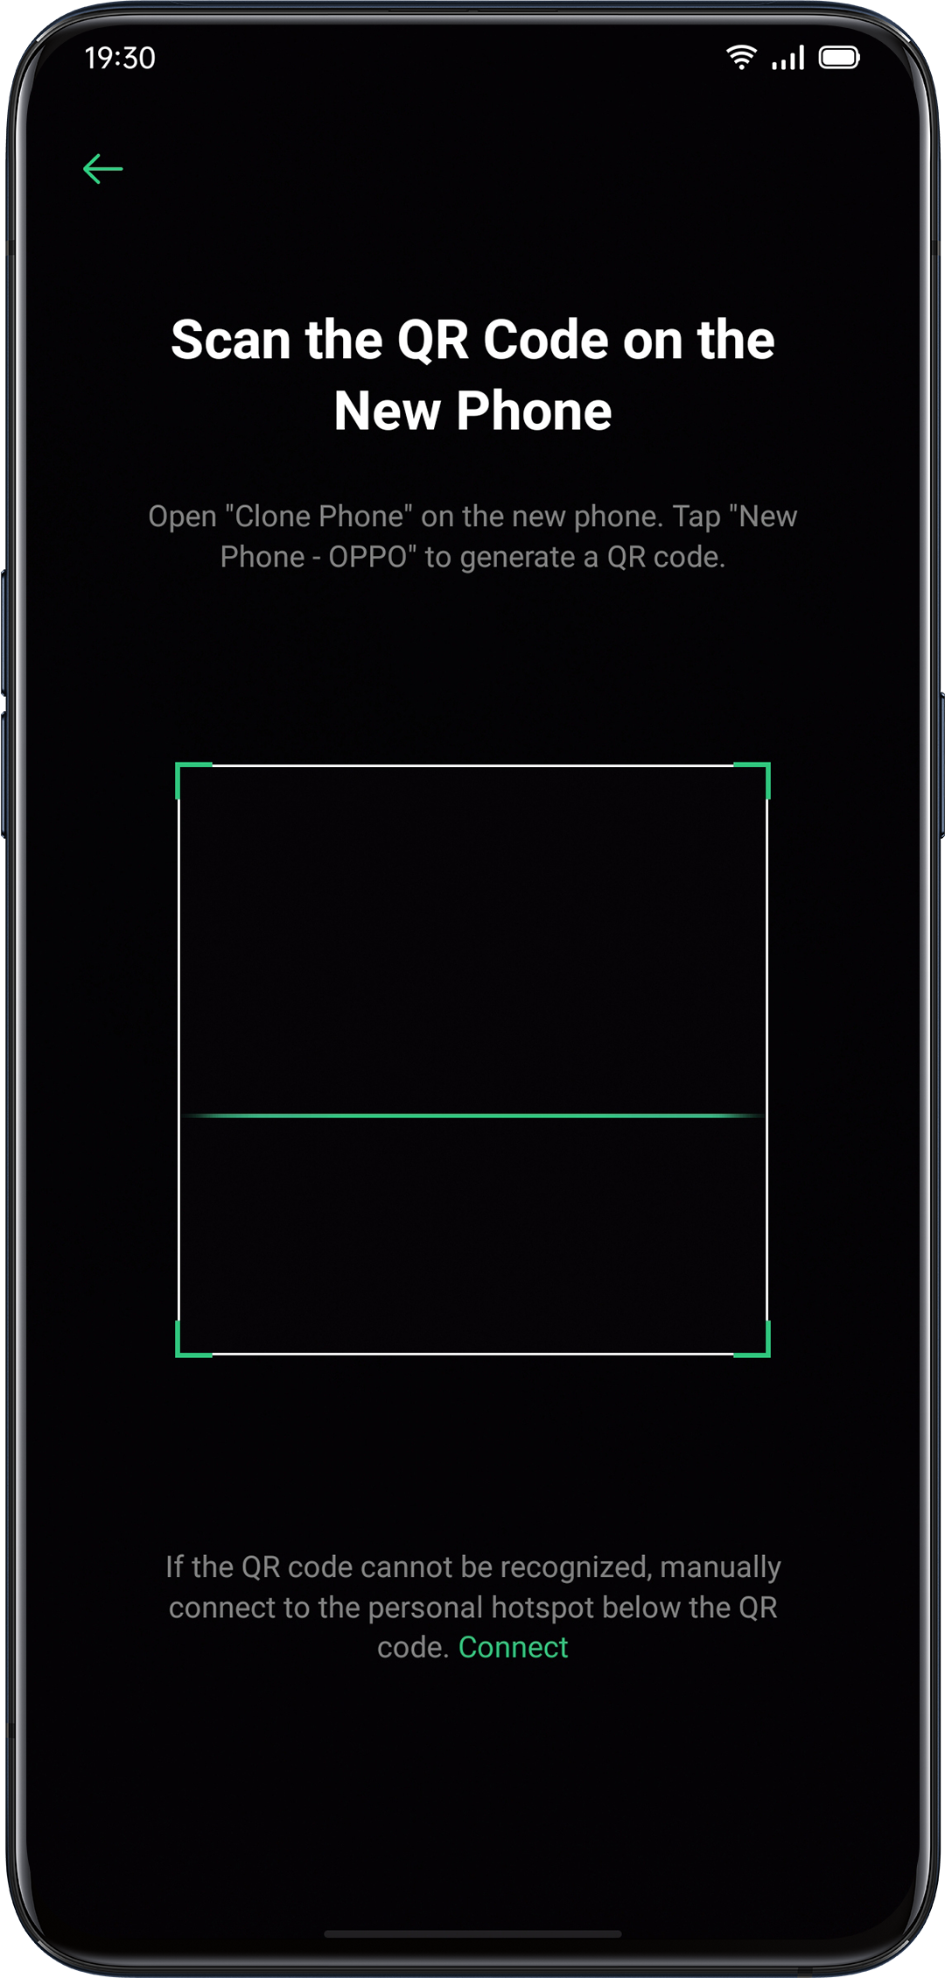

- After selecting "This Is the New Phone" or "This Is the Old Phone" as prompt, use the "Clone Phone" app on the old phone and scan the QR code on the new phone.
- Once paired, the devices will automatically transfer the selected data via personal hotspot.

Import from an iPhone
To import data from an iPhone, firstly, you’ll need to sync the data to iCloud. Tap "Import from an iPhone" in the "Clone Phone" app, log in to the iCloud account of the iPhone to import data.

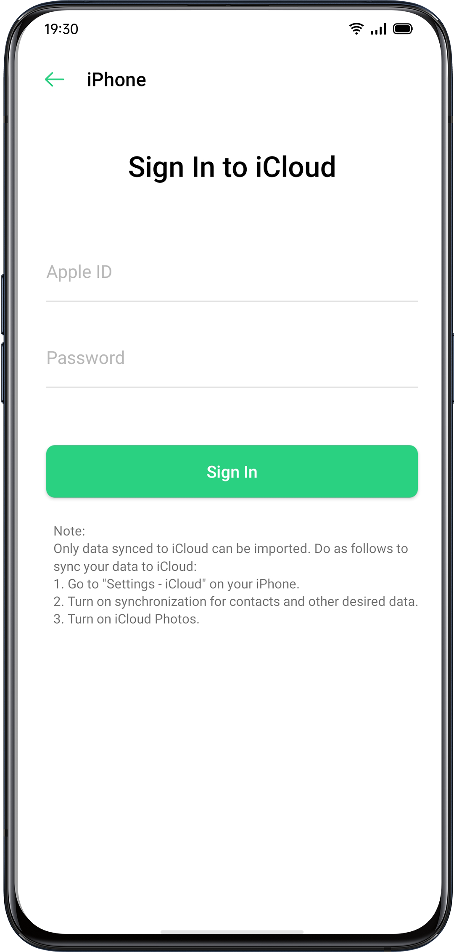
ORoaming
ORoaming provides data packages from local carriers while you are traveling worldwide. Purchasing a data package allows you to access the Internet without a SIM card.

Complete the following steps to gain access to ORoaming before you travel abroad.
- Open the data supermarket, select the package that you want to purchase and click "Buy" to finish the purchase.
- Go to "ORoaming" > "Settings" > "Automatically Turn On/Off Data Package". If it is yet to enable, you need to turn on the ORoaming package manually after you arrive abroad.
A data package cannot be activated and connected to the network until you arrive. No network is required to activate ORoaming. Once activated, it is unable to refund. It usually takes 1 to 3 minutes to activate a data package, depending on the local carrier.

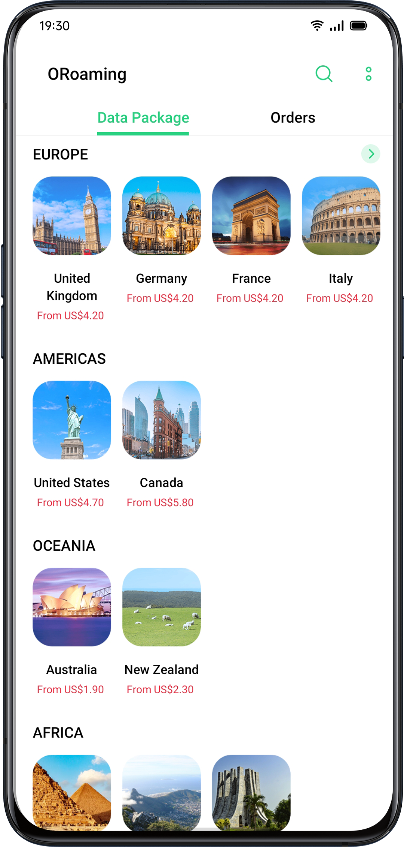

Smart Assistant
Smart Convenience Services
Smart Assistant is displayed on the screen furthest from home screen, providing smart convenience services such as quick functions, itinerary management, and weather information.
Go to "Settings" > "Smart Services" > "Smart Assistant".

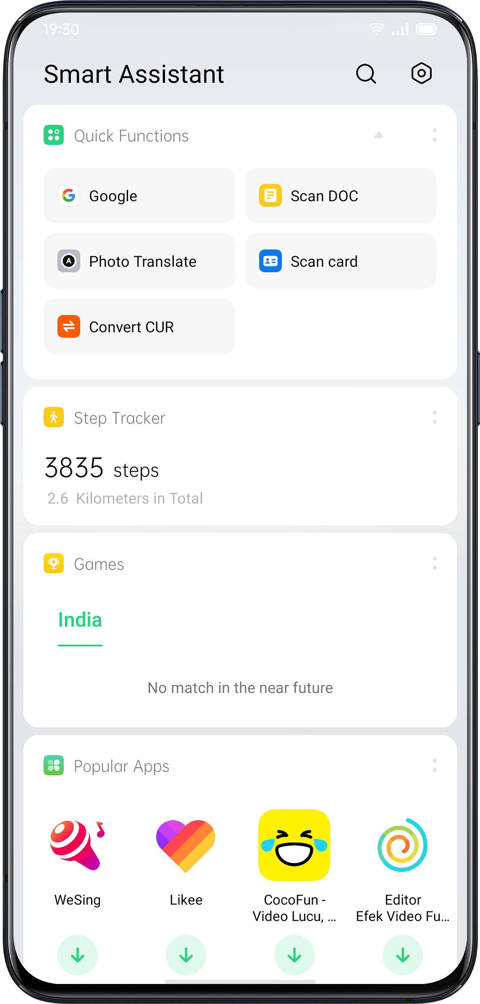
Search
"Search" will help you quickly find apps, games, quick apps and more on your device. Swipe the screen right to the furthest to "Smart Convenience Services". Tap "Search" at the top to search what you need, and click "Exit" in the upper right corner to stop the search.
Permanent Services
Permanent Services consist of permanent Smart Assistant, you can view and use those functions. For instance, Step Tracker, Photos, Favorite Contacts, and more. Permanent Services in Smart Assistant appear only in specific scenarios.
- Step Tracker
"Step Tracker" will display the number of steps and distance traveled for the day.
- Match (Available in India)
Follow the matches you love. Get automatic updates of scores and schedules.
- Favorite Contacts
One-tap calling of favorite contacts.
- Photos
A quick view of the latest memory.
Quick Functions
One-tap to open frequently used apps, such as "Scan DOC", "Photo Translate", "Scan card", and more. Tap the icon in the upper right corner of Quick Functions to turn on/off Quick Functions or add/remove functions according to your use habit.
Smart Scenario Services
Smart Scenario Services will identify your current scenario such as time and location to appear, disappear and arrange automatically, providing the useful information you are concerned about to make your life easier.
- Schedule
If you created schedules in Calendar, related information such as time and theme will be displayed in Smart Scenario Services, in case you forget important schedules.
- Online Order (Available in India)
Smart Assistant will get and display your online order information.
- Itinerary (Available in India)
Smart Assistant will get and display updated itinerary information.
Manage Smart Assistant Cards
Go to "Smart Convenience Services" and tap the icon in the upper right corner to manage smart assistant cards.
Tap "Mine" to add Scene Smart Services and Permanent Services.
You can also add different cards according to "Recommended", "Travel", "Life", "Convenience" and "Entertainment".

Make your Shots Outstanding

Learn How to Capture the Best Shots
Open "Camera" and start to create delicate and professional shots. ColorOS 7 also allows you to make the shots more stunning, as you can apply capture timer, HDR, Portrait mode, Night-scene mode, and Time-lapse photography.

Take PhotosAdjust Brightness
Open Camera. Tap anywhere in the frame to sharp focusing. You can customize the focusing area to change with where you tap on the screen. After you complete focusing, press and hold the screen, then slide up or down to adjust brightness.

Zoom in or out
You can tap the button  to focus on the object. The object will be zoomed in if you toggle the button, and it will be reverse if you toggle again. You can also pinch the screen to zoom in or out.

Turn the Flash on/off
Tap the flashlight button  to turn the flash on or off. You can set the button for different uses including "Off", "On", "Auto" and "Fill Light". When you set it as "Auto", your phone will be automatically detect lighting conditions and determine if flash is necessary. When you set it as "Fill Light", the flashlight will be kept on to add lighting for the shooting. It is advised that you set to flash as "On" when at night or under a dim-lit environment.
Portrait mode

The PORTRAIT mode enables you to easily shoot more natural and awesome portraits. The portrait bokeh function is available for both the rear and front cameras, and the degree of blurring can be easily adjusted. The system provides five built-in portrait styles.

How to enable: Open Camera and choose the PORTRAIT mode at the bottom of the screen.

AI Beautification

The upgraded beauty is more intimate, not only can match different skin colors in different scenes and lighting conditions, and easy to open a one-button makeup. It also intelligently adjusts the beauty intensity based on skin color and aesthetic differences. Your beauty, I am going to sublimate.

You can make 8 categories of AI-enabled beautification for your face appearance in the photos. Tap  at the bottom right corner to enter Beauty mode where you could airbrush your face, enlarge your eyes, make your face slimmer and more chiseled, add touch-ups. Drag the slider at the button of the camera to adjust the level of Beauty mode.

Night Mode

Under the Ultra Night mode, the camera will take 4 to 5 continuous shots at different exposures with AI-enhanced algorithmic operations, in a bid to combine shots for clearer and brighter photos.

The built-in AI Ultra Clear Engine is able to identify 21 categories of scene elements with other 800 scene combinations. While taking photos with Ultra Night mode, the camera will recognize the most suitable shooting solution and reconstruct color casts based on the overall color optimization, as a way to enhance color expressiveness under different lighting conditions.

OPPO Reno In the handheld mode, a night photo is synthesized by synthesizing 3-8 photos with different brightness and darkness. In the stand mode, up to 17 photos with different brightness and darkness can be supported for synthesis, and the image quality will be greatly improved.

OPPO Reno 10x Zoom boosts photography even under the lower-light condition at night. It enables more stable shooting experience, capturing more light and making the photos more vivid and brighter even if at night. In addition to the high performance in taking photos in dynamic night mode, OPPO Reno 10x Zoom also elevates portrait when it's taken at night, shortening the shooting duration to 1 to 2 seconds.

The self-developed dim image enhancement algorithm ensures a clear and textured picture even in extreme environments where the light is very weak . Photographs are never restricted, and you can make big movies anytime, anywhere.

Notes: Avoid shaking the phone and keep stable while taking photos in Ultra Night mode.

Open "Camera", tap  on the bottom left corner and choose "NIGHT" (Ultra Night mode is now only available on some OPPO phones).
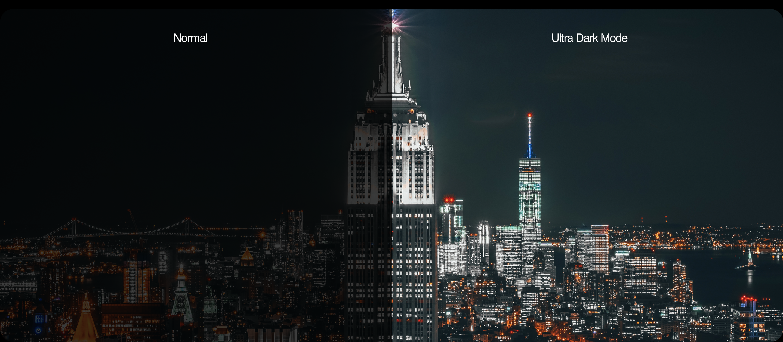

Dazzle Color Mode

When you turn on Dazzle Color mode, the camera will set color enhancement to be vivid and bright, making colors of your photos more striking. Dazzle Color mode is nothing like simply adjusting saturation or adding filters, rather, it will polish every pixel to optimize colors after identifying under which photo mode the photo is taken. Tap the button at the upper area of the screen to turn on.
Expert Mode

Expert mode allows you to take more professional photos under more precise settings.
Open "Camera", tap "MORE" at the bottom left corner and then choose "EXPERT".

The options that can be set manually include sensitivity (ISO), shutter speed (S), white balance (WB), focus (AF / MF), exposure compensation (EV), etc. Click on each option and slide the lower slider to the left or right. Adjust specific values. Click the button to switch the parameter value between automatic and manual.

Sensitivity adjustment: The lower the ISO, the smoother the photo will be. The higher the ISO, the louder the random background noise will become and the more distracting the quality will be.

Adjusting the shutter speed: The shutter speed determines how long the sensor is exposed to light. If you take a photo of a moving object, for example, a running child, then you need to increase the shutter speed.

White balance: White balance is closely relevant to color temperature. Under different lighting conditions, different color casts could be created. For example, it can be of the slight blue cast under the light source of fluorescent lamps and of the yellow cast under the light source of incandescent lamps. To present the realistic color cast, adjusting white balance could also lead to the change of color temperature to either cooler or warmer tones.

Focusing: Adjust focusing to make photos sharper. Choose to either focus on an object with a blurred background or focus on background with blurred objects.

Exposure compensation: Once exposure compensation is on, the camera will automatically come up with a suitable parameter for exposure compensation, making the photos brighter or dimmer.

Take Photos with Filters

You can add filters while taking shots and adjust different visual effects. Tap  at the upper area of the screen to select your desired filters. Swipe left or right to change filters, as you could view it in real-time. You can take shots immediately after you decide which filter to use as a way to edit your shots.

Take a Panorama Photo

When it is unable to capture scenery from a wide-angle, take advantage of the panorama mode while taking photos.

Use rear camera for panorama photos
- Open "Camera", choose "PANO".
- Tap the Shutter button, pan slowly in the direction of the arrow, keeping the arrow on the centerline. To finish the pan, tap the button again.
- To pan in the other direction instead, first tap the arrow.
- When you take photos of the high-rise buildings, rotate the phone to landscape orientation by panning slowly in the direction of the arrow.

Use front-facing camera for panorama photos

You can also use the front-facing camera to take panorama photos by panning the phone either to right or left.

Tips for panorama photos
- You can take panorama photos from the furthest locations as long as the panorama allows. You may also stop the shooting by tapping the Shutter button.
- Remember to pan the phone slowly to make sure that the camera captures as many details as it can and focuses better. This could also make the photos less blurring.
- Avoid moving the camera up and down during shooting, otherwise, the photos may be formed unevenly.

HDR

HDR is referred to as High Dynamic Range Imaging. When HDR is on, your photos will be reproducing a greater dynamic range of luminosity, making the photos acquire more display contrast and be closer to what the human eyes see. Tap HDR, you can set it as "On", "Off", or "Auto".

Watermark

You can add a watermark to your photos. You could also add the author of photos. It should be noted that every photo will be added with the author's watermark once you upload the name of the author.

Open "Camera", tap  at the top right corner, then add watermark or the author name for the photo.



Gesture to Take Photo

The gesture control allows you to take long-distance selfies or group photos simply with a hand gesture. No extra touch on the phone is required. You can pose a particular hand gesture, and the shooting is done.

Go to the camera settings and tap "Gesture to Take Photo" to enable automatic shooting based on hand gestures. When you use this function for the first time, follow the on-screen instruction to finish the gesture control. You can only raise a hand when facing the camera for 3 seconds, after that the camera will start automatic shooting.

Shoot Video

Tap the Record button to start shooting video. Tap again to stop recording. Tap "PHOTO" to switch back to photo-taking mode.

By default, video records at 30 fps (frames per second). Depending on your model, you can choose other frame rates and video resolution settings.
The faster the frame rate and the higher the resolution, the larger the resulting video file.

Video quality can be switched from either 4K / 1080p / 720p.
Note: Only several models could set video quality on your own.

Open "Camera", drag the slider down at the bottom of the phone to switch to video recording.

Take photos while shooting a video: You can also tap the Shutter button in the lower-left corner of the screen to save as photos while you are recording a video, and it won't interrupt the shooting.

Video Bokeh

After the rear, the blur adjustment of the front lens is handed to you. Blurring is more powerful, self-timer and he is free to shoot. The problem of false and false defects has also improved, and the post-deployment has further improved the effect of flare and asymptotic feeling.
What's even more amazing is that not only taking pictures, but also making videos can be blurred. At the same time as the real-time background is imaginary, the subject is more prominent.
SLO-MO Video

SLO-MO records a scene or object with a normal action or move and turns it into a video that plays back in very low speed. You can customize the resolution ratio of the SLO-MO video into 720P or 1080P. The higher the resolution ratio, the more space the video file will occupy.

Open "Camera", tap "MORE" and select "SLO-MO".

TIME-LAPSE Video

TIME-LAPSE video records a scene or object that has a slow state-of-change and turns it into a video that plays back at a high speed. Under TIME-LAPSE mode, the videos will be compressed to the short duration based on a ten-to-one ratio regardless of how long the video duration is.

If you want to capture a sunset, traffic flowing or other experiences over a period of time, be sure to place your phone at a stable and safe place.

Open "Camera", tap "MORE", select "TIME-LAPSE".
Notes: Not all OPPO phones support TIME-LAPSE video.

Editing a Video
After finishing shooting a video, you can operate the various editing directly within your phone.
Tap "Edit" at the bottom of the video and enter Editing mode.
Trim a Video
Drag either end of the frame viewer to cut unnecessary parts or shorten the video duration.
Speed Changing
Choose what speed you would like the video to play. There are five different speeds including 0.25X, 0.5X, 1X, 1.5X, and 2X. You can play the video in slow motion with the speed of 0.25X while in TIME-LAPSE motion if you apply the speed of 2X.

Add theme and filter
After finish trimming and speed changing for the video, tap "Next" to add more themes and filters.

Add soundtrack
To make a video more dynamic, you can also add soundtrack both from local and system music.

Add special effect
ColorOS 6 offers two kinds of special effects to better highlight the video, including Close-up and Pulsation.
- Close-up: The video frame will be zoomed in for more detailed shots.
- Pulsation: The beat of regular repetitive movements.
Add texts
You can add marks or subtitles at different frames in the video.

Add watermark
Add a watermark with the location and date of the video to show up in the bottom left corner of the video. After editing, tap "Done" to save the video.

Camera Settings
Open "Camera", tap at the top right corner to customize camera settings.

- Format settings: You can set the photo ratio to 4: 3, 1: 1, full screen, and switch each time you click.
- Countdown photo: After the countdown photo is turned on, pressing the shutter button will not take a photo immediately. You can set the time to 3 seconds or 10 seconds after each click to switch.
- Touch to Take a Photo: Touch anywhere on the screen to start taking photos.
- Volume Button: Set the Volume buttons to function as a shutter release or zoom controls.
- Grid: Display gridlines to ensure the camera is leveled.
- Shutter Sound: Make or mute camera shutter sound when capturing photos.
- Location: Tag your photos with geo-locations.
- Flip Selfie: Your selfies may look mirrored to what's actually taken. Turn on Flip Selfie to flip a mirror selfie image.

Photos
Photos
All photos and videos will be displayed with the taken date.

View photos
Pinch the screen with two fingers to look through the photos in the Year or Month timeline. Tap the thumbnails to view photos in full screen.

You can also pinch the screen by zooming in or out to view more details of the photos. Swipe left or right to browse photos.

Tap the photos for more options:
- Share: Send the photo to other users.
- Favorite: Tap to set the photo as favorite and restore in the favorite album.
- Edit: Tap to edit the photo.
- Delete: Tap to delete the photo.
- Others: You can also set a photo as wallpaper, assign as the avatar to a contact, make it private or public, or view more information.

Share photo
If you want to send a photo to your friends, tap  at the bottom left corner.

If you want to send more than one photo or video, select them in the thumbnail view, and tap at the bottom left corner.

After selecting, you can also do the followings apart from sending them to your friends:
- Set them as private
- Add them to an album
- Collage
- Delete
"Albums" will display all the photos and videos in categories, including camera shooting, screenshots, smart albums, etc.

View Albums
ColorOS 7 intelligently divides photos into multiple Albums, making it easy for you to manage and find photos.

All photos: All photos stored on your phone
Camera: All photos and videos taken by the phone
Screenshots: All screenshots and screenshots of your phone
Favorites: all photos and videos you clicked
Video: All video files saved in the phone
Recently deleted: All photos and videos deleted in the last 30 days, you can choose to restore to album or delete permanently.

In addition, ColorOS 7 also offers a smart album, which categories photos and videos regarding people and locations. You can view photos and videos of certain people or locations.

Create a new album
You can create new albums apart from the albums created by ColorOS 6. For example, create a new album that stores your photography named "Personal album".

Go to "Photos" > "Albums", tap at the top right corner, type a name for the new album, then tap "Save".
Once saved, you’ll be given categories of photos that you can transfer to your album. Just choose the image or tap "Select All" then tap "Save".

"Memory" will intelligently analyze your photos according to the shooting location, shooting time and shooting theme, and show various wonderful moments in the form of videos.

Tap thumbnails to enter Memories, and click Play. ColorOS 6 will automatically play a movie-like video edited with music and visual effects.

Go to "Photos" > "Explore"

Create a Memory album
You could create your own Memory album.

Enter "Photos" > "Explore", tap the top right corner，tap "New Memory" to create a Memory album, then type a name for the Memory album and select no less than 20 photos.

Customize Memory album
You can also edit or polish the Memory video. Tap "Play", click the "Edit" at the top right corner and start editing.

theme: Choose your favorite from the 10 themes, with each of them matching with different background music and display.
Music: Add the music either from the built-in storage or upload a local file.
Title image: Select one of your favorite title image from Memory video.
Title: Edit the title of the Memory video.
Photos: Choose photos to set time for display. You can also delete them if you think they don't perfectly fit the theme of the Memory album by tapping "Delete" at the bottom right corner. Tap "X" to delete the photos in batches.
Duration: Customize the duration of the video. The maximized duration is 48s.

Optimize Storage
Enable "Optimize Storage" to auto-sync photos and videos in order to make room for other files.

Open "Camera",tap the top right corner,tap settings, tap "Auto Sync", sign your HeyTap account or Google account,and tap "Optimize Storage".

After you enable "Optimize Storage", photos with the original size will be synced in OPPO Cloud, and the photos saved on your phone will be stored as a smaller size, allowing your phone to have more storage. After you disable "Optimize Storage", ColorOS 6 will automatically download the photos with the original size for you.

Search Photos
ColorOS 7 allows you to search for photos with the smart searching function.

Enter "Photos", and tap the search bar atop to start search photos.
You may view photos classified as Latest, by data, event/location, and person.

You can also search with keywords such as time, place, or people to quickly locate results. For instance, search "Scenery" and view the photos you took during travel.

Using Soloop to Create Vlogs

Thanks to technological advances in software and hardware, people everywhere now have the opportunity to take short videos of moments in their daily lives.

ColorOS includes a whole new short video editor called Soloop. Soloop lets you edit videos and add filters, music and effects to your videos in seconds. Amazing videos are just one tap away.

Smart Editing, Creating a Video in One Tap

Besides automatically creating wonderful stories, you may also experience the powerful editing functions of Soloop. The mobile phone becomes an omnipotent editor, realizing your dream of becoming a director.

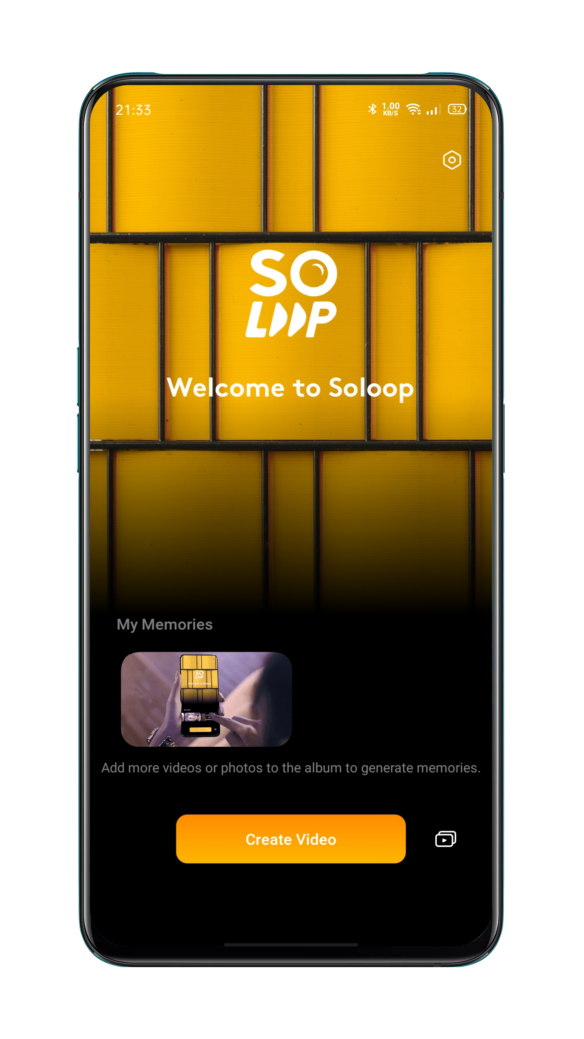

Importing Materials

Start Soloop, tap Create Video, and select and import the required videos and pictures.
You can quickly view and select files by type, for example, All, Photos, and Videos. You can also swipe to the Category module. On this screen, Soloop automatically recognizes over 80 picture scenarios and 24 video scenarios, and intelligently categorizes raw materials, comprehensively covering various scenarios in daily life.

Selecting Video Size
Soloop automatically selects a suitable display ratio based on the video materials. You may manually set the display ratio to 1:1, 4:3, 3:4, 16:9, or 9:16. After the required size is selected, the video and pictures are automatically cropped.

Selecting a Smart Template
Don't painfully learn to edit, just a little, it will automatically select the wonderful picture, and follow the music rhythm card to make the wonderful blockbuster instantly, even if you need to start, when it scans enough excellent clips, Will generate a wonderful story on its own initiative. All you have to do is export and share, and wait for praise.

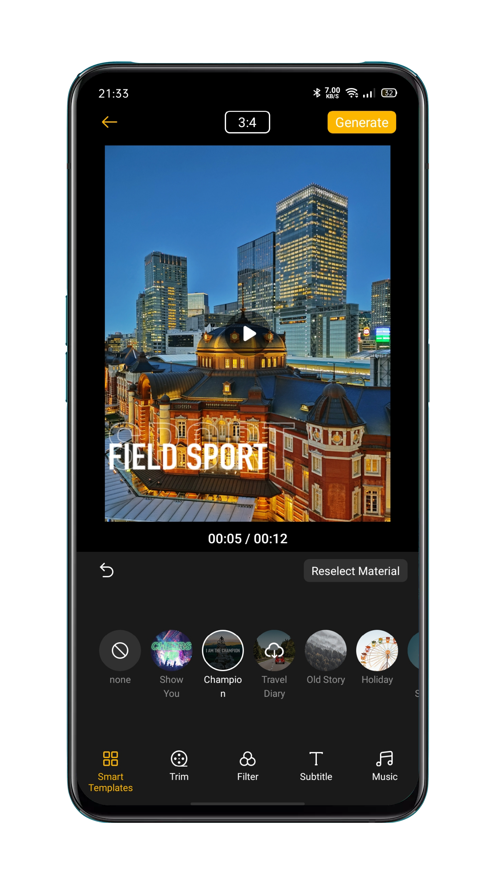

Editing Materials

- Tap Edit to process the materials more specifically.
- To add a material, tap the + sign on the left.
- To delete a material, side to the corresponding clip, and tap the delete icon.
- To cut a material, side to the corresponding clip, and tap the scissors icon to cut this segment into two.
- To change the sequence, press and hold any segment to go to the sorting screen. Press and hold the corresponding material to arrange it.
- To change the speed, tap the related clip, and choose to speed up or slow down the playing speed at the bottom of the screen.
- To change the duration, tap the related clip, press and hold the left end or the right end of the clip, and slide inwardly to the desired position.
- To add the reverse play effect, tap the related clip, tap the  icon to set this segment to be played in reverse.
- To rotate materials, tap the related clip, and tap the  icon, to rotate this segment 90 degrees clockwise.
- To add rotating animation, tap the  icon between two materials, and add rotating animation here, to make the video more smooth and vivid and give it an animated effect like a movie.

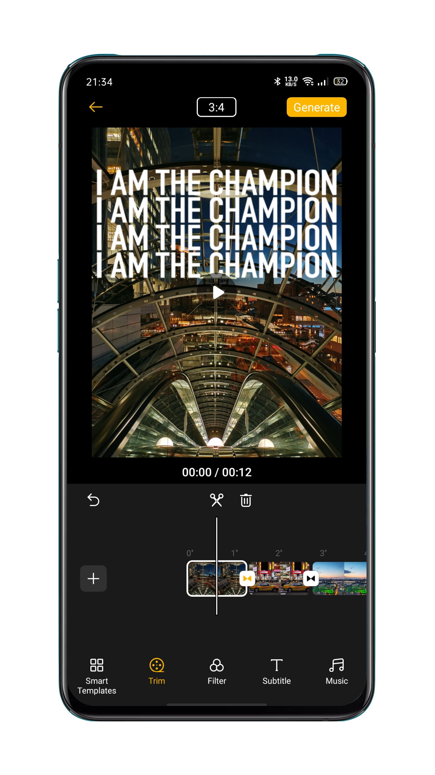

Selecting a Filter
Add a filer so that the video and pictures have a better texture. Tap Filter and select one for the video. Over 10 filters are available. After selecting a suitable filter, tap the filter again to adjust the intensity.

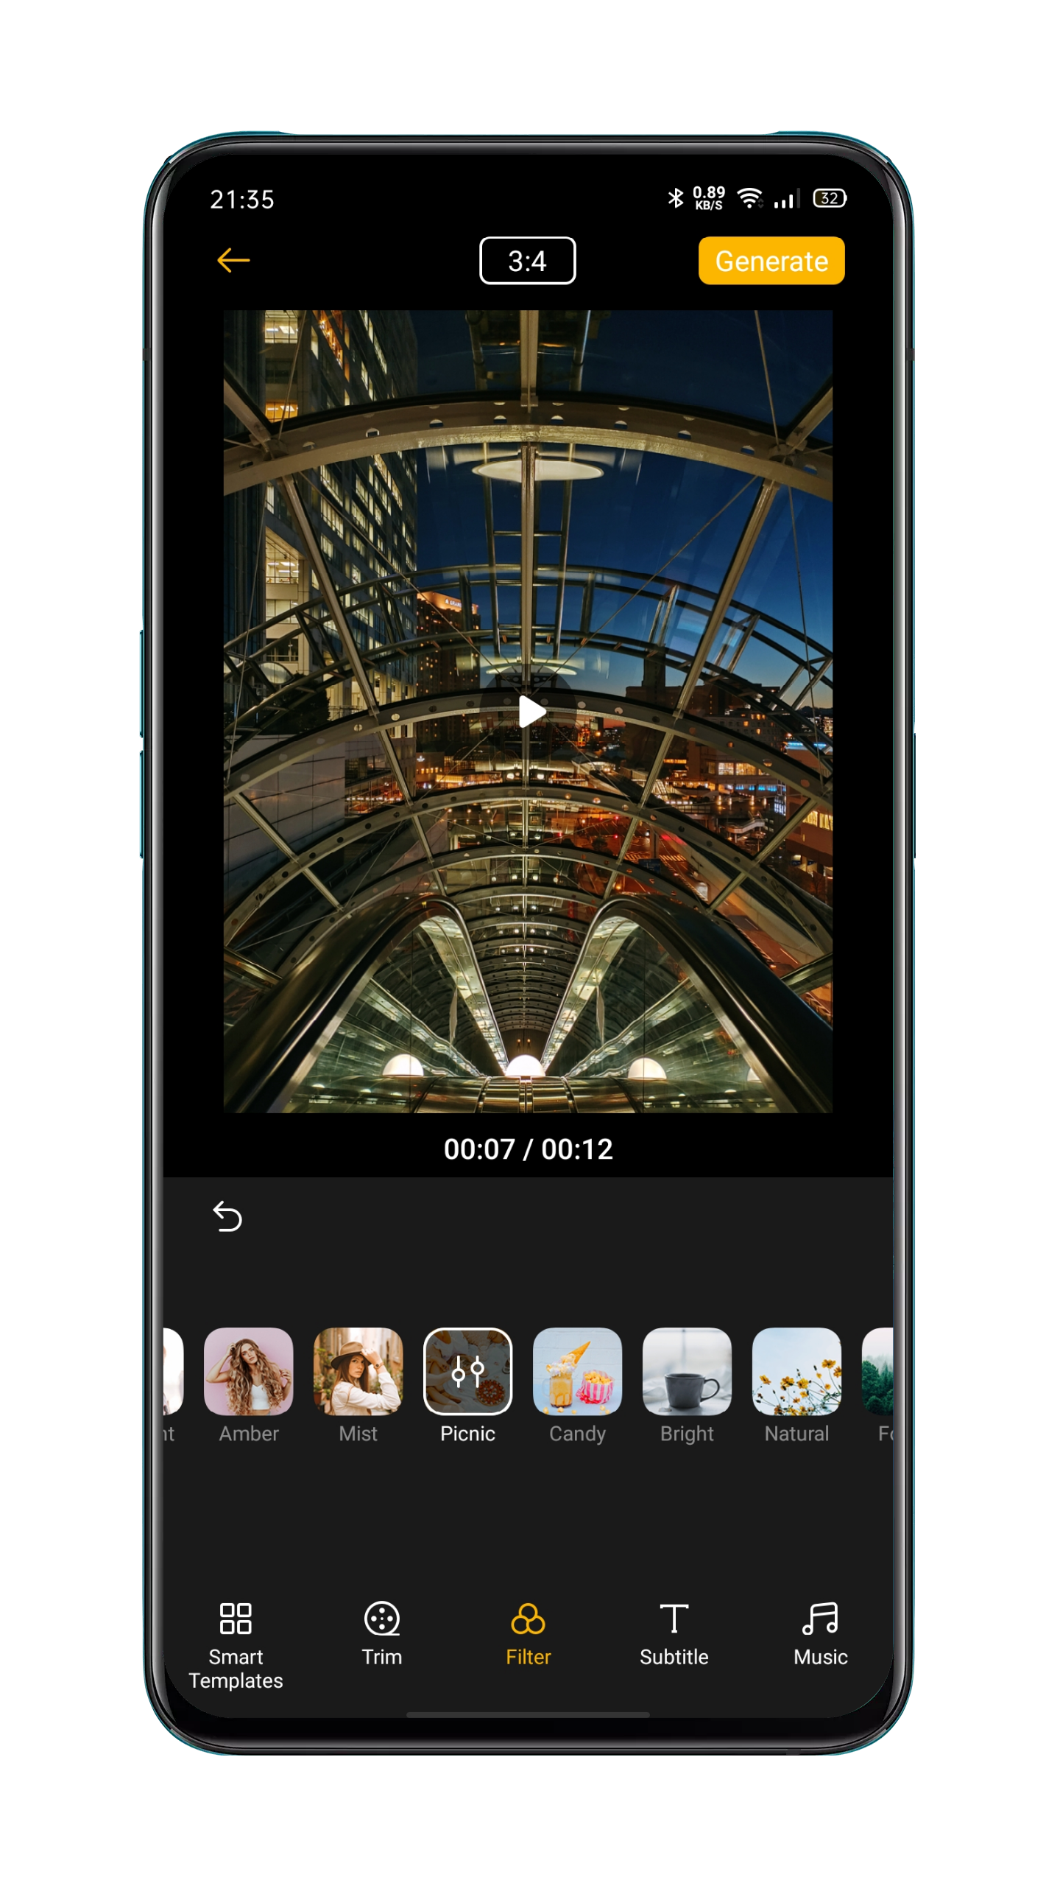

Adding Subtitles
Do you want to add subtitles like those in movies and TV series? This is easy in Soloop.
Tap Subtitle, and side along the time axis to the point where the subtitle needs to be added. Click Add Subtitle to go to the editing screen, enter no more than 100 characters, and select the font color.
Then, the subtitle will be displayed over the picture. You can tap on the subtitle to enlarge, rotate, move, re-edit or delete it.
After the subtitle has been added, a subtitle layer is displayed in the video editing area. You can press and hold the subtitle layer and change the time position the subtitle appears at, and press and hold the left or right end and slide inwardly to increase or decrease the duration the subtitle appears for.

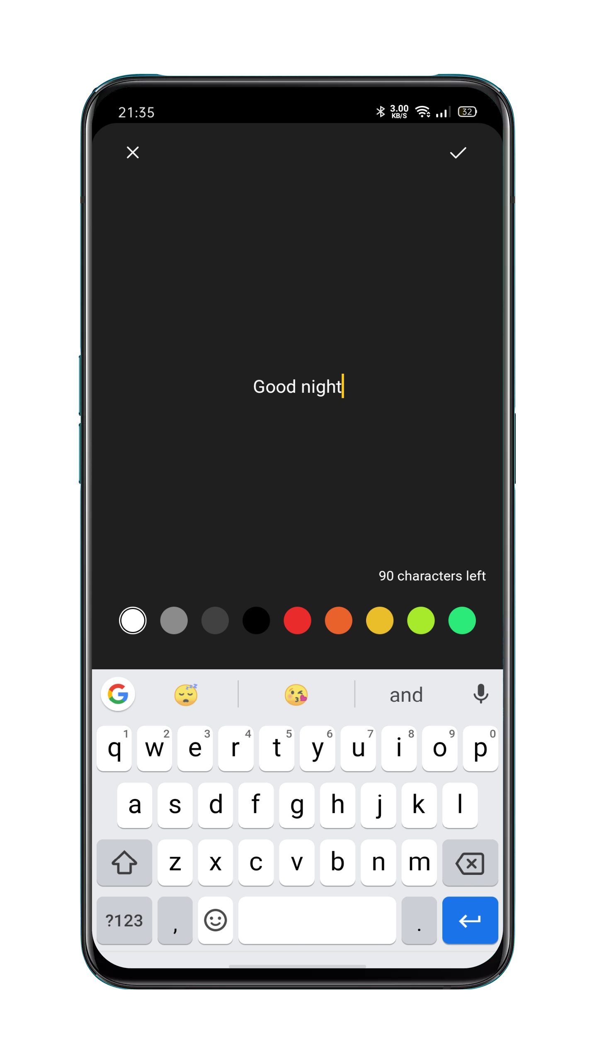

Adding Music
Tap Music and add suitable background music to the video. Soloop recommends music styles to you based on the video content, so you don't need to worry about the choice of music. The music library is updated regularly and follows trends to satisfy your ears at any time. You can also tap Local Music to add music locally stored on the mobile phone.

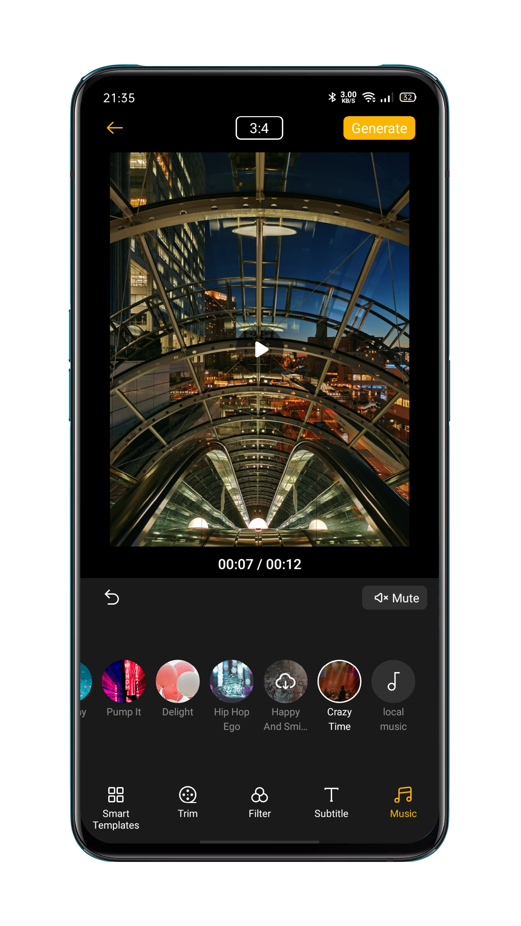

Generating the Video
After you've finished editing, tap Generate in the upper right. Wait a moment for your video to be finalized. The video will be automatically saved to Photos on your mobile phone. You can also share the video quickly by choosing OPPO Share, Facebook, or Tik Tok.

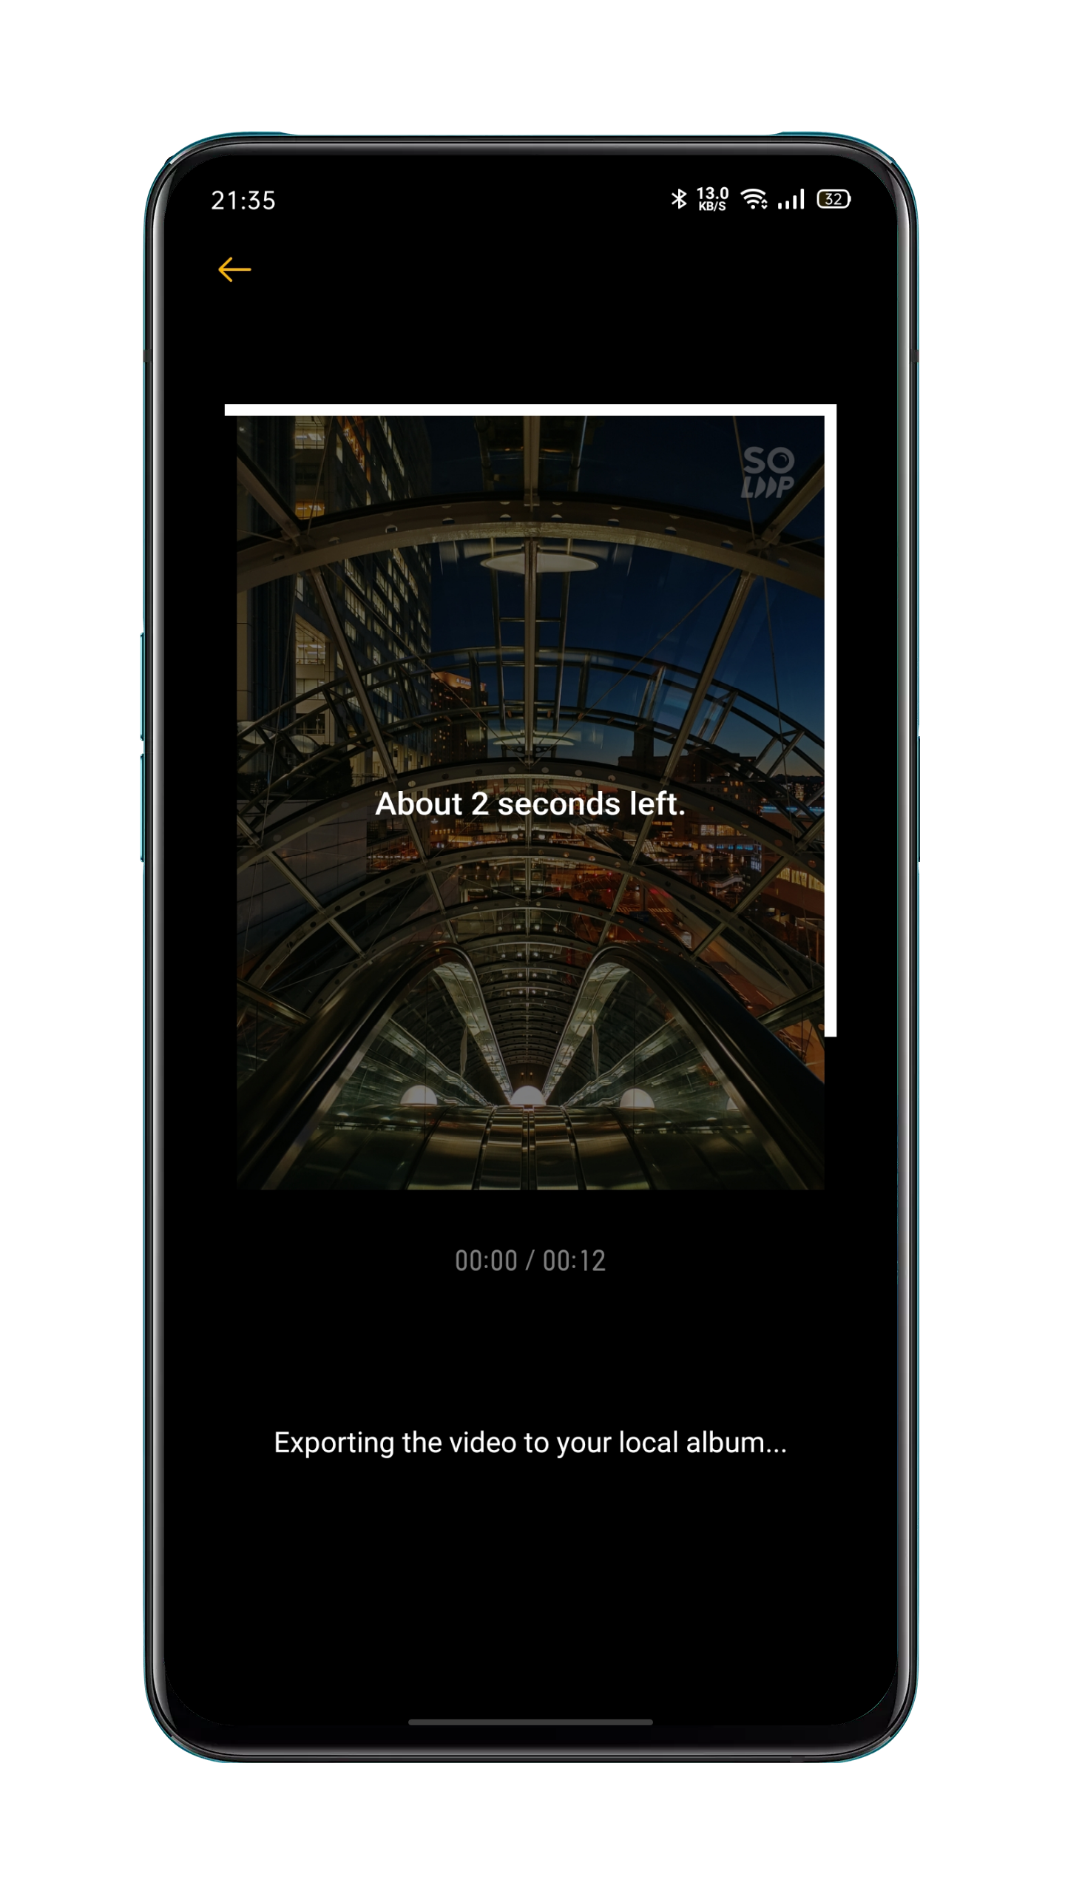

Adjusting the Export Resolution

Go to Soloop's home screen, tap the Settings icon in the upper right corner, tap Export Resolution, and select 1080p or 720p.

Adding a Watermark

Go to Soloop's home screen, tap the Settings icon in the upper right corner, and enable Video Watermark. Then a Soloop-specific watermark will be added to pictures in the video.

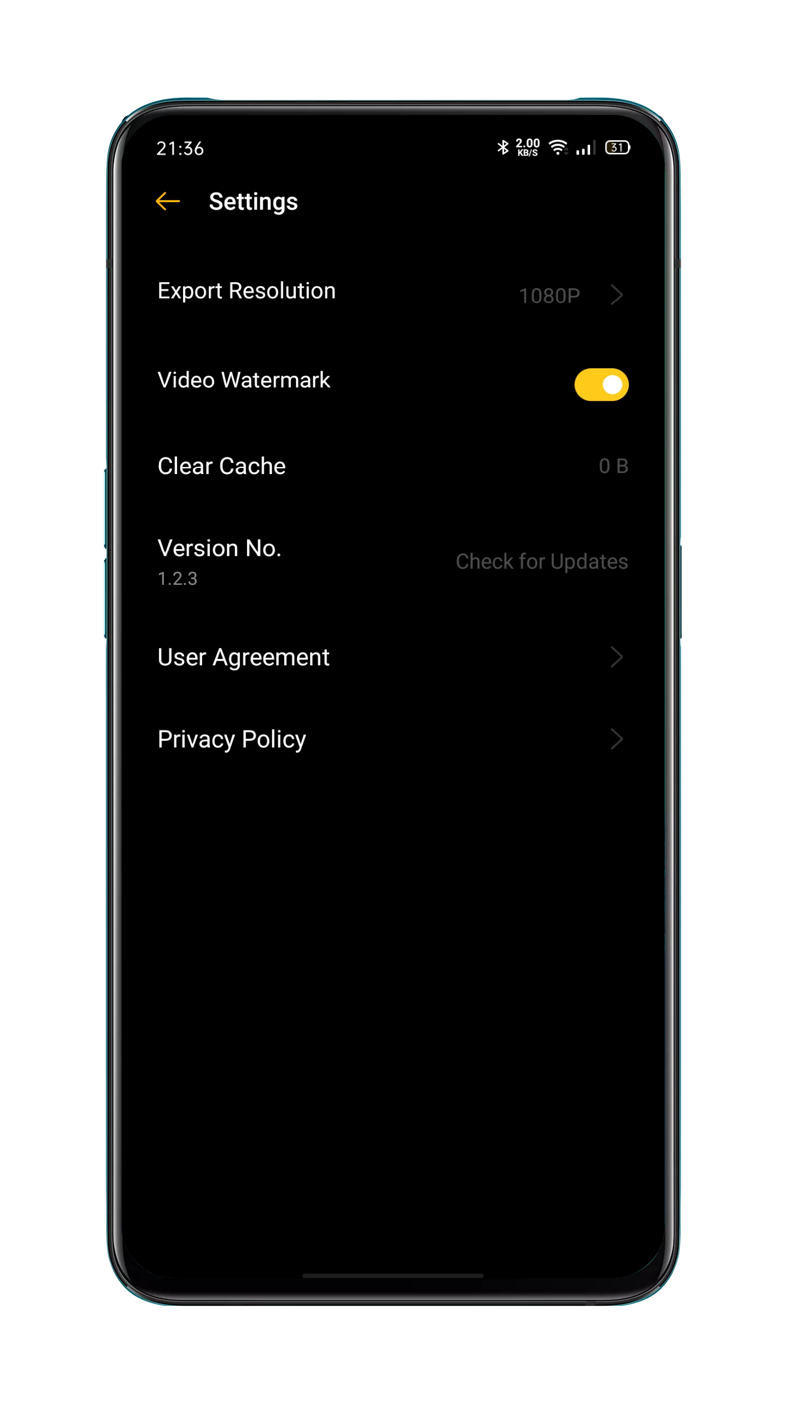

Viewing My Projects

Go to Soloop's home screen, and tap the icon in the lower right corner to view all your projects. You can tap on a project to enter the editing screen and continue editing it.

Game Experience
Hyper Boost
Hyper Boost is a full scene, system-level resource scheduling optimization solution developed by OPPO. Hyper Boost accelerates performance when needed, which could realize the two-way conversation in real-time between applications and system resources, making your phone operate more smoothly.

Game Space
OPPO mobile phone provides a dedicated application for game lovers, namely Game Space. It will be automatically installed on the phone with the game together in one place, which is convenient for you to unify the management of game applications. It also offers the performance mode, distraction-free mode, game acceleration, and other features to ensure the best quality game experience for you.

The Game Space will automatically launch game mode when you enter the game, where the phone will intelligently adjust the CPU/GPU/Storage/Network frequency according to the game scenario, ensuring the game to run smoothly at any time and reducing power consumption.

Hide Games Icons on Home Screen

It is inconvenient to search if the game icons are everywhere on the Home Screen. "Hide Games Icons on Home Screen" makes your Home screen organized and tidy.
Go to "Settings" > "Game Space"> , enable "Hide Games Icons on Home Screen", then the game icons for the games will no longer be shown on the home screen.

Note: Games Icons will not return to the original display, instead, they will appear on the last page of the home screen.
Game Mode Settings
Game Space introduces three types of performance modes and a selection of distraction-free mode. You can click on the icons on either left or right to open the menu.

In the middle area, there is an indicator showing the remaining battery usage and the current network latency. Swipe up the menu from the bottom to load more new features.

- Pattern Adjustment
Competitive Mode will improve the game app performance, frame rate and touch response, further enhancing your gaming experience. However, the pitfall is there will be increased power consumption. Thus, the pattern adjustment is recommended for some large competitive games.

Balanced Mode will balance the performance and power consumption, which is suitable for most light-weight games.

The low-power mode will lower the game quality, but it will prolong the battery usage, which is recommended for the phone in low battery.
Smart Dual-Channel Network Optimization

Swipe up from the bottom of the screen to display the menu, and enable Smart Dual-Channel Network. This function can further reduce WLAN delay by using the 4G network. However, this will consume mobile data.

Locking Brightness During Gaming
Gaming can be affected if the screen suddenly dims. Swipe up from the bottom of the screen to display the menu, and enable Brightness Lock to lock the screen brightness during gaming. This means that the screen brightness is no longer automatically adjusted according to the light sensor, and, therefore, the screen won't flicker when the light sensor gets blocked during gaming.

Game Assistant
While playing games, you can use the side-to-slide hand posture with the help of a Game Assistant. It will be displayed in a small window where the user can directly enable screen capture, recording, hang-up, and other related functions.

Flip the Switch
Go to "Settings", tap "Game Space", and turn on the button titled "Game Assistant".

Blocking Calls and Notifications
If you do not want to be disturbed during gaming, you can enable Block Notifications.
Tap the icon in the lower right corner to choose whether to reject incoming calls and whether to block incoming calls and notifications.

Answer Calls in Banner Notice
When you play the game in the landscape, incoming calls will appear as banner notice, you can answer or reject the calls, and the game will not be paused or stopped.

Decline Incoming Calls
If you do not want to be interrupted by any incoming calls during the game, you can turn on "Reject Calls".

Screen Capture
In the menu of Game Assistant, you can capture screenshots or record the screen.

Floating Window Chat
When you have to reply to some important messages, with the help of Floating Window Chat, you don't have to exit the game anymore. The Game Assistant can help you reply to the messages without quitting the game.

After clicking on APP that needs to be displayed in a floating window, the APP will appear as a small window on the side of the screen, allowing you to quickly reply to Wechat, QQ or SMS messages while you are playing games. All applications that support floating window chat will be displayed in the Game Assistant.

Capturing Game Moments
You can find all your gaming highlights here. Press and hold the game icon, and tap Screen Captures to view all the screen captures and screen recording videos.

Restart, Update, Back Up, Restore & HeyTap Cloud

Restart
Power on/off
To shut down your phone:
- Press and hold the Power button until the slider appears.
- Drag the slider down.
To power on your phone, press and hold the Power button until the OPPO logo appears.
Restart the Phone
Press and hold the Power button until the slider appears, drag the slider up. Or press and hold the Power button and Volume up button for more than 10s to restart the phone.

Software Updates
The upgrading process won't consume your cellular data. Back up your data and ensure your phone is fully charged before upgrading.

You can update ColorOS 6 in the following ways.
OTA Online Update
ColorOS 7 will automatically download the available updates while it's connected to a network, and you will receive a system notification before installing the new version.
Otherwise, you can manually update your phone in "Settings" > "Software Updates".
Local Update
- Download the update firmware package for the corresponding model from the OPPO official website (https://community.coloros.com/forum.php?mod=phones).
- Store the firmware package with the suffix OZIP in the root directory of the phone file storage.
- Open "File Manager", tap the firmware, and select "Update Now".
- Restart your phone after updating.

Back upYou can back up your data to the phone storage or OPPO Cloud.
Back Up to Phone Storage
- Go to "Settings" > "Additional Settings" > "Back Up & Restore".
- Open "Back Up & Restore", tap "Create New Backup", and select the data that you want to back up with.

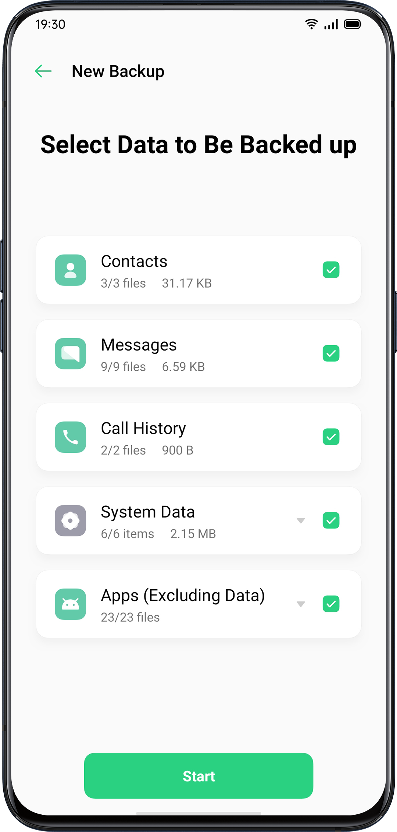
All data will be stored in the phone storage. Please copy all back-up files to an external storage device, computer or others before you start cleaning the cache or resetting the data.
Back Up to HeyTap Cloud
- Go to "Settings" > "HeyTap Cloud".
- Activate "Cloud Backup".
- To backup manually, tap "Back Up Now".

RestoreYou can restore your data and settings from backup, or restore your phone to factory settings. Be careful to back up your data before restoring the phone.
Restore Phone
Go to "Settings" > "Additional Settings" > "Restore Phone".
You have the following options when restoring your phone:
- Reset System Settings Only: It won't consume the stored data including photos and music.
- Clear Downloaded Apps and App Data: Keep data (e.g. photos, songs).
- Clear All Data: Clear all data including photos and music.
- Clear the Contacts and Call History on This Phone: Contacts on the SIM card will be retained.
- Clear the SMS and MMS Messages on This Phone: SIM messages on the SIM card will be retained.
Restore Data
Restore from Phone Storage
- Go to "Settings" > "Additional Settings" > "Back Up & Restore".
- Select the data to be restored, and tap "Start Restoring".
Restore from HeyTap Cloud
- Go to "Settings" > "HeyTap Cloud" > "Cloud Backup".
- Select the data to be restored, and tap "Start".

App OptimizationApp Cleaner
Clean up the junk cache files on your phone.
Open "Phone Manager" > "Cache Junk". You can choose the following options:
- One-click Clean Up
- Clean All App Data
- Clean Photos
- Cleans Videos
- Clean Audios
- Clean Files
- Clean Idle Apps·

Smart System Management
This is a new feature of ColorOS 6. The Smart System Management would intelligently stop the apps which have been barely used for a while, as a way to prolong battery usage.
Smart Memory Compression
This is another new feature of ColorOS 6. It works to detect inactive apps and compress its memory to make space for other apps.

HeyTap CloudHeyTap Cloud Backup serves to back up your contacts, SMS, photos, files.
Activate HeyTap Cloud
- Go to "Settings" > "HeyTap Cloud".
- Enter the lock-screen passcode and toggle on "Enable Cloud Service". The system will start the backup of photos, contacts, notes, calendar, browsing the history, and WLAN by default.

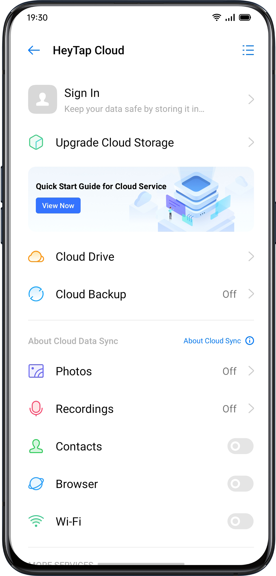

Optimize Storage

When enabled the optimized storage, the original photos will be stored at HeyTap Cloud, while smaller, clearly visible versions of photos will be stored on your phone to save space.

Go to "Settings" > "HeyTap Cloud" > "Photos" > "Optimize Storage".
When disabled, the original photos will be automatically downloaded to your phone.

Manage Cloud Storage
HeyTap Cloud provides 5G free storage for each user. If you need more cloud storage, you can delete unused data or pay for the upgrade of more storage.

Check Your Cloud Storage
Go to "Settings" > "HeyTap Cloud" > "Manage".

Free Up Cloud Storage
You cannot back up data to the Cloud after the storage is full. You may delete the unwanted data for more space. Backing up your device is recommended.

Purchase More Cloud Storage
Each user will acquire a 5GB free cloud storage. You can purchase more space when you need.

Go to "Settings" > "HeyTap Cloud" > "Upgrade Cloud Storage" .

You can upgrade the storage plan to either 50GB, 120GB or 1024GB. You can pay for renewal every month, three months, half a year, or on a yearly basis.

Contacts Time Machine
Whenever there are changes in contacts, a record will be automatically generated, allowing you to restore to the previous status.

Go to "Settings" > "HeyTap Cloud" > "More" > "Time Machine".

Support & Service

Contact OPPO Support
Contact OPPO Support Team to get more help.
Email: hello@oppo.com
Self Service
Find more information about user guide, spare parts price, warranty status, and more.
https://oppo.custhelp.com/
Get Help and Explore
View the most frequently asked questions about all popular topics of OPPO.
https://oppo.custhelp.com/app/popular_faq
Get More Information
View more relevant information and services about OPPO available on the OPPO official website https://www.oppo.com/en/.

